Draft (Oct 15, 2022)

Use of Life Cycle Costing in Procurement of Infrastructure Projects

Practice Manual: with sector specific guidance

The World Bank

October 2022

Abbreviations

EU: European Union
F-f-P: Fit-for Purpose
GPP: Green Public Procurement
ICT: Information and Communication Technology
LCC: Life Cycle Costing
MDB: Multilateral Development Bank
NPV: Net Present Value
O&M: Operation and Maintenance
PM: Practice Manual
PPP: Public Private Partnership
PPSD: Project Procurement Strategy for Development
PIM: Public Investment Management
TPI: Traditional Public Investment
V-f-M/VFM: Value for Money
QII Quality Infrastructure Investment
RE: Renewable Energy
SPP: Sustainable Public Procurement
TTL: Task Team Leader
WWTP: Waste Water Treatment Plant
WB: The World Bank

Overview
This Practice Manual has been prepared on the use of Life-Cycle Costing (LCC) in all types of contracts for different infrastructure sectors, based on Fit-for-Purpose (FfP) considerations, aligned with the Bank’s Procurement Framework of 2016, including green and sustainable procurement.

Quality infrastructure investment should attain value for money and remain affordable with respect to life-cycle costs, by taking into account the total cost over its life-cycle (planning, design, finance, construction, operation and maintenance) with due attention to economic, environmental and social benefits.

Value-for- Money does not necessarily mean selection of bidders on the basis of lowest evaluated initial cost but rather the lowest total cost of ownership or Life -Cycle Cost (LCC) over the useful economic life of the asset. Infrastructure projects have a long useful life and significant operation and maintenance costs.

In PPP mode of financing, the use of LCC principles is factored in selection of operator or concessionaire offering the lowest user fee while ensuring the quality of infrastructure and service delivery requirements. For the Traditional Public Investments (TPI), whether financed by MDBs or those through government’s own funds, governments tend to use traditional procurement methods for plants, works and goods focusing mainly on “lowest evaluated bid price” which may not be the best Value-for -Money.
Therefore, the focus of the manual is to explain the concept of LCC primarily for Traditional Investment Projects (TPI), with sector specific details on Renewable Energy, Water, Conventional Energy, Information Technology (IT) Infrastructure with case examples from all these sectors including experience from Road.

This application would cover the procurement strategy and planning phases, the bidding and proposal documents, the economic evaluation criteria, and the contract management phase so that after performance and guarantee tests, the facilities are delivered as intended in the contract.

The potential for value improvement is greatest at the design appraisal stage, which is not fully examined at the stage of PPSD. Check-lists and guidance and tips with case examples have been prepared with contribution from sector experts to provide a practical tool for application of LCC starting from PPSD to preparation of bidding document, bid evaluation, selection and award of contract. This application has been extended to cover contract management, performance and guarantee tests, post-warranty obligation including on servicing and supply of spares to ensure extended life of the asset.

The Practice Manual incorporates materials from training sessions and feedback from participants to ensure that material is of practical use.
The Practice Manual has been prepared as part of grant awarded by the Quality, Infrastructure Investment (QII) Partnership, to build practical knowledge in partner countries and in the World Bank’s procurement of infrastructure projects. The QII was established by the World Bank and the Government of Japan to raise awareness about the quality dimensions of infrastructure in developing countries. The QII Partnership aligns with the G20 Principles, the second principle focuses on economic efficiency in view of life-cycle-costs of infrastructure investments.
It is expected that this Practice Manual would help achieve the objective of raising economic efficiency through use of LCC principles at all the stages of an infrastructure investment projects
Contents

Section 1 7
1.1 Why this Practice Manual (PM) and scope of the PM? 7
1.2 Who are the intended users of this Practice Manual (PM)? 9
1.3 Concept of Economic Life and useful life of Asset/Infrastructure 9
1.4 What is Public Investment Management (PIM)? How PIM can be applied to select the contracting methodology/options? 12
1.5 Concept of Fit for Purpose, Where LCC could be fit-for-purpose option to consider? 14
1.6 Linkage of LCC to Quality of Infrastructure and Value-for- Money 14
1.7 Synergies between use of LCC, Green and Sustainable Public Procurement (GPP/SPP) 15
1.8 Other practices on LCC, Sustainable and green procurement 17
Section 2 – Important considerations, when to use LCC and linkage of application of LCC to Regulations 19
2.1 Important Considerations – when to use LCC 19
2.2 Linkage of LCC principles to the World Bank Procurement Regulations and Procurement Guidelines, Project Procurement Strategy for Development and Standard Procurement Documents 19
Section 3 –Application of LCC in Procurement Process – Critical Points to be considered 23
3.1 Procurement Process 23
3.2 Project Concept and Design and Procurement Strategy Stage 23
3.3 Bidding/Tender Document Preparation and Review stages: 24
3.4 Bid Opening, evaluation and award of contract stage: 29
Section 4 – How to use LCC as a factor in economic evaluation of bids? 30
4.1 Framework and Methodology of evaluation 30
4.2 How to simplify evaluation criteria? 32
Section 5 – Role of Different Stakeholders 35
5.1 Role of the Bank 35
5.1.1 Role of Bank’s Task Team Leaders and Procurement Specialist 35
5.2 Role of the Government/Ministry Responsible for the Project 35
5.2.1 Role of Project Implementing Agencies 35
5.3 Third Party Role 35
Section 6 –Background on Sector Specific Practices on Use of LCC 37
6.1 Renewable Energy 37
6.2 Water and Wastewater 37
6.3 Information Communication Technology (ICT) infrastructure 37
6.4 Transport 37
6.5 Conventional source of Energy (Generation, Transmission and Distribution) 37
Section 7 – Conclusion-Effective Implementation LCC in various stages of procurement process 38
Annexure 1: Use of LCC for Specific Sectors- Renewable Energy, WWTP, Conventional Energy, ICT 39
Guide for Using LCC in ICT Infrastructure Projects 89
Purpose of the guide 89
What is ICT? 89
What is Value for Money (VfM)? 89
What is LCC Analysis? 90
When should we conduct LCC analysis? 91
Use of LCC at the Business Case phase 91
Procurement phase 91
Ongoing Management Phase 92
Developing your LCC model 92
Step 1 – Scope of the analysis 93
Step 2 - Capturing the data and insight 93
Convergence Workshop 93
Ongoing Management 94
Risks Associated with using LCC as a Predictive Model 94
Case Study 95
Project background 95
Project Requirements and Assumptions 95
Requirement 95
Assumptions and Parameters - On-premises Delivery Solution 95
Assumptions specific to Cloud-based Delivery 96
Approach to LCC Analysis 97
Option 1: On-Premises 97
Option 2: Cloud-Based 98
Using LCC to Inform Procurement Strategy and Vendor Selection 99
Annexure 2 on Case Examples from sectors 103
Annex 3 on incorporation of LCC in PPSD 114
Annex 4 Relevant literature, source material and websites 124

Section 1

Why this Practice Manual (PM) and scope of the PM?
The aim of pursuing Quality Infrastructure Investment (QII) is to maximize the positive economic, environmental, social and development impact of infrastructure so that QII attain value for money and remain affordable with respect to life-cycle costs (LCC). The concept on application of LCC is infrastructure projects is not new, but has gained momentum with objective of fit for purpose, sustainable and green public procurement (SPP) for infrastructure projects and for items of common use in delivery of public services. The goals of SPP typically focus on reducing demand for resources and minimizing negative impact of goods, works or services across their life cycle.
The following diagram based on G20 Principles for QII is relevant in the context of use of LCC in particular Principle 2 and Principle 3

Related to Principle 2, quality infrastructure investment should attain value for money and remain affordable with respect to life-cycle costs, by taking into account the total cost over its life-cycle (planning, design, finance, construction, operation and maintenance (O&M), and possible disposal), compared to the value of the asset as well as its economic, environmental and social benefits.
Related to Principle 3, environmental considerations should be entrenched in the entire life-cycle of infrastructure projects. The impact on the environment of the development, operation and maintenance, and possible disposal of the infrastructure project should be continuously assessed.
The challenge for decision -makers and those responsible for implementing infrastructure projects in different sectors is to how to convert these principles into a project procurement strategy and practice for the entire procurement process to achieve value -for- money.
A detailed and universally applicable Practice Manual is needed on the use of LCC in all types of contracts for different infrastructure sectors based on the Bank’s Procurement Framework of 2016. The application of LCC principles needs to be examined and implemented based on Fit-for-Purpose (FfP) considerations during the entire procurement process, with a view to building quality infrastructure that also meets sustainability criteria. This application would cover the procurement strategy and planning phases, the bidding and proposal documents, the economic evaluation criteria, and the contract management phase so that after performance and guarantee tests, the facilities are delivered as intended in the contract.

There is a reluctance on the part of decision makers and government agencies to use LCC in procurement process for factors, among others, as under:
- Limitation and inability of government agencies to reconcile capital and revenue budgets;
  - Decision-makers/government favour procurement decisions based on the cheapest upfront costs;
  - Lack of understanding on benefits on use of LCC principles; and
  - A perception that application of LCC is complex as a factor for economic evaluation

There is a need to correct these perceptions through this Practice Manual, consider overall benefits on use of LCC and simplify the evaluation criteria as part of preparation of bidding documents.
As principles and practices in procurement and Standard Procurement documents are largely harmonized among Multilateral Development Bank, this Practice Manual uses examples on application of LCC from MDBs other than the World Bank as well for infrastructure projects.

The Practice Manual will also identify the use of sustainable procurement, energy-efficient equipment, and provisions in the technical specifications and employer’s requirements to support the LCC initiative. The Practice Manual will also provide references on use of LCC concept in common use items. The Practice Manual is intended to provide a practical guidance to users in all the phases of the procurement process with suitable case examples.

There is also a need to train procurement and operations staff from the Bank and from borrower countries on the application of LCC. Through this Practice Manual and with engagement of sector specialists, the case examples from infrastructure sectors would assist in development of training modules, including eLearning modules.

Who are the intended users of this Practice Manual (PM)?
The intended users of this Practice Manual are Task Teams of infrastructure sectors in the World Bank including project implementing units and ministries responsible for project implementation. The users would typically be Task Team Leaders, Technical Specialists, Procurement Specialist and those responsible for the entire cycle of project implementation. The Practice Manual is useful for all Stakeholders as per their role described in Section 5 of this PM. As the nature of LCC application in infrastructure sector is universal, this PM is expected to be useful for other MDBs and for projects financed by the government for large and complex infrastructure projects, with appropriate modifications as per procurement rules and regulations governing other MDBs and government-financed procurement, both for Traditional Public Investment (TPI) and Public Private Partnership (PPP) mode of financing.

Concept of Economic Life and useful life of Asset/Infrastructure
The concept of economic life of an asset (e.g. an infrastructure) starts with the design phase and ends with the dismantlement and / or recycling of the components of the asset when expected level of performance is no more met. Life Cycle Costing calculation methodology is the same all over the asset global life cycle. However, when initially done in the preliminary phases (study, design) costs are mainly future costs since the implementation project (including procurement) will be done later. If LCC calculation is done later, let’s say during operation, almost all fixed costs are already known (asset procurement, installation), while recurrent costs (maintenance) are future costs. The evaluation of present or past costs is often easier than future costs. When LCC calculation is done during the preliminary phases, an LCC Analysis (LCCA) approach is often considered: it relies on the comparison of LCC for alternative designs or options so that project teams may decide what would be the best technical orientation to achieve Value for Money. For instance, when designing a public transportation service, if volatility of diesel fuel price may deeply influence LCC calculation, alternatives based on renewable sources of energy might be considered instead.
First, let us deal with the fundamental concepts of Life-Cycle Costing as applied to the procurement of infrastructure projects. What are the Objectives:
#1 Quality infrastructure investment should attain value for money and remain affordable with respect to life-cycle costs, by taking into account the total cost over its life-cycle (planning, design, finance, construction, operation and maintenance) with due attention to economic, environmental and social benefits.

#2 Decision-makers for both traditional public investments as also for projects for PPP mode of financing have got the same objective of minimizing the total cost/tariff or user -fee over the useful economic life of the asset. Achieving Value-for-Money (VfM) requires framing evaluation criteria to factor all costs over the life of the asset and not just the initial cost of acquisition.

# 3 In the PPP mode of financing, the use of LCC principles is factored in selection of operator or concessionaire offering the lowest user fee while ensuring the quality of infrastructure and service delivery requirements. For the Traditional Public Investments, whether financed by MDBs or those through government’s own funds, governments tend to use traditional procurement methods for plants, works and goods focusing mainly on “lowest evaluated bid price” which may not be the best Value-for -Money.

According to the European Commission (EC), “Under the 2014 EU procurement rules a contract must be awarded based on the most economically advantageous tender (MEAT).” A number of different approaches are available under this general heading, some of which may be considered appropriate for green public procurement (GPP). Cost or price will form part of the assessment of any procedure and is usually one of the most influential factors. Costs may be calculated on the basis of a product’s life cycle, but how is the cost defined?

When a product, service, or work is purchased, a price is always paid. The purchase price, however, is just one of the cost elements in the entire process of purchasing, owning, and disposing of the product. LCC means considering all the costs that will be incurred during the lifetime of the element purchased:
- Purchase price and all associated costs (delivery, installation, insurance, etc.)
- Operating and maintenance costs, including, for example, energy, fuel, material and water use, spares, insurance, and warranty and maintenance costs
- Cost of land
- End-of-life costs (such as decommissioning or disposal) or residual value (i.e., revenue from the sale of the product)

LCC may also include the cost of externalities (such as greenhouse gas emissions) under specific conditions laid out in the directives of the European Union (EU). The most recent (2014) EU directives require that where LCC is used, the calculation method and data to be provided by tenderers are set out in the procurement documents. Specific rules also apply to the methods for assigning costs to environmental externalities to ensure that they are fair and transparent.

According to the World Bank Procurement Guidance on this topic:
Life-cycle costs: Evaluation of Bid/Proposal cost may also include an assessment of life cycle costs. The principle of VFM does not necessarily mean selecting the lowest price, but rather total cost of ownership (or lifecycle cost) over a specified period, generally the useful life of an asset. VFM represents the optimum combination of total cost of ownership and quality (or fitness for purpose) to meet the buyer’s requirements. It allows the relative benefits of different Bids/Proposals to be measured by taking into account all costs including for example: a) purchase price or upfront costs of acquisition; b) installation and commissioning costs; c) cost of operation and maintenance including costs of materials, servicing, spare parts, etc. over the useful life; d) sustainability savings e.g. lower fuel consumption; and/or e) decommissioning and disposal costs.

The potential benefits of LCC application if done during design phase are higher than if done during bidding phase with decreasing potential for value improvement in Operation & Maintenance phase.

Based on ISO 15686-5, the potential for value improvement is greatest at the design appraisal stage as depicted in the following diagram.
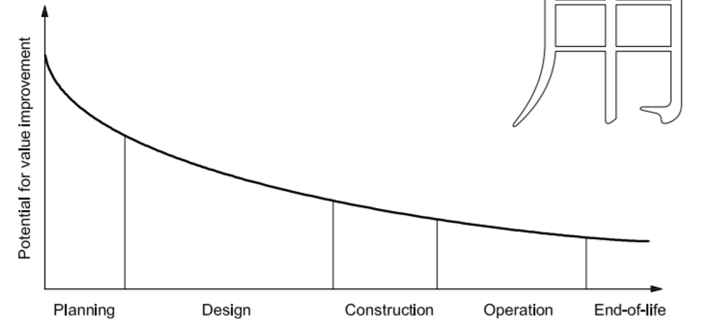
A Supplement to this standard has been published as “Standardized Method of Life Cycle Costing for Construction Procurement.”
Based on the above considerations, application of LCC is to be examined first at planning and design stage and part of Project Procurement Strategy for Development (PPSD) and applied at all subsequent stages of project cycle for value improvement until the facility is taken over. This includes preparation of economic evaluation criteria to determine the cost to the Borrower / Employer for each responsive bids in a manner that permits selection on the basis of evaluated cost offering maximum VfM.
The users of this manual would find application of LCC relevant for planning and design phase for all the sectors with application Life-cycle costing should be used: (i) when the costs of operation and/or maintenance over the specified life of the facility are estimated to be considerable in comparison with the initial cost and may vary among different Bids/Proposals; (ii) Where there is potential for savings over the life-cycle of -the facility on energy water and fuel; and (iii) when Equipment and facility are complex and specially engineered
Bids are evaluated on a net present value (NPV) basis by combining initial cost with benefits, for example, of lower fuel consumption over the life of the asset.
Based on the above considerations, typical examples for application of LCC may be procurement of a Combined Cycle Power Plant, Gas Storage facility, Water and Waste Water Treatment contracts and other similar facilities.
This topic of applicability of LCC is covered in greater detail in Section 1.7 of this Practice Manual

What is Public Investment Management (PIM)? How PIM can be applied to select the contracting methodology/options?
Need for Harmonized PIM-PPP System
This section is based on Public Investment Management Guide in the context of constraints in application LCC and how this Guide could be useful for policymakers in choice of financing and contracting methodology and options
As per PIM Guide, Public investment management (PIM) is a crucial component of infrastructure investment and economic development. Improvements to PIM are expected to enhance the efficiency and effectiveness of infrastructure investment as well as its contribution to achieving development goals and there is need for “developing a harmonized and integrated PIM-PPP system, focused on achieving the best outcomes at the lowest cost and risk, regardless of the implementation and contracting modality. All public investment projects, whether they are implemented through a PPP modality or through a traditionally implemented project (TIP) modality, should aim to support the creation of viable economic infrastructure—such as roads, airports, and railways—or to provide social infrastructure and public services”.
As indicated earlier one of the constraints in application of LCC is limitation and inability of government agencies to reconcile capital and revenue budgets. Decision-makers/government favour procurement decisions based on the cheapest upfront costs
There is need to integrate the strategic planning, project selection, and capital budgeting cycles. Upstream PIM processes, if designed well and working properly, should ensure that strategic planning, quality at entry, and capital budgeting are closely integrated, so that the right infrastructure is provided at the right price and at the right time.
In many PIM systems there is the failure to plan for the operation and maintenance costs of newly completed projects. A medium-term budgetary perspective can help to avoid this problem, which is often caused by poorly integrated capital and recurrent budgeting.
Life Cycle Cost, sustainable operation and Integration of Capital and Recurrent Budget
PIM document provides a guidance to policy makers on integration of capital and recurrent budget where there is projections of the total life-cycle cost of major investment projects, including both capital and recurrent costs together with a year-by-year breakdown of the costs for at least the next three years, are included in the budget documents, as explained fully in the box below:

Sustainable operation requires planning and budgeting for adequate funds to cover the costs of operation and maintenance over the planned economic life of a new facility. Poor integration of capital and recurrent expenditure planning and budgeting are frequently cited as weaknesses of public financial management systems.
Poor integration often leads to the planned benefits of investment not being realized in full because a shortage of funding for operating expenses or maintenance prematurely ends an asset’s planned operating life. This shortage may be particularly problematic where a large share of public investment is planned and financed by donors and inadequate attention is paid to the financing of operation and maintenance through domestic financial resources.
The importance of these failings is illustrated by the public expenditure and financial accountability (PEFA) assessment framework, where the rationale for dimension 11.3 of PI–11, “Public investment management,” is described as follows (PEFA Secretariat 2016 Dimension 11.3 evaluates whether budget documentation includes medium-term projections of investment projects on a full-cost basis and whether the budget process for capital and recurrent spending is fully integrated.
Sound budget management requires preparation of comprehensive and forward-looking project budget plans for capital and recurrent costs over the life of the investment. Projections of recurrent cost implications from projects are needed to plan and incorporate costs into budgets.
Solid budget and cash-flow management, as well as cost-benefit analysis, depend on comprehensive financial analysis of investment projects. Under this dimension, the highest score is reserved for those systems where “projections of the total life-cycle cost of major investment projects, including both capital and recurrent costs together with a year-by-year breakdown of the costs for at least the next three years, are included in the budget documents.”
The ideal model is one where information on the total life-cycle costs of major projects16 is presented to decision makers at budget time and includes an annual breakdown of expenditures over the medium term. At the technical level, this information needs to be supported by cost estimates for the entire life of a project, which are developed during preparation of a feasibility study and updated after detailed design, before a project is selected for budget funding.
Source: PIM, The World Bank (2020)
The PIM document advocates that “it is therefore important to use a unified system of project identification, appraisal, and implementation—which includes projects funded by the budget, by donors, or by the PPP—to ensure consistency in selection choices and throughout the life cycle of the project”.
In many countries, most PPPs have been prepared, appraised, selected, budgeted, and monitored separately from traditionally implemented projects (TIPs). This disparity has undermined efficient public financial management.
At the appraisal and selection stage, a PPP project should be assessed using Value-for-Money (VFM) analysis and approved by the PPP Review Committee over a TIP procurement option. At the contract agreement stage, the PPP Review Committee should review the analysis to ensure that the negotiated PPP contract still provides better value for money
The World Bank has been working with several countries to develop the relevant legal framework to harmonize and integrate PIM and PPP management, which are described in PIM Guide including examples a coordinated and integrated decision-making system covering all projects funded by the budget (Capital A), donor funds (Capital B), public corporations’ funds, and PPPs with PIM Committee established, supported by a secretariat, to screen, review, and prioritize all projects, including TIPs and PPPs, at an early stage
Finance ministries play a central “gatekeeping” role in the overall PIM system in most countries. The avoidance of parallel systems for TIP and PPP implementation is essential to determine appropriate contracting modalities and options that considers Life -Cycle Cost (LCC) and Value-for- Money.
MDBs at the stage of project appraisal and financing decisions for projects need to ensure that contracting arrangements and financing options have adequate provisions for operation, maintenance and replacement costs of capital asset consistent with LCC principles, whether following TIPs or PPPs.
Based on experience from countries, one example being India, in Road, Water and Renewable Energy sectors LCC principles were applied with innovative contracting arrangements and financing options that led to better Value-for-Money for the governments

Concept of Fit for Purpose, Where LCC could be fit-for-purpose option to consider?
Fit for Purpose. The principle of fit for purpose applies both to the intended outcomes and the procurement arrangements in determining the most appropriate approach to meet the project development objectives and outcomes, taking into account the context and the risk, value, and complexity of the procurement.
In accordance with Guidelines and applicable bidding document, evaluation of bids may also include an assessment of life cycle costs. For example, in complex facilities and equipment following Plant Design, Supply and Installation of large value (say in a contract of above US$10 million) the economic evaluation factors must contain incentive/advantage to those bids that offer equipment with better efficiency or lower consumption of fuel for the given output than specified as an example for Combined Cycle Power Plant or lower consumption of electricity and chemical like in a Waste Water Treatment Plant. There may be other factors like replacement cycle and cost of power inverters (for solar) and storage cells (BESS).

It is possible that in a very small value contract, like US$1 million, the principle of LCC may be analyzed and embedded as part of technical specification requirement requiring energy efficient equipment requiring a specified maximum consumption of electricity or fuel for a given output at specified conditions. In such cases a pass/fail criterion on technical specification should be sufficient

Based on principle of “fit-for-purpose”, there is no point in incorporating LCC as part of economic evaluation criteria for low value contract, which may be relevant for large value and complex contracts, where risk for non-performance is to be managed through appropriate provisions of liquidated damages for shortfall on guaranteed parameters.

Linkage of LCC to Quality of Infrastructure and Value-for- Money
The Bank defines VfM as the effective, efficient, and economic use of resources, which requires the evaluation of relevant costs and benefits, along with an assessment of risks, and of non-price attributes and/or life cycle costs, as appropriate. Price alone may not necessarily represent VfM.
For any meaningful life-cycle costing in procurement as concept of quality starts at the project design and technical specification stage, important considerations to ensure quality and life of the equipment/facility are as under:
- Performance – based specifications;
- Use of international codes and standards;
- What kind of type tests are to be specified in the bidding document that provides evidence of a proven design;
- Incorporation of quality plan as part of bidding document to be used as a basis for inspection (example, what tests are required at material induction stage, what tests are to be witnessed by the Employer or his representative before critical items are shipped);

- Define codes and standards for testing in factory or as part of performance and guarantee test;
- How proven is the factory where items are manufactured?

- What are the qualification and experience requirements for the bidders?
- What is the proven-ness of critical components supplied by the manufacturer and more importantly the sub-vendor?

- Need for extended warranty on critical component, servicing/overhaul agreement to extend life of the product; and
- Training of Operational and Maintenance personnel of the -Employer before the facilities are taken over.

These important provisions are just illustrative and required to be examined and incorporated as applicable as part of Bidding Document/ Technical Specifications/Employer’s Requirements in combination with guidance similar to ISO 15686-5 as per international industry codes and standards and good practices.
The technical consultants of the Employer are expected to examine the above indispensable conditions as part of the task on preparation of the Technical Specification/Employer’s Requirements and in contract implementation

Synergies between use of LCC, Green and Sustainable Public Procurement (GPP/SPP)
The concept of LCC is very much a part of green and sustainable public procurement and practised based on the requirement of the asset/facility to be acquired, industry practice and relevant legal and regulatory framework of the government and/or applicable procurement regulations of financing institutions.
Based on Sustainable Public Procurement Guidance Document of the World Bank on the three pillars of sustainability, which are economic, environmental and social, total cost of ownership and LCC is part of economic pillar. Based this guidance document, the Bank encourages Borrowers to actively consider and apply sustainable procurement, where appropriate. The use of sustainable procurement has been enabled through the Procurement Regulations, which state: “5.12 If agreed with the Bank, Borrowers may include additional sustainability requirements in the Procurement Process, including their own sustainable procurement policy requirements, if they are applied in ways that are consistent with the Bank’s Core Procurement Principles”
Based the given guidance document sustainability considerations need to incorporate life-cycle costing principles at each of key stages of procurement process to start with PPSD. The sustainability considerations cover: (i) initial considerations; (ii) market research and planning; (iii) procurement process design; (iv) sourcing process; (v)contract implementation; and (vi) checking sustainability outcome to assess V-f-M outcome over the whole life of the asset. These stages are illustrated in the following diagram
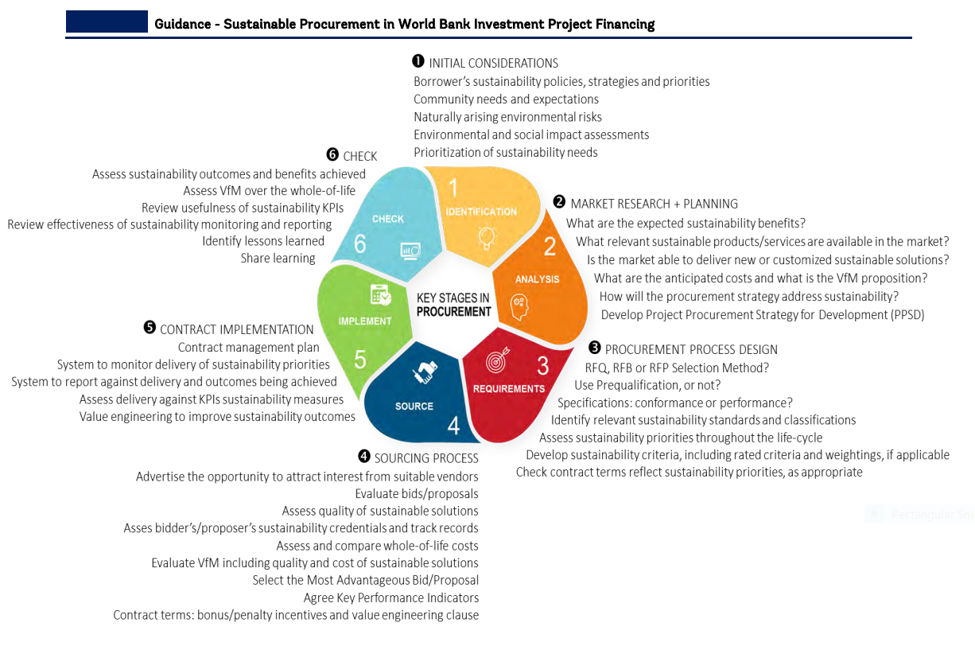
Consideration of LCC in Green Procurement
LCC principles are linked to Green Procurement, as illustrated in a tabulation from the recent publication of the World Bank The following diagram illustrates the considerations of LCC starting from production, acquisition, operation, maintenance and end-of life stages and deals with economic, social and environmental impacts:
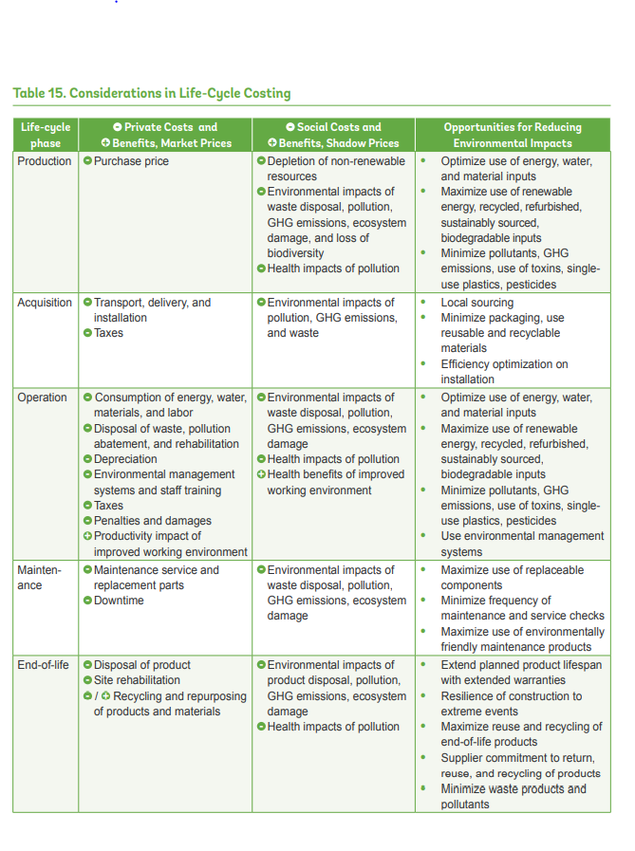

Other practices on LCC, Sustainable and green procurement
One important source of practice on LCC, sustainable and green procurement that is linked to the topic of use of LCC in procurement of infrastructure projects comes from European Union. LCC may also include the cost of externalities (such as greenhouse gas emissions) under specific conditions laid out in the directives of the European Union (EU). The most recent (2014) EU directives require that where LCC is used, the calculation method and data to be provided by tenderers are set out in the procurement documents. Specific rules also apply regarding the methods for assigning costs to environmental externalities, which aims to ensure that these methods are fair and transparent.
LCC makes good sense regardless of a public authority’s environmental objectives. By applying LCC, public purchasers take into account the costs of resource use, maintenance, and disposal that are not reflected in the purchase price. Often this will lead to “win-win” situations whereby a greener product, work, or service is also cheaper overall.
Related to application of LCC based on 2014 EU Directives, the publication by SIGMA in 2016 provides several practical examples
The EC has developed five sector-specific tools to facilitate consistent LCC calculations across member states on vending machines, imaging equipment, computers and monitors, and indoor and outdoor lighting. The EU Smart SPP project developed a tool (spreadsheet) and user guide to calculate the life-cycle costs and CO₂ emissions of energy-efficient technologies. The GPP 2020 project developed five spreadsheets designed to calculate energy and CO₂ reductions over the whole life cycle of goods, services, and works. The calculators cover: energy contracting, office information and communications technology (ICT), vehicles, clean fleets (aligned with the EU Directive), and street lighting. Depending on the product, service, or work in question, the impact is calculated either by drawing on existing calculation tools or, if no such tool exists, by referring to the product’s environmental declarations. In cases where neither is available, a rough calculation of the impact of part of the life cycle is applied.
LCC is has an extensive literature, the subject being linked to green and sustainable procurement, and the last section of this manual on source materials and websites covers additional details
As indicated earlier, the above concepts on green and sustainable procurement may be used consistent with procurement regulations, country and sector specific needs.

Section 2 – Important considerations, when to use LCC and linkage of application of LCC to Regulations

Important Considerations – when to use LCC
For procurement of equipment and facilities following considerations are important for application of LCC:
- Where value of the contract is significant;
- Where there is potential for savings over the life-cycle of goods, works or services on energy water and fuel and further on maintenance and replacements; and
- Equipment and facility are complex and specially engineered.

Life-cycle costing should be used when the costs of operation and/or maintenance over the specified life of the Goods or Works are estimated to be considerable in comparison with the initial cost and may vary among different Bids/Proposals. It is evaluated on a net present value (NPV) basis.

Based on ISO 15686-5, the potential for value improvement is maximum at design appraisal stage as indicated in the previous section. Therefore, application of LCC has to be incorporated in the first instance as part of procurement planning and strategy and then for all the subsequent phases of procurement cycle till the facility is taken over.

Linkage of LCC principles to the World Bank Procurement Regulations and Procurement Guidelines, Project Procurement Strategy for Development and Standard Procurement Documents
Procurement Regulations
Based on Procurement Regulations for Investment Project Financing (IPF) Borrowers some of important provisions related to LCC are as under:
- VfM means the effective, efficient, and economic use of resources, which requires the evaluation of relevant costs and benefits, along with an assessment of risks and of non-price attributes and/or life-cycle costs, as appropriate. Price alone may not necessarily represent VfM.

- To achieve VfM, the evaluation criteria may take into account such factors as the following:
a. Cost: evaluation of cost using a methodology that is appropriate to the nature of the procurement including: i. adjusted Bid price; or ii. adjusted Bid price plus the running/recurrent cost over the useful lifetime of the asset on net present cost basis (life-cycle costs);

b. Quality: evaluation of quality using a methodology to determine the degree to which the Goods, Works, Non-consulting Services or Consulting Services meet or exceed the requirements;

c. Risk: criteria that mitigate the relevant assessed risk;

d. Sustainability: criteria that take into account stated economic, environmental, and social benefits in support of the project objectives, and may include the flexibility of the Proposal to adapt to possible changes over the life-cycle; and/or

e. Innovation: criteria that allow assessment of innovation in the design and/or delivery of the Goods, Works, Non-consulting Services, or Consulting Services and that give Bidders/Proposers the opportunity to include, when appropriate, in their Bids/Proposals, solutions that exceed the requirements or alternative solutions that could deliver better VfM.
Therefore, as per Procurement Regulations the concept of LCC is inextricably linked with VfM that includes quality, sustainability and innovation.
Project Procurement Strategy for Development (PPSD):
PPSD document translates, the above concept of LCC at the early stage of project preparation, design, planning which inter alia includes the following aspects: The Three “D” Procurement Planning Approach: This approach is depicted with corresponding pairs as under in the Acquisition Life Cycle
3-D stage | Acquisition Life Cycle | Examples of incorporation of LCC concept
Design | Procurement Approach | To consider options on Performance-based specification, inclusion of sustainable procurement requirements, Design/Build/Operate/Maintain (for few years), performance-based contract, PPP model, long term commitment on supply of spares/replacements, leasing options
Demonstrate | Bid Evaluation | Economic evaluation factors should capture key parameters and provide a quantitative measure (in Dollar terms), a methodology to evaluate bids offering different efficiency and consumption, while these bids meet the requirements of technical specification  Advantages on efficiency parameters or lower fuel/power consumption as offered by bidder/contractor could be verified and demonstrated before taking over of the facility.  No point in incorporating operation, maintenance costs or spares consumption as an economic evaluation factor, if these are not demonstrated by the selected bidder
Deliver | Contracts Management | The selected bidder is required to deliver the agreed performance/functional guarantees, which was the basis of selection at bid evaluation stage, failing which liquidated damages for shortfall in performance (calculated on a pre-determined basis as part of contractual commitment)

The above concepts are elaborated further under Section 3 and in sector specific examples (to add case examples from sectors)

Standard Procurement Documents
SPD of the World Bank incorporates the concept of life-cycle costing as economic evaluation criteria in following categories of contract, with reference to document and specific provisions given (this is an illustrative and not an exhaustive list)
sl | Category of Contract | Reference of SPD | Specific provisions in Section III: Evaluation and Qualification Criteria
1 | Goods | Request for Bids- Goods (one-envelope Bidding Process) June 2021 | Life Cycle Costs: If specified in BDS 34.6, an adjustment to take into account the additional life cycle costs for the period specified below, such as the operating and maintenance costs of the Goods, will be added to the Bid price, for evaluation purposes only. The adjustment will be evaluated in accordance with the methodology specified  Performance and productivity of the equipment. An adjustment representing the capitalized cost of additional operating costs over the life of the goods will be added to the Bid price, for evaluation purposes if specified in the BDS 34.6. The adjustment will be evaluated based on the drop in the guaranteed performance or efficiency offered in the Bid below the norm of 100, using the methodology specified.
2 | Information Technology | Request for Bids- Information System, Design Supply and Installation (one-envelope Bidding Process) June 2021 | Recurrent Costs (R) Since the operation and maintenance of the system being procured form a major part of the implementation, the resulting recurrent costs will be evaluated according to the principles given and reduced to NPV as per the formula
3 | Works | Request for Proposal Works Design& Build (Single Stage RfP after initial selection) January 2021 | Life cycle costing should be used when the costs of operation and/or maintenance over the specified life of the Works are estimated to be considerable in comparison with the initial cost and may vary among different Proposals. It shall be evaluated on a net present value basis
4 | Design, Build Operate | Request for Proposal – Works and Operation Services- Design Build and Operation of Water Treatment Plant (WTP)/Wastewater Treatment Plant (WWTP) January 2021 | The Design-Build Proposal Price shall not be discounted if price is totally paid during the first year.  If the PDS provides for Net Present Valuation of the Operation Service Proposal Price, the annual amounts in the Operation Service price schedules, as adjusted in accordance with ITP 40.1 (a) to (e), shall be discounted using a discount factor of [ ……] %. The discount base year shall be the year preceding the first year of the Operation Service Period.
5. | Plant | Request for Bids-Plant  Design, Supply and Installation (after prequalification) January 2021 | Life Cycle Costing  Option 1: The operating and maintenance costs factors for calculation of the life cycle cost  Option 2:Reference to the methodology specified in the Specification or elsewhere in the bidding document  Functional Guarantees of the Facilities: The minimum (or maximum) requirements stated in the Specification for functional guarantees required in the Specification. For the purposes of evaluation, for each percentage point that the functional guarantee of the proposed Plant and Installation Services is below the norm specified in the Specification and in the above table, but above the minimum acceptable levels also specified therein, an adjustment of ___________________will be added to the tender price. If the drop below the norm or the excess above the minimum acceptable levels is less than one percent, the adjustment will be prorated accordingly.  Sustainable procurement [If specific sustainable procurement technical requirements have been specified in Section VII- Employer’s Requirements, either state that (i) those requirements will be evaluated on a pass/fail (compliance basis) or otherwise (ii) in addition to evaluating those requirements on a pass/fail (compliance basis), if applicable, specify the monetary adjustments to be applied to Bid prices for comparison purposes on account of Bids that exceed the specified minimum sustainable procurement technical requirements

This Practice Manual provides guidance on use of above provisions in sector specific examples. The option of operating and maintenance costs as factors for calculation of the life cycle cost should be used when O&M is the responsibility of the contractor. As a default method Option 2 should be used, where Bids are evaluated on a net present value (NPV) basis by combining initial cost with benefits, for example, of lower fuel consumption over the life of the asset, based prespecified figure of quantified benefits over the life of the asset

Section 3 –Application of LCC in Procurement Process – Critical Points to be considered

3.1 Procurement Process
The process that starts with the identification of a need and continues through planning, preparation of specifications/ requirements, budget considerations, selection, contract award, and contract management. It ends on the last day of the warranty period. This process may include any post-warranty obligation of the contractor as part of the contract

3.2 Project Concept and Design and Procurement Strategy Stage
The Employer need to consider and check the following aspects (an example from Combined Cycle Power Plant)
- To examine if LCC tools for international standards such as (BS ISO 15686-5) at design/ concept stage to find choices between alternative designs, alternative components all of which have acceptable performance levels

- To identify items of plant and equipment where performance- based specification are appropriate.

- To examine for major plants and equipment for the project, if costs of operation and/or maintenance is significant compared to the initial costs for a facility and where use of LCC would bring substantial cost savings

- To ensure an industry/supplier engagement to guide procurement strategy to get feedback from such engagement. For example, what could be an ideal plant configuration for a given range of output to lower capital cost, achieve higher efficiency resulting in lower fuel consumption and lower environmental pollution, shorter lead time for construction and modular installation, smaller number of operating and maintenance personnel, while maximizing competition and VfM.
- To examine contractual arrangements to be adopted to mitigate risks, delays and cost overruns in the plant construction contract.
- To examine options for a well thought out maintenance plan that increases availability of the plant after operational acceptance. For example, could there be a Maintenance Service Contract as part of initial selection, with limited operation support from the Original Equipment Manufacturer (OEM) based on industry practice to coincide with extended defect liability period (3-7 years).

- The objective at this stage should be examine all options to deliver a quality infrastructure to provide services as per performance standards over the useful economic life of the asset.
The above aspects need to be considered as part of PPSD template based on the nature of the facility, industry practice under the section Value-for- Money (VfM) and as elaborated in sector specific examples. Further details and check-list is given at Section 7 on incorporation of LCC principles at PPSD stage

3.3 Bidding/Tender Document Preparation and Review stages:
The Borrower/ Project Implementing Agency at this stage needs to decide use of appropriate Standard Procurement Document and adapt or modify the specific clauses consistent with the requirements of Technical Specification/ Employer’s Requirement. The adaptation or modifications are to be carried in Bid Data Sheet, Evaluation and Qualification Criteria, Bidding Forms, Price Schedules Particular Conditions to prepare a fit-for-purpose bidding document.
For example, for facility like Combined Cycle Power Plant, Water Treatment Plant use of Plant Design, Supply, Installation (DSI- one stage or two stage bidding) may be adopted as justified. If responsibility for Operation and Maintenance for a specified period (like 3-7 years) is to be entrusted to the same bidder/contractor who is responsible for DSI, the bidding document needs to be modified as indicated above.
The Borrower/ Project Implementing Agency needs to consider the following:
- Related to application of LCC, the different sections of bidding/tender documents, like Employer’s Requirements/Technical Specifications, Instructions to Bidder/ Bid Data Sheet, Economic Evaluation Criteria, Functional Guarantees (on Output, efficiency/major items of consumption like water, energy, chemicals for the rated output and compliance to environment norms) are consistent.

- LCC principles are followed as a factor in evaluation in choosing the firm providing the best Value-for-Money and the selected firm is required to take responsibilities, which are verifiable and demonstrable, in execution of contract which is the basis of selection.

- Need to analyze and understand process flow, output, efficiency, environmental norms and check factors that are to be used a factor for economic evaluation of bids related to LCC and factors that used a Functional Guarantee.

Specific provisions to be checked for LCC application for Plant Design Supply Installation: Request for Bids (January 2021)

Functional Guarantees are part of technical specification to be demonstrated in accordance with General Condition at the time of performance and guarantee test. Some of the Functional Guarantee requirements like efficiency or fuel and power consumptions are specified as economic evaluation criteria (defined as FUNC in Section IV of Bidding Form).

Technical Evaluation (ITB 35): The Employer is required to carry out a detailed technical evaluation of the Bids not previously rejected to determine whether the technical aspects are in compliance with the bidding document. The Bid that does not meet minimum acceptable standards of completeness, consistency and detail, and the specified minimum (or maximum, as the case may be) requirements for specified functional guarantees, will be rejected for non-responsiveness.
Instructions to Bidder/ Bid Data Sheet ITB/BDS 17 on Bid Prices and Discount: In case Operation and Maintenance services for a specified period after the operational acceptance is required to be entrusted to the same bidder/contractor responsible for construction of facility, an additional price schedule needs to be added, with a method of quoting prices for each year and formula given under evaluation criteria to discount such O&M services to arrive at Net Present Value of such future costs. The additional Price Schedule in Section IV should indicate in a table the different elements of prices to be quoted by bidders for each year as per the requirements/scope of operation/maintenance services

Instructions to Bidder/ Bid Data Sheet ITB/BDS 26.8 on Bid Opening: BDS to be modified to state that Guarantee figures used in Econnomic Evaluation any other critical parameters like output/availability shall be read out at the time of bid opening ( Refer Form FUNC in Section IV Bidding Form).

Economic Evaluation Criteria Section III Evaluation and Qualification Criteria Section 1.2 (b) on Life Cycle Costing
These provisions stipulate following options: Option 1 or Option 2 or any other.
Option 1:
The operating and maintenance costs factors for calculation of the life cycle cost are:
(i) number of years for life cycle: ____[Insert number of years]
(ii) operating costs [state how they will be detrmined]
(iii) maintenance costs, including the cost of spare parts for the initial period of operation [state how they will be determined], and
(iv) Discount rate: ________[insert discount rate in percent] to be used to discount to present value all annual future costs calculated under (ii) and (iii) above for the period specified in (i).
Borrower should select this option when operation and maintenance services is the responsibility of bidder/contractor for a stated number of years (like 3-7 years). In that case a table on method discounting future prices should be specified as part of economic evaluation criteria. If bidders/contractors are not responsible and accountable for O&M services, Option 1 is not applicable.
Option 2
Reference to the methodology specified in the Specification or elsewhere in the bidding document
The factors like years for life cycle, efficiency/fuel consumption and applicable discount rate may be used in engineering/financial calculation to determine advantage to be given to bidders for each percentage of higher efficiency or lower fuel consumption, which are guaranteed and verified before the facility is taken over by the Employer
The comparison and evaluation of bids offering efficiency or consumption figures better than specified may be used as stated in technical specification/Functional Guarantee by using Option 2. The Standard Procurement Document stipulates the following table for Functional Guarantee of the facilities:

Functional Guarantees of the Facilities: The minimum (or maximum) requirements stated in the Specification for functional guarantees required in the Specification are:
Functional Guarantee | Minimum (or Maximum, as appropriate) Requirement
1.
2.

These provisions stipulate that for the purposes of evaluation, for each percentage point that the functional guarantee of the proposed Plant and Installation Services is below the norm specified in the Specification and in the above table, but above the minimum acceptable levels also specified therein, an adjustment of ___________________will be added to the Bid price. If the drop below the norm or the excess above the minimum acceptable levels is less than one percent, the adjustment will be prorated accordingly.
The same principle of adjustment to bid price due to “ the drop below the norm or the excess above the minimum acceptable levels” may be adopted by making no adjustment to bid price for a responsive bid that has offered the best efficiency or lowest fuel/electricity consumption, and an adjustment applied by a prespecified monetary value (representing Net Present Value of each percentage point of lower efficiency or higher fuel/electricity consumption, over the life of the asset, compared to the best offered efficiency or consumption figures). This is a simplified method that permits a comparison on the basis of the evaluated cost in order to select the Bid offering maximum VfM.
Functional Guarantees (on Output, efficiency/major items of consumption like water, energy, chemicals for the rated output and compliance to environment norms) needs to analyzed in consultation with technical specialist and adjustment factors specified as a dollar figure in this Section III.
A simplified differential price adjustment approach is explained with an example in Section 4.1 of this Practice Manual
Section IV on Bidding Forms – Form FUNC on Functional Guarantees
The Bidder shall copy in the left column of the table below, the identification of each functional guarantee required in the Specification and stated by the Employer in para. 1.2 (c) of Section III, Evaluation and Qualification Criteria, and in the right column, provide the corresponding value for each functional guarantee of the proposed plant and equipment.

Required Functional Guarantee | Value of Functional Guarantee of the Proposed Plant and Equipment
1.
2.

(The above table should be read out at the time of bid opening for each bidder and this table should identify those guarantees which are factors in economic evaluation (like efficiency/consumption of fuel or electricity) and others to determine the responsiveness to meet the critical technical parameters like output and environment norms (all these parameters should be part of Appendix 8 on Functional Guarantees)
Sustainable procurement: This part of economic evaluation criteria ( 1.2 ( e) )stipulates that [If specific sustainable procurement technical requirements have been specified in Section VII- Employer’s Requirements, either state that (i) those requirements will be evaluated on a pass/fail (compliance basis) or otherwise (ii) in addition to evaluating those requirements on a pass/fail (compliance basis), if applicable, specify the monetary adjustments to be applied to Bid prices for comparison purposes on account of Bids that exceed the specified minimum sustainable procurement technical requirements.]

General Conditions of Contract GCC 28 on Functional Guarantees: These provisions inter alia states that if, for reasons attributable to the Contractor, the Functional Guarantees specified in the Appendix to the Contract Agreement titled Functional Guarantees, are not attained either in whole or in part, but the minimum level of the Functional Guarantees specified in the said Appendix to the Contract Agreement is met, the Contractor shall, at the Contractor’s option, either(a) make such changes, modifications and/or additions to the Facilities or any part thereof that are necessary to attain the Functional Guarantees at its cost and expense, and shall request the Employer to repeat the Guarantee Test or (b)pay liquidated damages to the Employer in respect of the failure to meet the Functional Guarantees in accordance with the provisions in the Appendix to the Contract Agreement titled Functional Guarantees.
The figures for liquidated damages failure to meet the Functional Guarantees as specified in Particular Condition and in Appendix should be either the same as value used for economic evaluation criteria or maximum 1.5 times of such values. For Functional Guarantee figures which are not used for economic evaluation like guaranteed availability or output should be related a genuine pre-estimate of revenue loss to the Employer and not punitive or arbitrary.
General Conditions of Contract GCC 27 on Defect Liability Period: Based on the provisions of Standard Procurement Document the Defect Liability Period shall be five hundred and forty (540) days from the date of Completion of the Facilities (or any part thereof) or one year from the date of Operational Acceptance of the Facilities (or any part thereof), whichever first occurs, unless specified otherwise in the Particular Conditions of Contract (PCC)
The Employer should not extend the Defect Liability Period beyond the period prescribed in GCC Clause except where it is commercial practice for critical components in that type of Facilities, and in which case the relevant period shall be specified in the PCC
PCC specifies “The critical components covered under the extended defect liability are ____________________, and the period shall be _________________(to be inserted only when an extended defect liability is requested)”
The critical components covered under the extended defect liability needs to be specified in PCC or a reference should be made to the related paragraph in the Employer’s Requirements], and the period shall be limited shall not exceed five (5) years. (This provision is to be inserted in PC only when an extended defect liability is requested).
It is recommended that in case where responsibility for Operation and Maintenance Services is given to the Contractor responsible for construction of the facility, extended defect liability period may be matched with period for which O&M services are envisaged after Operational Acceptance for better accountability and responsibility of the contractor and to minimize disputes.
Section X Contract Form: Appendix 8 on Functional Guarantees: The text in Appendix 8 of Standard Bidding Document is related to a process plant facility. The terminology used in this section on output, availability, efficiency, fuel consumption should be based on the technical specification and functional guarantees as per Employer’s Requirement and these provisions should be consistent with the applicable section of the Technical Specification.
In general, this Appendix sets out(a)the functional guarantees referred to in GC Clause 28 (Functional Guarantees); (b)the preconditions, if any, to the validity of the functional guarantees, either in production/output and/or consumption; (c)the minimum level of the functional guarantees(d) the formula for calculation of liquidated damages for failure to attain the functional guarantees.
Failure to Attain Functional Guarantees: Notwithstanding the provisions of this paragraph, if as a result of the guarantee test(s), the specified minimum levels of performance guarantees (and consumption guarantees) are not attained by the Contractor, the Contractor shall at its own cost make good any deficiencies until the Facilities reach any of such minimum performance levels, pursuant to GC Sub-Clause 28.2
It is possible that based on guarantee tests the Contractor is not able to achieve the Functional Guarantee figures as per the contract and as offered at the time of bidding, but still it meets technical specification requirements, in that case if Contractor elects to pay liquidated damages to the Employer in lieu of making changes, modifications and/or additions to the Facilities then the Contractor shall pay liquidated damages at the rate which is equivalent to those used as economic evaluation factor or maximum 1.5 times of such factor for each unit of deficiency (like for reduced efficiency or higher fuel consumption).
If any amount is specified for Functional Guarantee related to other factors like output or environmental norms, any figure which is specified should be justified and represent a genuine pre-estimate of loss to the Employer (like revenue losses) and not punitive.
Appendix 8 on Functional Guarantee provides that a rate be specified. Similarly, for capacity/consumption parameters there is a range given (95% or 105%) which are outer limits. These figures or percentage needs to be defined in the bidding document carefully to provide an incentive for bidders to carefully design and manufacture the facility to stay within the range and not pay LD

Bidding document stipulate Liquidated Damages for Shortfall in performance for different parameters like efficiency, consumption, output which might be a specified figure or a percent of contract price, with overall limit generally as 10% of contract price

Appendix 8 on Functional Guarantee provides that a rate be specified. Similarly, for capacity/consumption parameters there is a range given (95% or 105%) which are outer limits. These figures or percentage needs to be defined in the bidding document carefully to provide an incentive for bidders to carefully design and manufacture the facility to stay within the range and not pay LD

Technical consultant of the Borrower needs to cross -refer Appendix 8 with economic evaluation criteria and performance guarantee section of the technical specification and ensure consistency among these provisions referred above.

3.4 Bid Opening, evaluation and award of contract stage:
To examine if evaluation methodology related to LCC is applied transparently and as per specified evaluation criteria in bidding document in determination of winning bid. In particular, the Employer needs to ensure the following:
- Evaluation methodology related to LCC is applied transparently – bidders understand its application upfront – need to include it as part of bidding document and explained in pre-bid conference (refer to Annex that provides an illustration on how bids would be evaluated)
- Guaranteed figures (e.g. like fuel consumption, heat rate, efficiency, GHG emissions) which are used as factors in economic evaluation of bid are read out at the time public bid opening and recorded in minutes (Form FUNC – on performance guarantee)
- Apply LCC strictly as per the methodology described in economic evaluation criteria- no clarification should be asked on guarantee figures as read out at the time of bid opening that will change the substance of the bid
- Check if bidders have provided the same figures on consumption like on chemical consumption or electricity consumption (even to the last decimal points- a “Red Flag”) or if there is wide variation which is technically unexplainable.
- To incorporate conditions of performance guarantees in the contract in Particular Condition or Appendix, Employer’s Requirements/ Technical Specifications which are consistent which do not vary from the conditions which were the basis of evaluation and comparison of bids
- To avoid complaints through transparent handling and expeditious decision on award of the contract

3.5 Contract Implementation, performance guarantee including post -warranty, stage (Track Application of LCC including post-warranty for full procurement cycle
To Implement the contract, as per agreed conditions. In particular, in the context of LCC and VfM, to ensure the following:
- Suitable mechanism exists on contractor following adequate quality control measures in sourcing, manufacture and installation of facility to provide an assurance that facility as delivered meets the specification and quality standards for the intended life of the asset.
- To check compliance of guarantees and performance at the stage of inspection and/or factory acceptance test
- That the contractor fulfilled its obligation as per contract terms and performance guarantees were met
- That in case of shortfall applicable liquidated damages are applied.
- Contractor meeting the availability, extended warranty and any other post-warranty obligations
- Service agreements are in place to properly maintain and service the facility

Section 4 – How to use LCC as a factor in economic evaluation of bids?

4.1 Framework and Methodology of evaluation

This section describes with examples how to use LCC as a factor in economic evaluation of bids, how to evaluate different options in aggregating the combination of initial cost and differential cost between bids offering varying efficiencies, consumption of fuel/electricity and consequences of not meeting functional guarantees. The purpose of this section is also to illustrate how to simplify the evaluation criteria by following an approach which is consistent with the provisions of the Procurement Regulation/Standard Procurement Document.

It is essential that the comparison of bids is carried out based on provisions in bidding document which are contractually binding between the bidder and Purchaser/Employer with a view to select the Bid offering maximum Value-for- Money (VfM).
The following section is based on examples of facilities like Combined Cycle Power Plant or a Wastewater Treatment facility
Main parameters in a process: In any process there are three main parameters which are related to application of LCC:

- Output/Capacity: This is defined as required by the technical specification requirements. Depending upon the requirement there may be margins specified which are acceptable;
- Efficiency or consumption of fuel, electricity or water per unit of output;
- Environmental (like noise, emission, odor) as determined by the technical specification with margins, but required to be within limits.
It is important to understand first the process flow diagram and related parameters of a given facility to correctly specify LCC evaluation criteria. The sector specific examples provide details

Interaction between procurement expert and technical experts: The procurement experts of the Employer and their technical consultants need to interact at the stage of preparation of bidding document, to understand the process diagram of the facility, output/capacity, efficiency/consumption and environmental parameters to determine factors that are to be used as factors for economic evaluation of bids. These factors are part of technical specification requirements and functional guarantee.

Technical Specification and Functional Guarantee: In the context of application of LCC as economic evaluation criteria technical specification is a pass/fail criterion like output and capacity (generally within margins). Functional Guarantee like efficiency or consumption of fuel may be offered by competing bidders as better than specified efficiency or lower than specified consumption

Sustainability criteria: Whereas it is possible to calculate the measurable economic cost of lower output/capacity and lower efficiency or increased consumption of fuel and electricity, the environmental parameters/norms are set by regulations. For any environmental parameters which in actual is better than required, it is difficult to quantify the measurable economic benefit. But based on sustainability criteria, there may be a possibility to specify advantage to be given for environmental norms which are better than the norm, based on guidance available in standard procurement documents.

LCC factors to be demonstrable and verifiable: Any factor in evaluation which is neither demonstrable nor verifiable have got no relevance as a factor in deciding the bid providing best VFM (examples: Operations and Maintenance cost in future which is beyond the contractual period or an assumed fixed percentage of O&M cost as a fixed percentage of initial cost or an estimated overhaul cost say after 15 years facility being in operation for which Contractor is not responsible). As already explain in this manual, LCC calculation is not limited to what has been contracted (e.g. O&M costs beyond the contract and up to the end of life of the asset). As a consequence, the Employer has to publish what will be his O&M costs before selecting an offer so that LCC calculation will take into account all costs and will be transparent for all market players.

Differential approach to be used and not Total Cost of Ownership : The purpose of evaluation is not to determine a total cost of ownership (initial cost, plus operation and maintenance cost minus residual value at the end-of-life cycle), as absolute figure which may not be contractually binding (In fact, in many complex facilities there is no residual value rather as part of renovation and modernization, there may be additional cost to dismantle and remove the existing structures and equipment). These absolute figures may have relevance in assessment for economic or financial analysis for determination of rate of return, based on the quoted price of bids or value of contract to be awarded. In LCC evaluation at bidding stage, the differential approach is to be used as illustrated in examples

The evaluation and comparison of Bids is required to determine the global cost to the Employer of each responsive Bid in a manner that permits a comparison on the basis of their evaluated cost in order to select the Bid offering maximum VfM.

In practice, as economic evaluation factor, there is a need to carry out an engineering/economic calculation to determine benefit to the Employer for saving for each percentage point increase in efficiency or lower consumption (of fuel/electrical energy) to compare bids offering varying efficiencies/consumption. The evaluation process requires comparing these savings/benefits as Net Present Value (Dollar / unit of saving) over the life of the asset by using discount rate is as a proxy for average cost of borrowing for the Employer

An Illustration on Application of LCC as Economic Evaluation Criteria based on Differential Approach

As an illustration in a simplified example suppose a coal-based power plant needs to have a capacity of 500 MW with a maximum heat- rate of 2500 kcal/kWh (heat energy input per unit of electrical energy output) for a specified coal quality and operating conditions.

It is possible that employer specifies that any facility offering a capacity of less than 500 MW is unacceptable. Further based on Life-Cycle Costing (and economic modeling) a dollar value (say US$100,000) for each kcal/kWh is specified in the bidding document as economic evaluation criteria for any machine offering a heat rate better than the maximum. In comparison of bids a bidder (A) offers say a heat rate of 2450 kcal/kWh and another bidder (B) offers 2350 kcal/kWh.

In the given example, suppose both the bids are offering machines of required output and both bids are responsive. As an application of Life-Cycle Costing, on the bid price of bidder (A) an amount of US $ 100,000 X 100 = US$ 10,000,000 will be added to compare the bid which offers a better heat rate (efficiency) for comparison.

This heat rate for both the bidders should be based on their past data on similar machines, demonstrable at the time of factory test/performance and guarantee test. If bidder (B) is a winning bidder and at the time of Performance and Guarantee test the achieved heat rate is say 2400 kcal/kWh, the Contractor will be liable for payment of Liquidated Damages for Shortfall in performance at a pre-specified rate say in the range of 1.5 times of the rate specified for evaluation (or at least equivalent to the rate specified for evaluation).

For example, if the rate specified was US$ 150,000 for each kcal/kWh in the given case, the contractor would be required to pay LD of US$ 150,000 X 50 = US$7,500,000

Technical specification criteria/requirements should be embedded as: (i) specifying minimum required efficiency or maximum fuel or chemical consumption, specified output (within a range) or minimum availability; (ii) incorporating energy efficient products with proven performance for minimizing Life Cycle Cost; or (iii) other requirements for replacement of wear parts that fail earlier than guaranteed hours

The above discussion has to be completed with the environmental impacts of burning gas (e.g. CO₂ emissions). Contractor is not responsible for CO₂ price but has to meet national laws and regulation. As a consequence, if the national public policy expresses the need to reduce emissions, LCC calculation has to take into account an additional cost: either cost of emissions or cost of CO₂ storage. This shows also the consequence of using LCC tardily in the project: in the procurement phase, performance issues may have a quite small impact on LCC calculation compared to a storage option or to the use of a renewable source of energy.

A Case Example is given at Annex 2 Conventional Energy Sector (Example of Procurement of Combined Cycle Power Plant following Plant Design Supply and Installation)

4.2 How to simplify evaluation criteria?

The Employer could simplify evaluation criteria by adopting a Differential (or Delta) Approach rather than doing a complex calculation of determining the Absolute Value on Total Cost of Ownership. A Delta Approach would give the same results without getting into a complex calculation.

The evaluation should be carried out by specifying a figure in money terms that represents an adjustment for better heat rate in terms of US Dollar or local currency value for each unit of kj/kwh (heat energy per unit of electricity), which represents saving of fuel as NPV over the life of the asset.

It is recommended that under Option 2 of economic evaluation criteria in Section III of the Bidding Document an amount in USD or local currency be specified. The Employer may provide a basis for arriving at such figures in Technical Specification without any need for giving a detailed formula.
The Technical Specification may provide details of assumptions in specifying economic evaluation criteria for better transparency
Option 1 of evaluation criteria under Section Economic Evaluation Criteria is relevant provided O&M services is the responsibility of the contractor in the initial years (example 3 to 6 years)
An example
Net Present Valuation of the Operation Service Proposal Price, the annual amounts in the Operation Service price schedules, as adjusted in accordance with economic evaluation criteria and shall be discounted using a discount factor of [ ……] %. The discount base year shall be the year preceding the first year of the Operation Service Period.
For greater certainty, net present values shall be determined by applying the following discount factors to the annual amounts in the Proposal forms during the Operation Service Period.

Operation Period | Discount factor to be applied
Year 1
Year 2
Year 3
etc.

This application is relevant for facilities like Waste Water Treatment Plant, Information System where the responsibility of O&M for a limited period is stipulated in addition to the responsibilities under Design-Supply-Installation contract.

For example, in case Procurement of Information Technology System, the LCC may be applied by adding follow-on costs, for example, three years of warranty period (N) plus three years of recurrent cost on post warranty Period (M) on the following basis:
The Evaluated Bid Price (C) for each responsive bid will be determined as the sum of the Adjusted Supply and Installation Costs (P) plus the Recurrent Costs (R)
The Recurrent Costs (R) are reduced to net present value and determined using the following formula:
Where,
N = number of years of the Warranty Period, defined in Special/Particular Conditions
M = number of years of the Post-Warranty Services Period, as defined in Special/Particular Condition
x = an index number 1, 2, 3, ... N + M representing each year of the combined Warranty Service and Post-Warranty Service Periods.
Rx = total Recurrent Costs for year “x,” as recorded in the Recurrent Cost Sub-Table.
I = discount rate to be used for the Net Present Value calculation, as specified in the Bid Data Sheet
In some cases, the Option 1 and Option 2 could be used in combination. Option 2 would capture the advantages due to better heat rate, lower fuel consumption, higher efficiency as NPV over the life of the asset, and Option 2 covers, NPV of O&M services provided by the bidder/contractor for a limited duration for which the contractor is responsible.

Section 5 – Role of Different Stakeholders
This part is prepared in a generic way in a typical Project Implementing Unit situation of externally financed project following Standard Procurement Document for Plant, Design, Supply and Installation. The Role will differ depending on the nature of the contract

5.1 Role of the Bank
To create HELP DESK, Train Borrowers, TTLs, Procurement Specialist

5.1.1 Role of Bank’s Task Team Leaders and Procurement Specialist
To actively assist Borrower on LCC application at PPSD stage and throughout the procurement and contract implementation phases

5.2 Role of the Government/Ministry Responsible for the Project
To actively pursue LCC application in their budgeting based on PIM

5.2.1 Role of Project Implementing Agencies
- Should conduct analysis on critical parameters to be considered for LCC like output, efficiency, consumption and environmental requirement.
- Should develop draft Bidding documents taking into account guarantee figures, specification and Performance requirements.
- Should ensure that all guaranteed figures are read out at the time of bid opening and recorded in minutes of meeting, as this is a major factor in economic evaluation.
- Should conduct evaluation of bids strictly in accordance with LCC criteria stated in the Bidding Documents. There should be complete correspondence between prices quoted competitively and evaluated price for comparison. If O&M contract for certain period of years is part of bidder’s responsibility then the evaluation of bids should be on that basis after considering Net Present Value (NPV) of such costs.
- Should incorporate Functional Guarantee figures and Testing requirement and LD figures in the final contract before signature.
- Should implement the Contract in accordance with stated schedule of work with special attention on timely review of design/drawing by the employer, change in sub-vendor/subcontractor to be carefully review so that quality and proven-ness of critical components are not compromised. Regular factory visits to be undertaken to ensure that items are being manufactured.

5.3 Third Party Role
5.3.1 Contractor/supplier
5.3.2 Consultants/ Owner’s Engineer
- Should determine or assist the Borrower in determining critical parameters to be used as economic evaluation criteria. Should also develop a back–up calculation and provide it to the Beneficiary for arriving at dollar value based on NPV or levelized cost basis.
- Should develop or assist the Beneficiary in developing draft Bidding Documents, which reflect all parameters of LCC.
- Should assist the Beneficiary, if required, in evaluation of bids in accordance with LCC criteria stated in the Bidding Documents.
- Should implement the Contract in accordance with stated schedule of work with special attention on timely review of design/drawing by the employer, change in sub-vendor/subcontractor to be carefully review so that quality and proven-ness of critical components are not compromised. Regular factory visits to be undertaken to ensure that items are being manufacture

5.3.3 Country audit institution
To be part of Performance Audit / Value-for- Money on Use of LCC in the entire Procurement Process – Linkage to PIM

Section 6 –Background on Sector Specific Practices on Use of LCC
The practices on use of LCC vary across sectors. This section provides a brief background on application of LCC as covered in the Practice Manual Details of application is covered in Annex.

Renewable Energy
The next section details the basics of RE and practices consistent with the Bank Regulations, with guidance at PPSD, Bidding Document preparation, evaluation and contract implementation to achieve VFM

Water and Wastewater
Details of contracting options are given in the Annex with suitable case examples. Borrowers shall choose appropriate contract type in comply with Guidance Note of SBD considering duration of operation and applicability of LCC not just what is the cheapest facility to build but which represents the best value for money (VFM) over the duration of the contract.
There are three basic procurement alternatives that can be considered when planning any new publicly-funded treatment facility, namely; Separate contracts for design and build (Design-Bid-Build or D/B/B) a Design-Build contract (DB), and Design-Build-Operate contract (DBO).
Technology for WWTP/WTP plant, typical flow diagram and name of the structures, total intake capacities, technical parameters and functional guarantees shall be well described on feasibility studies, bid documents. Borrowers may specify award criteria to be applied for environmental factors and weights to be assigned to each requested aspect as well as functional guarantees.
Option 1 (evaluation of O&M cost for VFM over the duration of the contract) is preferable for WTP, WWTP projects. For Water/Wastewater treatment plants DB, DBO contracts are preferable with 3 to 6 years operation period. Public Private Partnership (PPP) or Design Build Operate Transfer (DBOT) contracts with 10+ year’s operations are getting common in nowadays For Water and Wastewater supply distribution system if O&M costs are negligible compared to the capital cost, D/B/B contract type can be selected to simply bidding period. Item rate bids with design drawings prepared by the consultant, will encourage local bidders to participate the bids.

Information Communication Technology (ICT) infrastructure
ICT is covered in Annex with specific focus on use of LCC with procurement on the options of On-premises and cloud-based solution

Transport
6.4.1 Railways and signalling: Case Example -to be added
6.4.2 Performance Based Road Contracts: Case Example- to be added

Conventional source of Energy (Generation, Transmission and Distribution)
The Annex contains a deeper technical analysis and guidance

Section 7 – Conclusion-Effective Implementation LCC in various stages of procurement process
The earlier sections (Section 3) provide guidance and tips on points to be examined from LCC considerations at PPSD, Bidding/Tender Document preparation, bid evaluation and award of contract stage. However, there is a need for deeper examination on application of LCC at the stage of PPSD where potential for value improvement is the greatest.
This examination inter alia covers the following
Objectives: How to incorporate LCC concept at design and PPSD stage? How to obtain Value-for- Money (VFM) representing the optimum combination of total cost of ownership and quality? What issues are to be examined to ensure correct application of LCC as part of Three “D” procurement planning approach of Design -Demonstrate-Deliver in Acquisition lifecycle in procurement approach, bid evaluation and contract management? What elements of costs are to be considered in Evaluation Criteria (or fitness for purpose) to meet the buyer’s requirements? How to incorporate sustainability considerations as part of LCC? Finally, how to achieve the objective of building a quality Infrastructure through use of LCC in the entire procurement process including at contract implementation and post -warranty stage till the useful economic life/extended life of the asset?
Ten Point Attributes of LCC to be Considered in PPSD
#1 Elements of costs in LCC:
#2 Consideration for use of LCC:
#3 Application of LCC in Design Phase:
#4 Operational context and Borrower perception/capability on use of LCC
#5 Market Assessment on application of LCC
#6 Types of Requirements/Specification to promote LCC
#7 Incorporation of Sustainability, Green procurement, Carbon Credit/footprint criteria, reduction in emission or gender diversity plan
#8 Selection Method and contract type to promote use of LCC
#9 Setting the Evaluation Criteria to factor LCC
#10 Contract Management and meeting the performance guarantee and consequences for shortfall to achieve VFM over the extended life of the asset:
Annexure 3 provides a check-list and details on how to incorporate the above concepts at PPSD stage.
It is expected that a critical examination of 10- point attribute of LCC at PPSD would bring substantial savings and efficiency gains over the life of the asset

ANNEXURES

Annexure 1: Use of LCC for Specific Sectors- Renewable Energy, WWTP, Conventional Energy, ICT

- Renewable Energy

- Water and Wastewater Treatment Plant including Network

- Conventional Energy

- Guide to using Life Cycle Cost (LCC) Analysis in Procurement and Management of Information and Communication Technology (ICT) Infrastructure

Renewable Energy
Project Design, Feasibility, and Preparation phase and input to technical specification

Components of Life-Cycle Costs to be considered and their importance. List of Major Components of various RE technologies. Currently as part of the global thrust for Beyond Coal Initiative and Just Transitions, the bank is looking to fund a clutch of renewable energy projects across the globe. These would be majorly solar PV (both large grid-connected as well as small rooftop ones), Wind, Biomass, geothermal, hydropower and hybrids of these technologies along with Battery energy storage systems which are not projects in isolation but are usually connected to large solar and/or wind projects. The major components of each technology and their cost considerations are given herewith.
- Wind: A wind turbine generator is an energy conversion device that essentially captures the energy from wind and converts it into electrical power using a generator. the pressure from blowing winds at a location rotates large blades of the turbine which are connected to a shift which provides the mechanical force to move the generator poles. The block diagram shows the basic concept of a wind turbine operation.

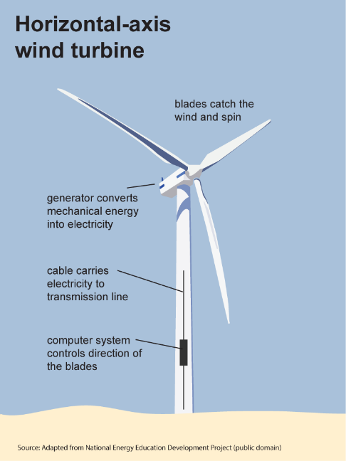

A large commercial grade wind turbine generator has the following major components – the steel tower, the blades, the nacelle atop the tower which contains the entire generator assembly, power converter units, gearbox (depending on technology) and yaw motors for turning the turbines. The major items that might replacement/ refurbishment at a later stage of operational life are the power conversion system and the generator bushes which directly affect the conversion efficiency of the turbine, thereby reducing the economic benefits accrued. But often owners/ operators of wind turbines do not bother refurbishment of the power conversion units and generators since either they are not sure of the cost implications or the project financials do not justify a long stoppage, unless is a breakdown maintenance issue (usually covered by insurance). Once we include indicative costing of a mid-life refurbishment in the Capex, we would have a much better sense of the LCC involved while bidding out wind and wind-hybrid projects.
- Solar- the major components of a grid-connected solar power project are solar modules (panels), Module mounting structures (MMS), DC -AC inverters and the low-voltage and high-voltage cabling.

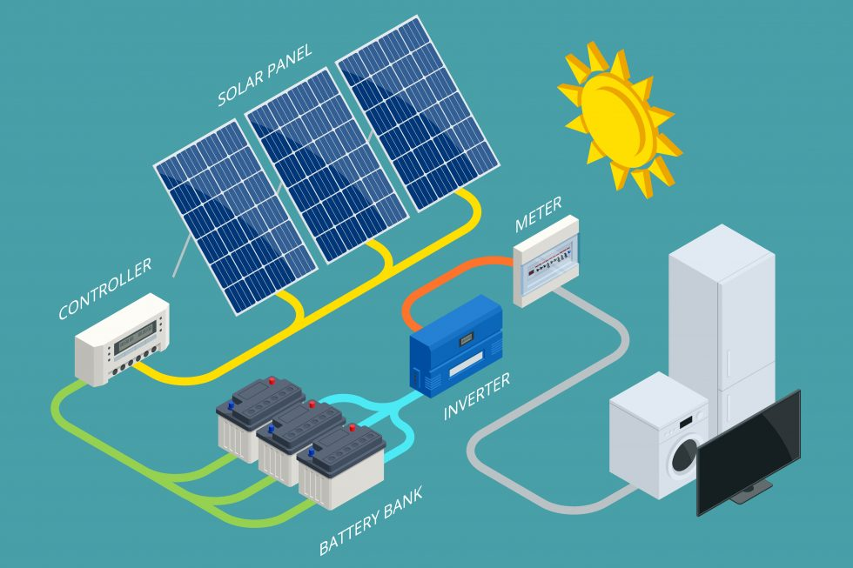
Of these, the modules have a linear degradation over the entire life of the project and in case the degradation exceeds a certain percentage, the OEM warranty for linear degradation covers the replacement cost. It is extremely important that while designing and finalizing the modules for solar project, we are mindful of the requirement of a 20-year Linear degradation warranty for the shortlisted module makes. The top 10 solar module OEMs all provide and honour such warranties. For the other major components, the MMS are prone to pure mechanical failures due to rusting and other environment related factors if proper inspection and preventive maintenance (like rust removal, application of anti-rust paints, and proper torquing) are not carried out. The major component that is prone of degradation and sudden stoppage of output are the power conversion devices or inverters. The power electronics components of an inverter have a design life measured in terms of cycles/ conversion efficiency life and beyond that, inverters need replacement. Usually depending on the oversizing of DC field and environmental factors, inverters have a life between 8-11 years. Often project owners do not account for this replacement cost (benchmark costs for MW sized central inverters are in the range of $35000/ MWp and this cost needs to be considered in the financial model while calculating the lifecycle cost of a solar project. Replacement of inverters at the end of the design life is not covered under any manufacturer warranty or insurance and omission of such mid-life cost considerations are against the concept of LCC. It is extremely rare for other components like cables to fail, but they are modular and easily procurable and common electrical items and can be included in the OMS costs.

3. Hydropower- the major electro-mechanical components of a hydropower projects are the actual turbine and the generators, transformers and control system components.

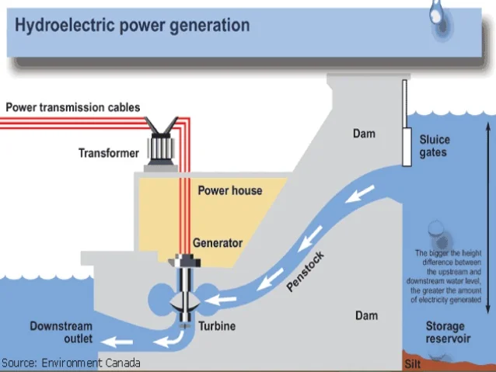

How a hydropower project works: water is stored in the storage reservoir and through the sluice gates that water is released towards the powerhouse which contains the main generation equipment – the turbine and generators. The water travels through the penstock from the inlet (usually at a higher level than the turbine in the power-house, the difference in height is called the head which determines the generation potential along with volume of water) and hits the blades of the turbine, which turns the poles of the generator. Thus, the potential energy of the falling/ downward travelling water is converted into mechanical energy in the turbine shift and the mechanical energy of the turbine shaft which is connected to the generator rotors is then converted to electrical energy inside the generator.
The power from the generator is then converted to higher voltage in the transformer and dispatched over long distances to the load centers (Industrial zones/ large cities/ commercial areas).
A medium to large-sized hydropower project (200-800 MW) has the longest gestation period of all clean energy projects since the challenges of working in complex mountainous areas with complex geology often slows down the boring for headrace tunnel and powerhouse and storage dam construction. Requirements of ESMP/ ESF also requires more on-ground consensus building with local stakeholders, but once completed, a hydropower project has a technical and commercial life of more than 40 years with very competitive cost of power. Also, the per unit cost of operations and maintenance is very low and is majorly limited to preventive maintenance of civil works and regular maintenance of the hydro-turbines.
Of these, the turbines blades tend to lose their efficiency due to hydro-abrasive erosion and the generators also tend to become inefficient over time. These issues tend to crop up after more than 10 years of continuous high load operation, especially in projects set up in rivers with high silt load, which tend to cause accelerated hydro-abrasion in the turbine blades, thereby reducing conversion efficiency and often turbine blade failures if not detected during preventive and pre-emptive maintenance. For large hydro projects set up in major rivers with heavy silt load, at the design stage itself large desilting chambers should be included and cost of regular desilting and non-destructive inspection of turbine blades using IR scopes and other non-destructive testing methods.
Also, it is extremely important that periodic inspection and maintenance is carried out for the headrace tunnel, surge shaft and other civil structures. Often in projects with complex geology, minor shifts in the surrounding strata may lead to water leakages and weakening of the walls. Periodic preventive maintenance and correct cost estimates for detailed non-destructive testing should be built into the project financials.
This renewable source of energy, in the case of a dam, may have a severe environmental impact. In particular with the land use which may be huge depending on the geography. The use of (agricultural) land has to be evaluated and taken into account in the LCC calculation. As for the gas example above, it is preferable to initiate this calculation before the procurement phase to ensure that this particular technology will provide the best value for money (e.g. run of river vs dam).
If a LCC Analysis is decided, it is of paramount importance to compare apples with apples. For instance, a 100 MW hydropower (dam) capacity has nothing to do with 100 MW of solar generation. So, the very first step is to clarify the needs. If the need is to have 100 MW available 24/7 then the solar generation has to be completed with storage (at least 12 hours). If there no need for a dispatchable generation unit, then run of river generation may be sufficient. LCC calculation shall be done only when user requirements are fully stabilized.
4. Geothermal energy:
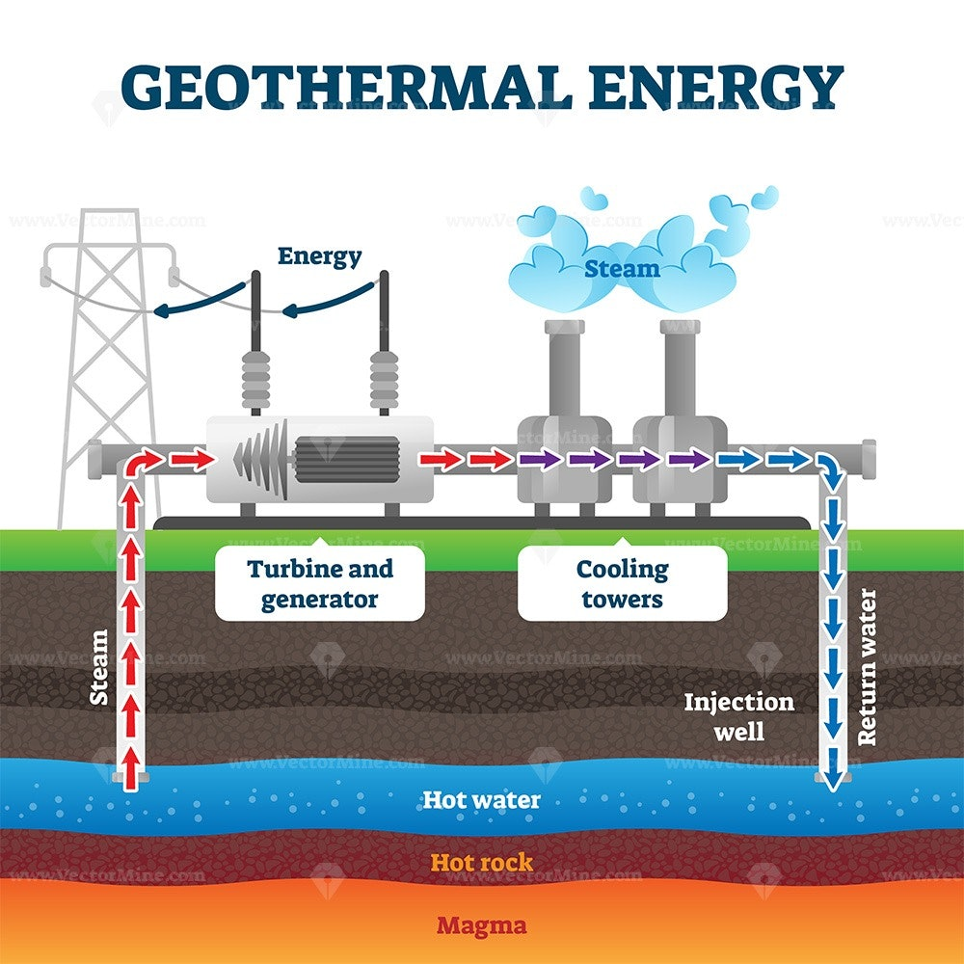

Mode of Operation of a Geothermal Energy plant: A geothermal energy plant utilizes the sub-terranean heat contained in geysers and hot rocks and magma layer to generate steam which is circulated through a network of piping to run a steam turbine. Once the steam is used, it is run through a cooling tower system and then the cooled water is pumped back to the underground heat exchangers where the water is converted to superheated steam, comes overground and turns the turbine again. This process creates a fuel-free steam turbine based generating station.
The turbine is connected to a generator and the rest of the plant operates like a standard thermal power plant without the fuel handling system. The turbine and the main equipment are the heat exchangers, generators and the associated complicated piping network for the steam and other liquids. In course of long operation, the main heat exchangers lose their efficiency and the piping network also needs regular refurbishment and replacement. Considering a conservative design approach, a project funded by the bank can incorporate regular upgrades and maintenance cost into the long-term tariff calculations and will be able to carry cost recovery and also extend the technical and commercial life of the project.

LCC calculation may seem to be quite straight forward. Steam (expressed in kWh) is given as an input to a generation unit for providing electricity (kW and kWh). The differential approach described above may be used to simplify calculation since steam generators have similar performances. However, the life cycle does not always start with steam. The first step is exploration in order to locate and extract good quality steam. This step may encompass very high risks. Private companies will ask either for certified studies proving resources (steam) are available or will make the exploration study taking into account the level of risk. Very often, the selection of a specific contractual arrangement (and funding) is decided during this early step of the project.

Technical Aspects

- The Mean Time to Failure (MTTF), Economic and Technical Life of major components- the major items used in any renewable energy project or for that matter large power generation project have reached a state of technical and commercial maturity where their useful economic and technical life are predictable to a major extent, and the OEMs/ suppliers are able to provide very accurate estimates of their performance degradation curve, mean time between failure, Root Cause Analysis for such failures, the suggested replacement/ refurbishment costs and lead times for major equipment delivery. When designing a project, it is extremely important that we consider the technical and commercial life of every major equipment with long lead times and their impact on the overall project performance including impacts on project availability (partial or complete closure of plant) and project viability. Often major items like high-voltage power transformers, boiler turbine generator packages and proprietary control systems are not available off-the shelf even if project owners are ready to pay full cost upfront.

A good project procurement practice is to consider the technical and economic life of major equipment, build their replacement/ refurbishment cost into the project LCC assumptions and keep back-to-back agreements in place with the suppliers/ OEMs of long-lead items so timely service delivery is assured and the project financials support such replacement costs. Often in solar and wind projects, the mandatory spares are set at 5% of the total supplied quantity of items as per Bill of Materials, right at the project design and bidding stage. For many long -lead items which are too expensive to replace and will seriously render the project unviable (for instance high capacity step-up transformers and control panels), often breakdown insurance is purchased by the project owner to safeguard their financials. Enhanced Standard fire and allied perils insurance with Reinstatement clause and safeguards against generation loss due to equipment failure can provide the requisite backstop against a heavy financial outgo and are preferred for large projects build with public funds ore in PPP mode, especially in developing markets.

- Performance Degradation over the economic life of the assets: any electrical or mechanical equipment used in electricity generation, be it statis (solar modules) or dynamic (gearboxes, generators) will suffer from gradual performance degradation over their useful life and this is part of their standard design. For items like solar modules, OEMs provide a clear linear degradation curve over the entire 20 years technical and economic life and project designers take the derating into their financial and technical assumptions and build requirements (both commercial and technical) to safeguards their project performance.
Further it is extremely important that the project owners and their consultant engineers formulate very detailed and stringent Quality Action Plans (QAPs) at the manufacturing stage and depute their representatives at the manufacturing facilities to carry out random samplings and also verify the traceability of the raw materials. A QAP is a detailed framework document which captures all the finer details of quality checking at every stage of the project implementation. A QAP will cover the material tracing from the raw material stage at the OEM`s manufacturing facility, the itemized quality checks needed at specific stages of the manufacturing process, guidance for random and batch sampling and also the detailed quality checks and functionality checks before dispatch from factory, the safety checks during material handling during transit phase and also at the site level before acceptance for use. A well-framed QAP and the presence of third-party independent inspection agencies are central to the quality and quantity of individual components used in a project.
The QAP also dovetails with the detailed Field Quality Plan (FQP) which is the guiding document for the quality of workmanship at the project execution stage. These two documents are extremely important for the framing of a good project design basis and once the QAP and FQP are prepared, agreed upon and followed diligently, the project execution is assured of a high standard of material and workmanship. With proper Operations and Maintenance, the performance degradation is minimized over the life of the asset and we are assured of continued trouble-free project operation without any discernible deviation from the set technical performance standards. For items like battery energy storage units (BESS cells), power inverters (for both solar and wind), the end of life in terms of performance degradation is clearly mentioned in the technical documents provided by the suppliers and such degradation in terms of reductions in depth of Discharge (BESS units) and reduction in DC AC conversion efficiency need to be clearly captured in the design philosophy. The replacement cost for BESS cells and Conversion units needs to be considered in the Capital Expenditure calculations and the tariff quoted needs to have these components clearly defined and priced in.
- Requirement of mid-life retrofit and their cost: One big issue that hampers the long-term viability and operations of any power project is the requirement of mid-life retrofits and their costs involved. Every power generation equipment has a design life and often the components which are either rotating/supports a moving member/ helps in power conversion are subjected to greater load and wear and tear and need mid-life retrofits to function properly. The timing, technical specs, price and delivery timelines of such retrofits are extremely important for project appraisal. For example, items like generator bushes, transformer panels, Current and Power Transformers, gearbox mounts lose their peak performance efficiency after prolonged use and while in many cases the reduced output are not analysed, we feel regular performance analysis and tracking of equipment life are needed to keep a plant in optimum performance band. In many cases, changing regulatory framework like tighter voltage and frequency control requirements from system operators need additional safety equipment like relays, Low Voltage Ride Through (LVRT)Panels,
- End of use value- both technical and commercial. – many of the items used in power plants do not completely stop performing at the end of their economic life and many of the small items can be used in other projects. For example, a transformer can be refurbished, oil changed, winding checked and then used in other projects either a main or as backup transformers. For a wind power project, the tower can be remelted in a furnace and made into other items like sewage covers, steel bars for residential use amongst others. Considering the huge amount of metal and electrical items that can be salvaged/ re-used/ repurposed at the end of a project life, it is important that a reasonable end of life value is considered for every project. At a good general practice, 5-7% of the upfront capex value can be considered as end-of-life scrap value. With some smart commercial judgement, this value can be easily realized by project owners. That would also improve their project financials and take care of environmental issues associated with disposal of metals and electrical items, by putting such items into a circular economy mode.
- Possibilities of second life of components and their resale value (or cost of disposal of constructed asset). – As discussed in the point above, possibilities for second life of many components are always present and the technical team needs to incorporate the resale value into their financial analysis.
- Cost of Removal of any hazardous materials (used lube oil from gearboxes, transformers, used/ damaged solar modules, damaged wind turbine blades, malfunctioning battery cells) during or at the end of life of the asset.- Hazardous wastes like gearbox oil, transformer oils which are routinely generated during scheduled maintenance services need to be removed and disposed off safety and the cost and onus of disposal needs to be either incorporated into the cost of OMS or in case the services of a specialized hazardous waste management agency is required on a regular basis, their service cost needs to be considered in the OMS assumptions. Another very important component that needs to be considered is the end-of-life disposal of items like wind turbine blades (usually made of fibre-glass), solar panels and components of the BESS. Globally, manufacturers are being increasingly asked to take charge of end-of-life disposal/ repurposing of such items but considering the relatively nascent independent E-waste and hazardous waste management industry, we need to be clear about the responsibility and cost of end-of-life disposal and codify the requirements in the scope of work and also consider cost for the scope.
- Impact on the environment-greenhouse emission estimation- this needs some input from the Climate Change and DRM Team.

Benchmarking costs: for CAPEX and OPEX. Long -term OPEX numbers for various RE resources- Wind, Solar, BESS, Biomass, Hybrids. Including minimizing cost of the land (or use of land already in the possession of the Employer- example an existing hydro-power plant of the Employer where Grid-Solar Power Project is proposed).
A very important factor that needs to be analysed and if possible quantified in the project conceptualization and design stage is the annual recurring cost of Operations and Maintenance Services and the possibility of designing a project that is robust, safe, reasonably easy to operate and maintain and does not have too many proprietary and difficult to source components with long lead time. For this, the project proponents and the OEs and technical team from the Bank need to clearly check the technical specs to make the document technology agnostic, with most major components having multiple suppliers and to minimize using technology which are not yet fully commercialized. This would ensure minimal disruption due to machine downtime due to breakdown or unplanned shutdowns and also keep costs of spare and consumables low.
For most renewable energy projects, the long-term operations and maintenance costs are quite well- defined and the scope and tenure for OMS services are quantified to a reasonable extent since the technologies are well-established with multiple large installations operating in different geographies with varied climatic and operational conditions. Some ballpark/ guidance numbers for various RE projects operating in grid-connected fully commercial modes are
- Onshore Wind- $25000-35000/ MW/ annum for a comprehensive O&M service with breakdown insurance cover.
- Offshore Wind- $45000-60000/ MW/ Annum depending on project size and distance from shore.
- Solar PV- Large ground-mounted- $ 6000/ MWp/ Annum with water supply from external sources, for large (100 MW+) grid connected projects in countries with local technical expertise, cheap labour and abundant free/ cheap water availability. For smaller projects set-up in mini-grid mode, or as part of rural distributed generation systems, this price is slightly higher for Floating Solar PV to account for vessel hiring and specialized marine operations safety experts.
- Hydro – The benchmark OMS cost for a hydro project varies with the size and location of the project and varying cost of local technical labour is a major component in estimates. As referenced in the IFC Hydropower handbook, estimates range between 1-3% of the CAPEX and for majority of the projects funded by IFC, the OPEX cost has been found to be in the range of $25-45/ MW/ Annum.

Procurement Strategy

Procurement Strategy PPSD – BAFO, E-Reverse Auction, Contract for Difference, Swiss Challenge- what is the current global trend in RE sector. Examine few sample PPSD on incorporation of LCC concept.

The importance of a well-formulated PPSD- One of the first documents that set out the project procurement plan or strategies specific to the project is the PPSD. The PPSD needs to be a clear, concise and analytical summary of the prevailing market conditions and global best practices followed for all projects of similar nature. The PPSD should have a clear guidance on the feasibility of the technology proposed, the number of service providers/ contractors in the market, the ease of implementation, the current tech trends, pricing trends, technological challenges, lead times of equipment and the best strategies for a VFM/ Fit for Purpose procurement. The PPSD should provide guidance on the best and most-fit for purpose procurement instrument.

Currently different countries follow different methods for procurement of power projects, depending on the market maturity and project complexity. But in all cases, it is advisable that the contract is structured for a Lump Sum Turnkey (LSTK) basis with 3-5 years of Operations and Maintenance Services included. This would attract only serious long-term players to bid for the project and safeguard the project owner from any sudden shock of willful abandonment of execution by non-serious players. Most generation assets in Germany, Denmark and India are bid out through auctions and often reverse auctions are followed to find the least cost supplier for very mature technologies like wind and solar projects.

For complex and slightly novel projects like Solar + BESS, a BAFO mode may be followed for the initial lot of projects to build market confidence and familiarity of the technology, but once the market stabilizes auctions are better at price discovery. This is considering that the procurement is done for absolutely standardized design of assets and not for highly customized project designs. Further, auctions are best at instances where the project owner is procuring these as serviced assets.

One of the biggest drawbacks of any auction-based procurement system of complex engineering solutions is the lack of control over performance and quality. If bidder evaluation/ selection of contractors is a single data point like CAPEX, we may not be able to accurately capture the quality and performance aspects. It is often noticed that reverse auction type modes end up with bidders offering assets which meet the bare minimum performance and quality standards and might not the most optimum solution.

Majority of the energy projects funded by the IBRD/ IDA look for engineering procurement contracts (EPCs) who will provide a lumpsum turnkey solution and hence the projects are mostly CAPEX type contracts and there are hardly any contracts with tariff-based competitive bidding unlike say roads and urban mass transport solutions. Since CAPEX becomes the main determinant for such energy projects, it is extremely important that the projects are designed and executed well with all costs considered and the final price considered for tariff calculation is within the acceptable tariff range and provides the best use of scarce trust and donor funds. It is often seen that for projects where the technology is well- established and the risk management matrix is clearly defined and mitigation measures (Payment Security Mechanism, Credit Guarantee Mechanism) are set in place, a single-stage bidding mechanism is the most preferred approach to achieving a competitive CAPEX.
Electronic Reverse Auction (E-RA)- Currently in some countries auctions are being used with varying degrees of success, and in India almost 60 GW of Renewable power is being procured under competitive bidding using the Electronic Reverse Auction (E-RA) Model. The E-RA model followed in India has led to price drop for tariffs to the tune of more than 50% from prevailing Feed-In-Tariffs (FIT) but E-RA mode is seen to work best for procurement of power/ energy as a bulk commodity and not for turnkey customized power generating equipment.

TBCB- In procurement of high-voltage transmission infrastructure assets, tariff-based competitive bidding (TBCB) mode is also being used, but here also the asset creation is under a developer and the bids are more geared towards procurement of services (transmission infra services). The assets are owned by specialist developers who offer the services of the assets as a monetizable figure the bids are evaluated on the basis of the most competitive transmission cost/kWh of electricity transmitted. The design, procurement, financing, construction and long-term ownership is still under the specialized asset owners/ developers, so TBCB or even an E-RA mode will work in such cases.

In many instances, it is seen that project owners, regulators and policy-makers suggest the use of E-RA or other modes of auctions for procurement of complex customized power generation assets procurement under the turnkey mode. It is always prudent to take cognizance of the qualitative differences between procurement of bulk electricity (like a common commodity – wheat, corn, soyabean, iron ore fines, crude oil ) and procurement of engineering equipment( wind turbines, solar + BESS systems) and their related construction costs and services’-RA can still be used, in specific cases like bulk procurement of solar home lighting systems(SHS), solar pumps, solar street lights, Distribution transformers, provided the technical specs are to be adhered without deviation and one stage of Pre-Selection/ Shortlisting has been carried out. For more complex items, it is advisable that a DSI contracting mode with BAFO is used, to keep track of the qualitative aspects.
BAFO- Best and Final Offer. This mode is procurement can be called a hybrid mode, where the bidders are given an extra opportunity to fine-tune and revise their offers. It is a step ahead of the Lump Sum Turnkey (LSTK) single stage two envelope bids, but without the dynamic reverse auction mechanism. Proponents of E-RA feel BAFO is not a very effective mode of arriving at a lower tariff and most bidders stick to their price bids, but it is expected that some bidder will reduce the price seeing the final list of competitors, either for pure business pipeline or to block the business growth/ entry of a new competitor. In either case, we do not have enough data to support BAFO over the Single Stage Two Envelope bidding mode in power generation sector across the bank.

Denmark- Thor Offshore Wind Farm (1 GW). This project is designed under a BOO scheme with payments decided under a Contract for Difference (CfD) scheme

The concession owner of the Thor Offshore wind farm will receive subsidies in the form of a price premium from the Danish state for a 20-year period. The subsidies will be granted in accordance with the Contract-For-Difference model, which has been designed for this tender.
The CfD model designed for this tender gives the concessionaire certainty for the investment in the long-term, but in the short term, it places more risk on the concessionaire by exposing him to market risks. This has been done to give stronger incentive to the socio-economic value of the electricity production.
It is a 2-way CfD which caps both the Danish state`s subsidy to the concessionaire and concessionaire`s payment to the Danish state, which will prevent that neither party carries the full risk of the electricity market developing fundamentally different from the forecast.
The generation license to the concessionaire will be granted for a period of 30 years with possibility of a 5-year extension. The concessionaire is responsible for selling the power in the Danish Power market and recover their costs. A similar system in followed in UK where the CfD is the preferred mode of signing concession agreements for large solar and wind power projects.

Checklist for guidance that from LCC considerations: What is required to be checked at the stage of Project Design/PPSD, in Bidding Document and in Contract Implementation?

Factors for Consideration | Stage for Consideration | Financial / Operational Implication.
Presence of proprietary technology, goods and services. | PPSD | Shortage/ cessation of supply of prop goods and services may cause project to fail.
Replacement/ refurbishment cost of major components at operation stage | Project Design and costing phase | Replacement of solar inverters, BESS are often expensive mid-life upgrades that need careful cost considerations at the design and procurement stage. Costs and delivery lead-time are both important factors in the LCOE/ Tariff calculations.
Complexity of works at OMS stage | PPSD and Project Design | The project owner may have difficulty in training or hiring short-term skilled manpower for carrying out specific high-skill service and routine parts replacement works to keep the project operational beyond the free/ mandatory OMS period. They need to look at project designs which are technically robust, simple and doesn’t require very limited and hard to acquire engineering skills.
Technical, managerial and commercial expertise available with the borrowing entity | PAD and PPSD Stage. | Necessary upskilling/ knowledge transfer programs can bridge the gap for successful project procurement/ long term sustainability.
Adequate stocking of regular use spares and long lead items. | PPSD and Bidding Document stage | Inadequate spares (modules, string inverters, current transformers, power transformers, and consumables like gear oil, transformer oil, fuses, tools and tackles often result in stoppage of operations and delay in procurement can reduce the long-term viability of the assets.

Appropriate Bidding Document:

One of the most comprehensive and integrated approach for setting u up large RE projects is using the Design, Supply Installation (DSI) contract with options on including O&M for initial 5-6 years based on market feedback, technical complexities involved in the project and the level of uniqueness in the contract. For example, a plain vanilla 50 MWp Solar project supplying power to the grid in well-developed market like Philippines or Ukraine or Bangladesh might not need a long-term OMS contract and the DSI contractor can be given a 3–5-year contract, post which the project owner can carry out the OMS using their own team or third-party OMS firms.
But a similar project in say Somalia or Central African Republic might need more commitment from the DSI contractor in terms of long-term OMS support. A medium sized hydropower project is a very standard project in terms of OMS and DSI contract with a minimal OMS period would par for the course.

Performance based specification
One of the most popular and industry standard method of formulating DSI or EPC contract is to include clear performance-based specifications. The specifications should be clear, quantifiable, easy to measure and follow the global best practices and relevant technical standards laid out by IEC, ASME, UL and ISO.
Specifications for most major and minor components should be included in the DSI contract document and once the bids are submitted, the first level evaluation should be done to check for compliance of the minimal technical standards and performance parameters. One very important data should be included is the Annual Minimum Output(generation) for any power generating equipment under the standard test conditions and also for the site-specific conditions if site specific meteorological data is provided. For instance, in a wind power project, a site specific annual estimated generation at P75 and P90 levels should be included as part of the bid evaluation report. This would make it easier to the evaluators to select the most optimum project since the most optimum bid will be an output of both Bid price and the performance of the equipment offered. Instead of pure cost, cost/ units generated (LCOE) can be the point of evaluation. This method will incentivize bidders to provide the best equipment in the market. It might happen that the best equipment may not be the cheapest upfront CAPEX-wise, but since prime evaluation parameter is the lifetime levelized cost of energy (LCOE) which includes all costs (CAPEX + OPEX) and the best output, the selected bid will be technically the most robust and financially optimal solution.
Often in cases where the Least Upfront capex is the sole parameter for evaluation, the cheapest bid is not often the most technically advantageous bid and may not be the best performing asset if lifetime output is considered. We suggest considering the following parameters while calculating the most advantageous bid
- Upfront Capex.
- Upfront OPEX/ OMS cost for 10 years from COD
- Annual Output under standard test conditions and site-specific output (if available).
- Cost of Debt and Equity – for considering Weighted Average Cost of Capital.
- Discounting factor.
These above factors will help in estimating costs using Discounted Cash Flow method. Method to calculate most advantageous bids based on Project Lifecycle Cost- NPV and Discounting rates to be considered. Specify Output, efficiency and environmental norms. Liquidated Damages for shortfall in performance/functional guarantees-

Types of Contracts used in RE projects-RE projects can use either Lump Sum Turnkey (LSTK) contracts under CAPEX Mode where the project is bid out on a complete EPC (engineering procurement and construction basis) based on L1 mode. The bidding entity has a standard project design in mind and a DPR is provided along with the Bid documents Bidder who submit bid deemed valid (technically and financial capability wise) are considered for the financial bid opening stage and from among them, the lowest quote is considered for contract award. This construct works in cases of gas turbine generating stations, hydro power projects, highways, roads, simple solar rooftop PV projects, solar pumping projects, biomass gasifier projects where the design basis and output parameters are known and within a reasonable band and all qualified and competent bidders will build a project of all almost similar design and performance. For many government departments and agencies, this is the preferred mode of contracting and considered the value for money option.
Tariff Based Competitive Bidding – TBCB – in this kind of contracts, the bidding entity expects the bidders to set up a project under BOO or BOOT mode with a long-term concession. The project design especially in case of BOO mode are left to the bidder and the contract is structured to be more of a service contract, where the bidder is expected to provide a service and get compensated for use. High voltage transmission infrastructure is one area where such projects are being implemented successfully and recently the same type of contracts are being implemented for bulk procurement of renewable power. The advantages of awarding projects through this mode are that bidding entities/ utilities can concentrate on improving their core operational performance like distribution, collection and service quality and leave the generation business to private sector players who can often crowd in better EPC and OMS practices and technical expertise. The payment from the utilities is often de-risked through Escrow Account creation, Backstop guarantees from the state and federal governments and specialized financial instruments like Credit Default Swaps. Tailored insurance policies against non-payment risks and Letters of Credit are often used by contracted generator/ service provider.
Contract Implementation and enforcement on meeting performance/functional guarantee, Liquidated damages on not meeting these guarantees.
There are 3 major safeguards to ensure effective contract completion for RE projects in our opinion.
- Construction Bank Guarantee (CBG)
- Performance/ Functional Guarantee – (PBG)
- Liquidated Damages and other recourses for non-adherence of above 2 points. (LD Clauses)
- Construction Bank Guarantee: It is extremely important that a Construction Bank Guarantee( CBG) of reasonable and adequate value be held by project owner during the project construction stage which will act as a deterrent for the execution agency to deviate from the project design ( in technical design, QHSE standards, ESIA standards) and also give enough financial coverage to the owners so that in case the contract is terminated for any reason whatsoever, there will be enough financial coverage for appointing a new contractor or taking legal recourse without having to dip into their other financial instruments. We suggest a minimum CBG of value at least 10% of the project CAPEX be held by the project owner. In case the project has very complex design where there is chance of default and it would be difficult to find alternate contractor agencies (this would come out in the PPSD stage itself), a slightly higher CBG can be considered though one must keep in mind that ultimately too high an amount locked in CBG will have a direct bearing on the working capital cost of the contractor and add to the project financials. For plain vanilla grid-connected solar or wind or biomass or hydro projects without much complications and in a mature market with enough suppliers/ contractors, a maximum CBG of 10% of CAPEX value is considered optimal.

- Performance/ Functional Bank Guarantee: A set of well- defined performance/ functional clauses need to be formulated at the project design stage so that the project delivers the expected outputs consistently, regularly, safely and with minimal repairs and downtimes and deviations. Once the functional clauses are clearly defined and agreed upon by both project owner as well as contractor, it is incumbent upon the contractor to design and execute the project so that the performance and output parameters are all met at the stage of commercial operation clearance. In case the contractor is unable to meet the performance guarantee ( like power curve testing/ short-term performance test for wind, PR and CUF for solar and minimum guaranteed output under standard test conditions for hydro or biomass), they should make all possible improvements/ changes to the project to meet the guaranteed performance parameters and in case the contractor is unable meet the minimum performance standards even after 2 additional test runs within a reasonable period( 90 days is considered good enough time for cure for most large wind and solar projects since STPTs and PR tests are typically run for 15 days ) the contractor should pay back to the project owner a sum which equals the Net Present Value of the lifetime loss of profit due to non-performance of the generating asset, discounted to the cost of WACC for the project owners. Such a clause will ensure that the project execution agency do not over-promise at the bid stage and underperform at the project execution stage and also give them enough time and opportunity to make changes or improvement in the design to be able to meet the agreed upon functional guarantees. Usually, the 10% CBG will cover any potential losses and in case the project is totally unable to meet the project requirements, an additional penalty in terms of Liquidated Damages up to the tune of 10% of the estimated CAPEX can be considered, based on the circumstances.

- Liquidated Damages (LD) for non-adherence to design, construction timelines and performance parameters: Liquidated damages are to be levied on the contractor after giving all possible chance for improvement to the contractor as per the contractual norms. Once all possibilities of recourse are exhausted, it is extremely important the project owners are able to recover enough money to employ another firm to make good the lapses in quality or performance and in case that looks difficult and entails major rework, the owners are able to cover their losses due to non-performance/ underperformance of the projects. Typically, LDs are capped at 10% of the CAPEX but in exceptional circumstances where major technical deficiencies are noticed or the completed project underperforms by more than 25%, a higher sum can be clawed back as LD.
Under all circumstances, we feel that the performance and engineering design requirements should be clearly stated in the ITB section of the bid documents and owners should have an owner`s engineer on board to help and bolster their technical teams. Presence of a strong OE will reduce the chances of wrong/ flawed/ over-ambitious project assumptions and also keep a strong check on the site-level execution. If the project underperforms and is poorly executed despite the presence of an OE and owner managerial team and the contractor tries to make all possible efforts to make good the losses, a proper all-party Root Cause Analysis also should be carried out and all such learnings of the root cause analysis should be incorporated as learnings in further projects.
At all times, the Owner and OE should give fair chance to the contractor to make good any flaws in the execution and performance mismatch and financial recourses like encashment of CBG, PBG and LD should be used as Last Resort solutions. The legal and commercial ramifications of being fined and blacklisted for underperformance in a major MDB funded project is a threat to most going concerns and hence they do not willfully underperform or underdeliver in such projects.
Options for long term service contracts, availability of spares and to ensure availability guarantee- For projects executed in FCV regions and using technologies that are complex and uses proprietary hardware and software, it will important that that such items are clearly identified and demarcated in the project design. For short lead-time items are easily available against advance payment from the OEMs or their suppliers, a clear replacement plan and procurement guideline should be included in the Operations Manual (OM). For items that are not available off-the-shelf/ long lead time and are of limited supply, all efforts should be made to include in the list of mandatory spares in adequate quantity or the entire scope of spares management, procurement, repair, refurbishment as deemed necessary should be included in the operations and maintenance services (OMS) Contract. In certain cases, for complicated items like Energy Management Systems (EMS) which are tailor-made for each project, it might make sense to give a long-term turnkey OMS contract to the EPC contractor or EMS supplier or system integrator. The OMS agreement must have clear performance and equipment uptime clauses built into it and penalties for non-performance should reasonably cover the losses due to equipment downtime beyond the agreed levels. As part of the long-term viability of the asset, it is important that the project owner develops the technical and commercial skills to operate and monetize all the available revenue streams and incorporate changes in the operational aspects of the project to increase their technical and economic value. For this, it is extremely important that a clear technical training and knowledge transfer plan is put in place right at the project inception stage and the OE and EPC contractor are contractually obligated to design and deliver training modules and technical study. Such technical modules help in reducing the requirement of external consultants needed to conceptualize and design similar such projects and also makes the project owner and their staff a source of technical and economic guidance for other agencies which might be interested in executing similar projects, acting as a Lighthouse of best practices and industry know-how.

Water and Wastewater Treatment Plant including Network

Introduction
Main objective of this guidance is to assist borrowers in proper application on use of Life Cycle Costing (LCC) for entire procurement cycle including design phase documents, at procurement and evaluation stage for the borrowers to incorporate provisions in the bids, contracts and to ensure that these implemented at the stage of performance and guarantee tests.
Important Considerations for Application of LCC
LCC shall be considered where there is potential for saving over the Life Cycle of Goods, Works and Services. LCC shall also be evaluated on net present value (NPV) basis.

Project Design, Feasibility, and Preparation phase and input to technical specification

The application of LCC in procurement needs to encourage bidders to promote better design parameters with measurable benefits, beyond functional guarantees specified in the bids.
Shorter construction period, less land area usage, smaller number of staff required for operation and long-term maintenance contract with the OEMs can be included to procurement plan to mitigate the risks, delays and cost overrun the contract amount.
A performance-based approach usually allows more scope for innovation and new technologies with highly efficient equipment has significant effect on NPV basis for WWTP and WTP.
Feasibility studies, which is a benchmark case of a procurement for WWTP and WTP, shall indicate foreseen energy and chemical consumption on environmental and social impact assessment report (ESIA) with requested minimum functional guarantees requested by norms or committed by the borrower to the authorities.
Technology for WWTP/WTP plant and name of the structures, total intake capacities, technical parameters and functional guarantees shall be well described on feasibility studies.
Bidders appreciate the opportunity to promote their own choice for sustainable design within technical parameters but typical flow diagram may help bidders to understand expectation of the borrower.

Procurement
Borrowers shall choose appropriate contract type in comply with Guidance Note of SBD considering duration of operation and applicability of LCC not just what is the cheapest facility to build but which represents the best value for money (VFM) over the duration of the contract.
Initial cost and LCC shall be evaluated to determine maximum VFM. Application of LCC as economic evaluation criteria is upon depends to measurable parameters. Output and capacity of the plant, consumption of energy and consumables per unit of output are the key figures for evaluation.
There are three basic procurement alternatives that can be considered when planning any new publicly-funded treatment facility, namely; Separate contracts for design and build (Design-Bid-Build or D/B/B) a Design-Build contract (DB), and Design-Build-Operate contract (DBO).
Borrowers shall either engage an engineering consulting firm to undertake the detailed design prior to bid (D/B/B) or borrowers undertake feasibility and prepares framework of the design, identify the technology, output specification and bidders may submit bids with different technologies and opex/capex tradeoffs (DB and DBO).
LCC has limited importance for D/B/B contracts but has significant effect on DB and DBO contracts.
Using LCC for gravity sewerage lines is not practical but any pumping station for sewerage network or for drinking water network may be applicable for LLC
Borrower does need to prepare a detailed design drawings for DB or DBO contracts. Employer requirement with preliminary conceptual design, flow diagram, output, efficiency, environmental norms, and parameters for functional guarantee shall be prepared by consultant to be a part of bidding documents.
Borrowers shall only indicate plain functional criteria which are not complicated and easy to compare.

- Evaluation
Borrowers shall indicate duration of LCC taken into consideration for evaluation of maintenance and operation cost. Methodology of monitoring LCC and the operational acceptance shall be a part of bidding documents.
A well-defined concept design will have hints for demonstrable functional guarantees which must be proven during operational acceptance tests.
Bidders shall consider the foreseen maintenance, operational costs according to concept design and evaluate the order of importance to have plain cost items for spare parts, power consumption, chemicals and external environmental costs, if any.
List of cost items shall be delivered to borrowers with the standard bidding form and bidders shall submit with their bid proposal including LCC.
The costs of spare parts, power consumption, chemicals and any external environmental costs shall be transparent, demonstrable and verifiable during bidding stage and during operational acceptance test.
All guarantees shall be measurable in accordance to norms and regulations. All expenses for operational acceptance tests, expenses long term monitoring, regular operational tests and punitive actions against revenue loss of borrower, in case of failure of guaranteed consumptions, with methodology of calculation or limitations, shall be specified in bids.
Operational acceptance tests shall be done in comply with specified international codes and quality plan. Demonstrable tests and employer’s requirements requesting international codes, energy labels etc. shall be a part of quality plan to be followed during taking over.
- Additional criteria to add to bids such as sustainability - odor, noise which is better than environmental norms/regulations
Borrower may specify an award criterion to be applied for environmental factors and the weight to be assigned to each requested aspect.
In case of applying award criteria, borrower shall announce the weight and details of environmental award criteria transparently including methodology of monitoring.
Odour, noise and indirectly CO2 emission can be included to evaluation criteria upon request of borrower.
- PPP (Public Private Partnership) Contracts and Long-Term Design Build Operate Transfer (DBOT) Contracts (10+ years operation by the bidders)

The financial evaluation will have to identify the best financial offer taking due account of any discounts offered, following the formula below:
CP = CAPEX + Duration of Operation x (OPEX)
Where;
CP = Comparable Price,
CAPEX = Capital Cost (CAPEX represents the company's spending on physical assets)
OPEX = Operating Costs (OPEX represents Operating cost incurs for running its day-to-day operations, long term and short-term maintenance services for agreed duration)
A template shall be included to bid documents or SBD and Bidder shall fill the table with required consumables, expenditures, maintenance costs, insurances, replacements/refurbishments
- Commitments on Unit Rates for Operational Costs
The operating costs shall take into consideration the consumables (electric, chemicals, organic load, on the plant specified here under and calculated for average flows and loads given
According to the actual flow/load (in pro rata to the average conditions as stated in contract), the Bidder’s committed figure for each item shall be determined. To perform this, a scatter type graph (unit rate against flow/load for the four data set for 25%, 50%, 75% and 100% flow/load case) shall be plotted for the Bidder’s committed figures and a trend line (polynomial, logarithmic or else whichever suits to the Bidder’s data) shall be applied.
If this correlated unit rate is NOT less or equal to the actual unit rate, then the penalties shall be paid to the end recipient by the Contractor as described in the employer’s requirements.

- Non-performance Damages for Exceeding OPEX Commitment

Non-performance damages shall be due for failure to meet the Commitments for Operating Costs stated in the contract.
Non-performance damages shall become payable to the Borrower by the Bidder or if the actual operating cost of consumables during the Defects Notification Period, exceeds the estimated annual consumption stated in the tender for named indicators. The non-performance damages payable by the Bidder shall be the amounts calculated by the formula as specified in tender.

- Transferring the Plant to the Borrowers
It is obvious that some of main equipment which are considered as a part of Capex cost will need replacement due to aggressive, corrosive conditions of WWTPs and WTPs. Moreover, major equipment like scrapers, screens, pumps, panels, transformers will need mid-life retrofit despite regular maintenance of OEMs. For this, consultant of Borrowers and technical team from the bank need to clearly check the technical specs to prepare document for MTTF (the mean time to failure) for considering the economic and technical life of major components with degradation curve, mean time between failure.
Checklist for guidance that from LCC considerations what is required to checked at the stage of Project Design/PPSD, in Bidding Document and in Contract Implementation

Factors for Consideration | Stage for Consideration | Financial / Operational Implication.
Feasibility, technical specifications for the plant | PPSD | Benchmark of a bank financed project and non-availability may cause failure
Technical specifications, technology of the plant and expected functional guarantees shall be decided before bidding. | Design Phase | Borrower may leave bidders to promote their design but conception design and flow diagrams shall be provided before bidding. Bidders shall submit their proposal in accordance to requirements transparently.
Feasible Contract Type | SBD | Borrower shall evaluate the type of the work and decide applicability of LCC. Any project such as gravity network, with negligible O&M cost shall not be subject for a bid including LCC economic evaluation.
Number of Years for LCC | SBD | Bidders shall submit their O&M costs for same duration for economic evaluation.
Functional Guarantees and operational acceptance | SBD | Bidders shall submit their proposal according to requested format of the borrower. Any discrepancy between bid, employer’s requirements, proposal of bidders may cause termination of bid phase.
Replacement/ refurbishment / Spare Part cost of major components at operation stage | Project Design and costing phase | Replacement or mid-life upgrades that need careful cost considerations at the design and procurement stage.
Technical, managerial and commercial expertise available with the borrowing entity | Design, PPSD Stage and Operational Acceptance | Necessary upskilling/ knowledge transfer programs can bridge the gap for successful project procurement/ long term sustainability. Measureable functional guarantees shall be documented to prevent future claims and to mitigate Borrowers loses, in case of dispute.

Conventional Energy

Introduction
Main concepts used by LCC have been presented in section 1.2 of the Practice Manual. If the formula for evaluating the total cost is the same for all the sectors, specific cost structures have to be identified for energy.
As defined in Section 1.3 of the Practice Manual, the life cycle of a project encompasses the main steps during the life of a project as presented on the figure below.
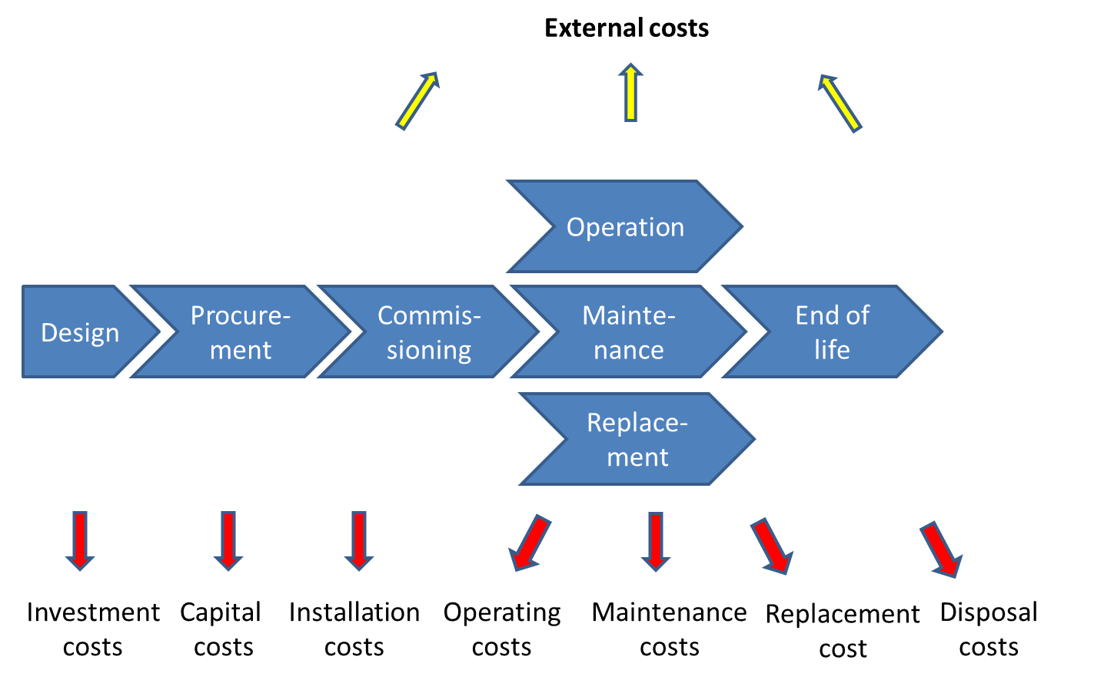
The goal of this section is to present how Utilities in the energy sector may use Life Cycle Costing (LCC) when preparing an infrastructure project. The project may be composed of products / equipment, work / construction and consulting. The projects which are addressed here are mainly made of one or several parts of the energy value chain (see figure below).
- Power generation (new capacity, extensions and refurbishment of existing power plants)
- Transmission (high voltage lines, substations, control centers, interconnections)
- Storage (electricity, water for hydro power)
- Distribution (low/medium voltage lines, transformers, feeder, meters)
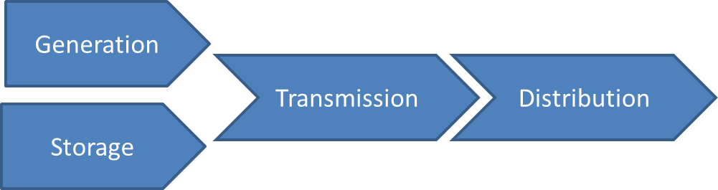
It should be noted that even if the perimeter of the new project is limited, LCC will have to take into account all the impacts of the project on the global value chain and all its dependences. For instance, a new power generation may impact the transmission grid but when introducing a new MV (medium voltage) transformer, losses may be influenced by the generation profile. Clarifying asset boundaries and dependencies is critical when calculating life cycle costs. This raises several questions: what costs should be included in this calculation? Where to find these costs? Some of them being hidden or unknown, how to approximate them? During the life cycle of an infrastructure, when to use LCC and why?
This section will identify the main categories of cost (cost structure and cost check-list)) occurring during the lifetime of the project and which are almost common in the whole energy value chain. In other words, LCC of an infrastructure (or new part of it) is the sum of all costs C_{i} incurred by the infrastructure during its full life cycle (design, infrastructure acquisition [supply of equipment, construction], installation, O&M, replacement, downtime, environmental and decommissioning costs). When the costs are spread over several years (e.g. construction, O&M, etc.) the following formula is used, for example for the costs of operation. Costs are discounted to the present using the time value of money (NPV):
$OpCost=\sum_{i=2}^{N}{\frac{{OpCost}_{i}}{{\left(1+rate\right)}^{i}}}$
Where: OpCost_{i} is the cost for operating during year i
rate is the discount rate
N is the lifetime in years of the infrastructure
2 is the first year when operation costs are taken into account in this example
NB: inflation rate has been taken into account when calculating OpCost_{i}
Total life cycle cost is given by the following formula:
LCC = Design costs +acquisition costs + Installation costs + … + decommissioning costs – residual value
Additional and more specific details will be given when reviewing the various technologies used for power generation and transmission. At the beginning of the life cycle of a new project many costs are not yet fully known. Solutions have to be found in order to acquire accurate data and complete the total costing and thus enabling the comparison between different designs. The process used to compare different costings is called LCC Analysis or LCCA. It offers flexibility to decide what alternative or what option would bring the most value to the infrastructure owner. It is also an approach for performing project risk analysis by a sensitivity analysis of the most uncertain inputs.
At the end of the life cycle, almost all the costs are known. Unfortunately, there is then almost no more flexibility to reduce these costs. See figure below. That is the reason why life cycle costing is encouraged during the design and procurement steps.
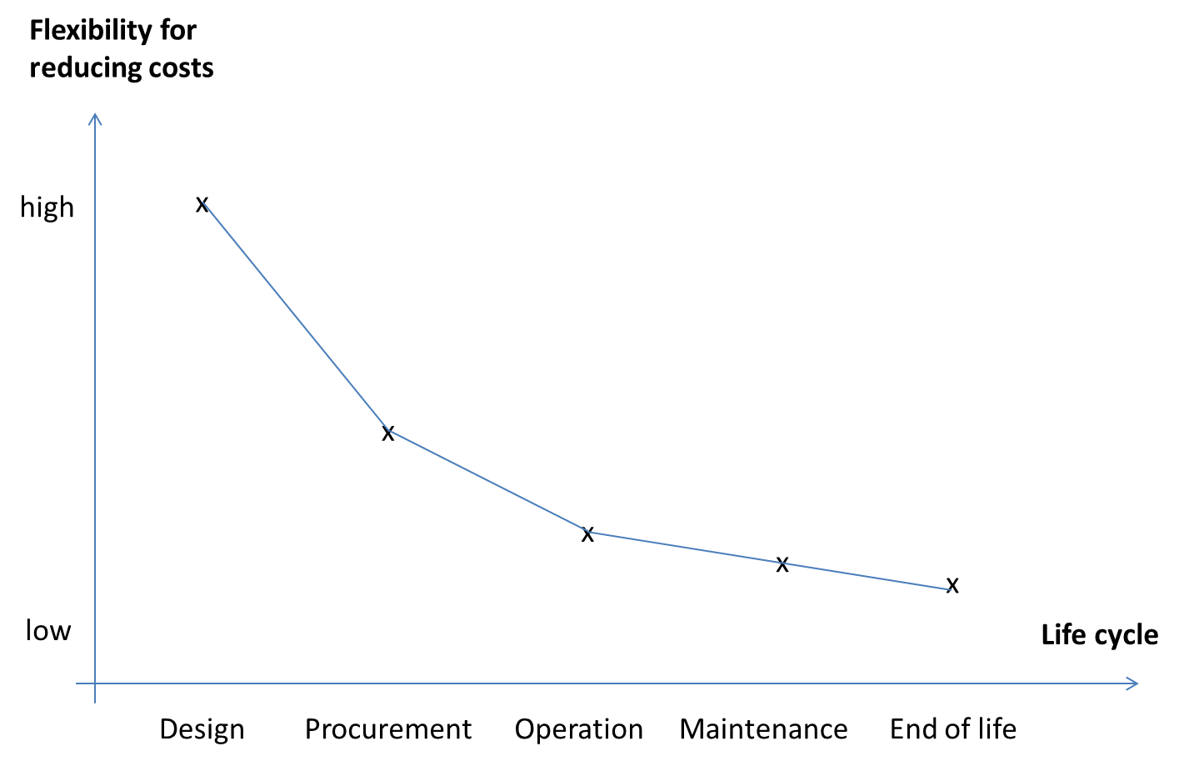

During these preliminary steps, LCC is well suited to compare alternate designs or options that do satisfy a required level of performance but that may have different levels of initial investment, and different costs for operating, maintenance and repair costs.
So, coming back to the question when performing life cycle costing, we can answer that the concept and design steps are the greatest opportunities to influence a successful infrastructure project. As a consequence, to make the LCC analysis helpful, it must be completed before freezing the architecture of the infrastructure of the project and construction tenders are awarded. LCCA could become a sine qua none condition to enter in a tendering process.
How to organize the work for calculating Life Cycle Costs?
The process proposed in this guide for the energy sector is quite straight forward.
The main steps are the following:
Step#1 Express the user / infrastructure Owner requirements for the project
This first step is of paramount importance. The main challenge for the Owner is to express the expected performances from a functional point of view and not as a particular solution. This is important to be able to look for alternatives.
Step#2 Identify feasible alternatives or option to an initial design
It is assumed in this guide that technically sound alternatives are available. At this point, the potential cost of an alternative should not be considered in order to be open to all solutions offering the same level of performance as expressed in Step#1

Step#3 Establish common hypothesis and parameters for each alternative
For example, the base date of the project, the lifetime of the infrastructure, the LCC analysis period, and the time reference for the money should be the same. The rate used for discounting future costs to present value should be the same too.
Step#4 List all the costs and estimate them with their time of occurrence for each alternative
This practical guide focuses on the identification of these costs (see next section). The types of cost which are proposed are generic enough to cover a large spectrum of energy projects. They can be used as a checklist for raising pertinent questions. The most important challenge in LCC calculation is to find accurate data. This is relatively easy for investment related costs. For operational cost and in particular the future ones associated with new technologies, Utilities may lack experience.
Many publishers provide generic data built on the analysis of a large number of projects. For instance, investment cost and O&M cost per kWh may be found for each technology. These sources of information may help Utilities to estimate missing data.
Step#5 Select a discount rate, calculate LCC for each alternative and compare them
The discount rate is the opportunity cost of capital. For Utilities, the discount rate is mainly influenced par the level of risk. When technologies are mature, the level of risk in the public sector is quite moderate.
Step#6 Consider sensitivity analysis of particular parameters or inputs and assess uncertainty of estimated costs.
Several parameters may have a deep influence on LCC calculation. The discount rate, the price of energy and the forecasted inflation rate are good examples.

What general costs have to be included and how to calculate them?
Costs may have many different natures: they may be direct or indirect, fixed or variable, explicit or hidden, internal or external, etc.
The cost calculation boundary shall include everything that is required to totally fulfill the project objectives, but also all the other pieces of equipment in the existing infrastructure which will be impacted by the project. Since might be tricky in some cases. For instance, a project extending generation capacity will use the transmission grid to evacuate energy. This will have a cost (use of transmission capacity, maintenance, and operation of the grid).
Since LCC reflects the complete life of the project, cash flows will occur at different points in time. Discounting net present value (NVP) will be the mechanism used here to bring all costs to a common base, the present value of money.
1) Design costs
Main costs are:
- Feasibility study
- Concept and design analysis
- Design engineering
- Site studies and preparation
- Obtaining permits
- Environmental and social impact reports
- Specification preparation
- Procurement, qualification of suppliers
- Setting up and administering the contract
- Project management
- Quality management
One of the key issues raised during the design phase is to decide either to acquire a new asset or to refurbish an existing one.
2) Initial asset acquisition / capital cost
Acquisition cost is the cost of the infrastructure being purchased.
It is the purchasing price if paid immediately or the net present value (NPV) if the cost is spread over several years (interest rate). The initial cost does include the purchase and the construction costs of the solution to be delivered to the infrastructure Owner/Customer/Borrower. In the case of a generation unit, the connection to the grid is generally included in the price. For a solar or a wind farm, the price generally encompasses the preparation of the site, the assembly of the panels or the erection of the masts.
Other costs may be included such as purchase of land (e.g. solar PV plant) or civil work if not already included in the selected offer.
NB: purchasing price is supposed to include all the manufacturing costs (raw materials, R&D, tools, labor costs, commercial …).
3) Installation costs
They are all startup costs which have not been included in the purchasing price (e.g. staff training). These costs are assumed to occur the first year of operation.
4) Operating costs
These costs are the day-to-day expenses incurred in the running of the infrastructure and the supporting organizations. Examples of operating costs:
- Training
- Operators’ salaries (based on the number of operators (constant), the man-hours per year (constant) and man-hour cost (increase with inflation))
- Transmission and grid connection costs ($/year)
- Administration, sales, accounting organizations
- Support services (clients)
- Consumables (e.g. lubricant, filters, oil)
5) Fuel costs
They are variable costs ($ per kWh)
Fuel costs may very difficult to forecast. Even if the thermal efficiency of a power generator is well known over a period of 20 or 30 years, the cost of fuel (fossil oil, gas) is uncertain even with long term contracts.
Questions: How does volatility in fuel costs impact LCC? Should we use stochastic models for the most uncertain input variables (e.g. Monte Carlo method, probabilities, cost ranges)?
NB: non-dispatchable generation technologies (solar, hydro, wind) have no fuel costs.
6) Maintenance costs
They are the cost of service and planned repairs (preventive maintenance). Formulae include:
- Service frequency of routines
- man-hour cost to do the service (planned maintenance)
- Spare parts for replacement / disposal / upgrade
- Spare parts for major repair
- Holding spare parts, warehousing
- Training
These costs can be divided into two parts. The first one is the controlled costs which can clearly be calculated. The second part is depending on risks such as failures, breakdowns. Risk is defined as being the product of a probability of occurrence of a breakdown during operation and the impacts it will have.
The usage of the projected asset may also influence the maintenance costs. For instance, a 400 MW combined cycle gas turbine (CCGT) has been procured. If this new capacity is used for (semi-)base load or for peak following, the maintenance costs will be very different because of the number of startups.
An infrastructure project may encompass several pieces of equipment with a specific lifetime for each of them. For example, in a solar power plant the lifetime of the PV panels may reach 20 or 25 years before being replaced. Electronic components (e.g. inverters) may have s shorter lifetime (8-10 years. So when evaluating the LCC of such project over a life cycle of 30 years, large portions of the asset would have to be replaced. In order to get an accurate LCC, the lifetime for the main pieces of equipment is important to know.
NB: some cost may be variable ($/kWh) (e.g. non-fuel consumables) and other may be fixed ($/kW/y) (e.g. operation labor).
7) Deferred maintenance costs
These costs come often for refurbishment or redevelopment of part of the project ($, increase with inflation). When funds used for maintenance competes with new projects, maintenance activities may be deferred and as a consequence increase the risk of breakdown and decrease the quality of service. In this case, deferred maintenance is no more capital renewal (replacement costs) and has to be identified as a risk. Deferred maintenance means an under investment in maintenance and may lead to higher replacement costs.
8) Replacement costs
Pieces of equipment which lifetime is less than the project lifetime have to be replaced before the end of the life cycle (capital replacement costs ($)). For example, batteries and inverters in a solar farm will have to be replaced during the life time of the PV panels.
NB: minimum criteria for replacement have to be defined for each component having a life time inferior to the one of the total infrastructures.
9) Downtime / breakdown costs
They include: downtime (stop and loss of production) cost; hourly stop cost ($); yearly hours of unplanned stand still; number of unplanned yearly stops (breakdown frequency); man-hours to do repair (hours); cost of spare parts and capital replacement costs ($); startup cost ($)
10) Social costs:
Only people involved during the project have been considered here:
- Property damage
- Personal injury damage
NB: these costs are contingent costs: they may or may not be incurred at some point in the future. They are described in probabilistic terms: expected value, range, probability.
11) Decommissioning / disposal cost
It is the cost for decommissioning a plant/unit and it can be expressed as a cost occurring at the end of the lifetime or net present value of the decommission (lifetime in years, decommission cost ($), interest rate).
- Refurbishment/rehabilitation
- Deconstruction
- Transport to the waste treatment operator
- Closure / decommissioning
- Disposal of inventory
- Recycling
- Restoration of the local environment

12) Residual value or salvage
Residual value is the value of the asset at the end of the life cycle. It is the case when the lifetime of an asset is greater than the analysis period. Salvage value is the scrap value of an equipment at the end of its service life. It is a negative cost. In some cases, this residual value may lead to refurbish an existing infrastructure in lieu of building a new one.
13) Cost of externalities
These costs may be also assigned to the specific categories of the life cycle.
- Regulatory authorities
  - Reporting (operation)
  - Monitoring / testing (maintenance)
  - Studies / modelling (operation)
  - Training (operation)
  - Inspection (maintenance)
  - Protective equipment (asset)
  - Medical surveillance (social)
  - Environmental insurance (environment)
  - Pollution control (environment)
  - Waste management (operation)
  - Spill response (oil, fuel)
  - Legal and compliance fees
- Environmental costs
  - CO2 / GHG emission rates
  - carbon price
  - Environmental studies
  - Habitat and wetland protection
  - Landscaping
  - Contingent costs:
    - Costs of remedying and compensating for future accidental releases of contaminants into the environment (e.g., oil spills)
    - Fines and penalties for future regulatory infractions
    - Future compliance costs
    - Legal expenses

Cost calculation
Before presenting the major formulae to be used, it is useful to list the variables which are the most frequently used and to select the appropriate values when implementing LCC calculation:
Interest rate (%)
Inflation rate (%)
Man-hour cost ($/h)
Man-hours per man-year (h/year)
Cost of energy ($/kWh)
Lifetime of an equipment (years)
Hours of operation of an equipment (h/year)
Discounted cash flow rate (%)
Escalation rates for the cost of carbon (%)
Period of LCC analysis (Year)
Equipment longevity (y)
Taxes (%)
Capacity (generation) (MW)
Load factor (generation) (%)
Generation flexibility (base load, semi base load, peak load)
Minimum generation level (%)
Intermittency requiring backup sources (generation) (MW)
Cost of fuel ($ per kWh)
Efficiency losses (%)
Transmission losses (%)
Distribution losses (%)
CO₂ emission (generation) (CO₂ eq t/MWh)
Proxy carbon cost ($/ton)
Land use (m²/kWh)
Water use (l/kW)
Time value of money is an important parameter for calculating LCC. Indeed, the infrastructure Owner will have to compare various proposals where capital costs and O&M cost are expanded at different times. In order to fairly compare these proposals, we need to express each alternative / option in today’s money value since money changes value over the lifetime of the project (20 to 30 years for power generators, grids). This is because a given amount of money today is worth more than the same amount at a future date: the money received today may be invested to earn interest.
Since some parameters in the list above may have unknown future values, it might be useful to run sensitivity tests. This is true in particular for the discount rate and the inflation rate.
It should be noted that traditional LCOE (levelized cost of energy) does not have the same perimeter as LCC. Traditionally, LCOE represents the cost of capital and operation per kWh. All investments occur at the beginning of the project and the life time is the length of the investment (no replacement, no residual value). With LCC, not all costs occur at the beginning. As a consequence, the cost per kWh can be expressed as the net present value of all costs during the full life cycle divided by the total amount of energy produced over the full life cycle. This calculation improves the accuracy of the cost per kWh but it should be noted this approach does not capture the possible intermittency of many renewable sources of energy.
Last but not least, positive externalities may be created although they are not taken into account in the LCC calculation. This the case of a power plant based on renewable sources of energy. Solar and wind power, for instance, when plants are running, may displace fossil oil generation. As a consequence, less GHG is produced.
Complements on LCC for Energy
LCC calculation can be practically done using the list of all the potential costs presented in the previous section. However, specific costs may appear when looking at a particular technology. This is the goal of this section: to provide LCC calculation with additional costs which may have an impact on the final result.
For each technology that may be used in the energy value chain, this section will describe:
- The main structure of the asset
The objective is to provide a global list of the main components used in a particular infrastructure so that it will be possible to compare the initial / capital cost of different solutions. Obviously, it is assumed that these solutions should all offer the same functional performance level. Key performance indicators are also proposed. This section can be seen as a simplified BOM (bill of materials).
- The specific costs which may be encountered during the life cycle
Details are provided when costs are very specific or when activities are directly related to a particular technology. For instance, operating or maintaining a gas turbine does not look like operating a wind farm.
- Case study
When an infrastructure is extended, Utilities have almost all the data related to the future costs of their project. However, when new technologies are used, Utilities may not have experience and references. In this case, the missing costs may be approximated by values given by international databases, compiling many similar projects.

Generation

Thermal conventional (oil fired, gas/CCGT – with/without CCS)
Note: we consider here the options for reducing pollution (CO₂ eq for all; SO₂ for oil fired; NO_{x} for oil fired, LNG fired, gas turbine, diesel generators; SPM for oil fired and diesel generators; VHC for oil fired, LNG fired, gas turbine, diesel generators).
Natural gas combined cycle (NGCC)
- The main structure of the asset
Natural gas combined cycle power plants have four major characteristics:
1- generation is flexible (dispatchable) which is very useful to compensate intermittency of renewable sources of energy,
2- CO2 emissions are reduced compared to coal-fired power plants,
3- efficiency of NGCC ranges from 45 to 60%,
4- however, CO2 emissions reduction may imply the implementation of carbon capture technologies (e.g. storage in wells, Ca-based sorbents, amine-based capture process, chemical looping combustion) which increase the generation cost and decrease the generation capacity (-15% as an average).
That is the reason why CCS technologies should be included in the LCC for NGCC.
Main components that should be taken into account:
- Design, purchase of equipment (gas turbine, steam turbine)
- CCS options
  - CO₂ pipeline and injection site
  - Use of chemical dry sorbents
  - Capture process (e.g. post combustion)
  - Chemical looping combustion (CLC)
- Substation (step up transformer, switchgear, metering system, communication & remote monitoring, point of connection) (30 y)
- Transportation
- Land acquisition
- Land permit
- Land preparation
- Civil work (if needed)
- Construction, mounting and testing
Key performance parameters:
- Net generation capacity (MW) (with and without CCS)
- Net plant efficiency (high heat or low heat values) (%) (with and without CCS)
- Net plant heat rate (high heat or low heat values) (kJ/kWh or Btu/kWh)
- Combined cycle efficiency (low heating value) (%)
  - Combustion turbine power (MWe)
  - Combustion turbine efficiency (%):
$${CT}_{eff}=\frac{{CT}_{pwr}}{{Th}_{in}}$$where:
CT_{pwr} is the combustion turbine power – generator losses (kW)
Th_{in} is thermal input to turbine (kWt) = NG feed rate x gas heating value (NB: divide Btu by 3,412 to get kW)
  - Steam turbine power (MWe)
  - Steam turbine efficiency (%):
$${ST}_{eff}= \frac{{ST}_{pwr}}{\left({Th}_{in}- {Th}_{cons}\right)}$$where:
ST_{pwr} is the steam turbine power – generator losses (kW)
Thin is thermal input (enthalpy of the flue gas to the heat recovery steam generator – enthalpy of the flue gas exiting the HRSG)
Th_{cons} is thermal consumption for CO₂ capture (enthalpy of the stream extracted for capture and CO2 dryer subsystems – enthalpy of the condensate returned to the condenser)
  - Steam turbine heat rate (Btu/kWh):
$$SThr=\frac{1}{{ST}_{eff}}x3,412$$
  - Raw water consumption (m³/mn)/MWnet
- Plant capacity factor (%)
- CO₂ emissions (kg/MWh)
- 𝐶arbon capture efficiency (%):
$${CCap}_{eff}= \left(1-\left(\frac{C_{out}}{C_{in}}\right)\right)x100$$Where:
Cin = carbon in natural gas + carbon in air (CO₂) (kg/h)
Cout = CO₂ in the stack and CO₂ captured (kg/h)Auxiliary power requirement (MW)
- Selective catalytic reduction efficiency (%)
- Dissipated water (l/kW)
- Fuel cost ($)
- CO₂ transport and storage cost ($/tonne)
NB: The decision to implement a CCS or not may be based on the two following parameters:
- The breakeven CO₂ sales price ($/tonne) is the minimum CO₂ plant gate sales price that will incentivize carbon capture compared to a plant without CCS. It is given by the formula:
$$Breakeven {CO}_{2} sales price \left(\frac{\$}{tonne}\right)=\frac{\left({LCC}_{CCS}{-LCC}_{non-CCS}\right)}{{CO}_{2} Captured}$$
- The breakeven CO₂ emissions penalty ($/tonne) is the minimum CO2 emission price that will incentivize carbon capture compared to a plant without CCS. It is given by the formula:
$$Breakeven {CO}_{2} emission penalty \left(\frac{\$}{tonne}\right)=\frac{\left({LCC}_{CCS}{-LCC}_{non-CCS}\right)}{{{{CO}_{2}{emission}_{non-CS}-CO}_{2} emission}_{CCS}}$$

- The specific costs which may be encountered during the life cycle
Initial asset acquisition / capital cost and installation:
- Power plant construction:
  - Gas turbine (combustor, air compressor, gas expander, generator)
  - Steam turbine (heat recovery steam generator, boiler feed water, condenser, generator)
  - Gas pipeline
  - Lubricating oil, inlet and exhaust, NG fuel, starting and air subsystems
  - Cooling water subsystem
  - Power generator
  - Engine assembly
  - NOx control subsystem
  - Accessory electric plant (transformers, switchgears, control equipment); instrumentation and control
  - Waste treatment (including neutralization and separation for water/oil, demineralized water storage, condensate pump)
  - Buildings (power generator, water treatment, control room, warehouse) housing
  - Access road and unloading station
- CCS options:
  - Training of project teams and specific tools to analyze, compare and select carbon capture technologies
  - CO₂ pipeline construction
  - CO₂ injection site construction (e.g. saline aquifer)
  - MEA capture for reducing CO₂ emissions: CO₂ compressor, amine absorber, amine regenerator, stack
  - Chemical looping combustor
  - Air reactor control, air reactor cooler
  - Dehydrator
Installation costs / pre-production costs:
- Labor (3 to 7 months)
- Initial cost for catalyst and chemicals
- Non fuel consumables for 1 month
- Mandatory spare parts and equipment (e.g. boiler feed water pump, fire pump)
- Fuel for 1 week
Operation:
- Fixed operating costs (independent of power generation)
  - Operating labor (based on the number of operators)
  - Administrative and support labor
  - Property taxes and insurance
- Variable operating costs (proportional to power generation)
  - Water (l/MWh)
  - Makeup and waste treatment chemicals (tonne)
  - Non fuel consumables (e.g. oil, sorbent and other chemicals)
  - Waste disposal (chemical, slag, fly and bottom ash)
- If CCS option:
  - CO₂ injection platform operation
  - Water production and treatment
  - CO₂ transport operation
  - NB: operating costs are very similar in comparison with no CCS except for fuel costs which may be increased by 10 to 20%

Fuel costs:
- Natural gas
Maintenance:
- Fixed maintenance costs
  - Maintenance labor (based on the number of agents)
  - Administrative and support labor
- Variable maintenance costs
  - Maintenance material (spare equipment)
- NB: this total cost may be evaluated on the relationship between maintenance cost and initial capital cost
Decommissioning / disposal:
- No data available

Future gas price and CO₂ sales prices are the two major sources of uncertainty in a NGCC project since they dramatically influence the cost of power generation and thus, its competitiveness. Cost of power generation is also influenced by the plant capacity factor.
The North American Electric Reliability Council (NERC) provides data on existing power plants such as generation analysis report or historical availability statistics.

Substations (transformers, active/reactive compensation, protections)

- The main structure of the asset

- The specific costs which may be encountered during the life cycle
Transformer losses
A specific component of the cost for using a transformer (LV or MV) is the cost of losses. The formula giving the cost for one year is the following:
Grid assigned cost of no load losses ($/kW) x transformer rated no load loss
With cost of no load losses = $\frac{\left(1+i\right)-1}{i{(1+i)}^{n}}×C_{kWh}×8760$
Grid assigned cost of load losses ($/W) x transformer rated load loss
With cost of load losses = $\frac{\left(1+i\right)-1}{i{(1+i)}^{n}}×C_{kWh}×8760×{\left(\frac{I_{load}}{I_{rated}}\right)}^{2}$
Where:
i= interest / discount rate (%/year)
n= lifetime (years)
C_{kWh}= kWh price ($/kWh)
Iload= loading current (A)
Irated= transformer rated current (A)
NB-1 : grid costs are dependent on energy price and grid load its during lifetime
NB-2 : These formulae assume that energy prices and the loading are constant over the transformer life which is an approximation because it may be difficult to predict the future load profile and electricity costs.
Selection of a procurement arrangement
When to introduce LCC calculation?
As explained in the previous sections, LCC Is mainly used during project design for comparing different options or alternatives. Let’s take an example derived from subsection 6.1.5.4 Distribution. The Public Authority of a City wishes to renew its public lighting infrastructure. The maintenance costs of the existing system are becoming too high: spare parts are more and more difficult to procure and prices are going up.
Two different scenarios involving LCC calculation may be implemented by the City:
- S#1: LCC initially done by the Bank team and the Borrower during design phase (LCC1) and updated when comparing offers (LCC2)
The City decides to make a pre-study and to compare the LCC for different technologies: high pressure sodium, plasma, induction, ceramic discharge metal-halide, CFL, LED. In order to compare these different models, the project team has to look at new specific parameters: luminous flux (lm), color temperature (K), luminous efficacy (lm/W), power factor (%), photometric distribution and operating life (year). The LCC calculation leads to select only one technology. The City can then proceed with the call for tenders with the adoption of the most economically advantageous offer as the new award criterion.
- S#2: LCC done by tenders at procurement phase (LCC2)
Usually, the procurement process starts with the preparation of Terms of Reference or technical specifications. In this example, requirements are quite simple: wattage of the luminaire and number of luminaires. However, in the call for tender, the City decided to introduce a new selection criterion: the O&M costs should be minimal. In this scenario, the selection will be based on the least cost. As a result, the content of the final offer may be totally unpredictable since each tender will decide what technology he will use to build his offer. This is more or less the traditional procurement process with the lowest price criterion even if a simplified LCC calculation is introduced.
The early LCC calculation (LCC1) helps to select the best technology before allowing for competition. The technical specifications are then more detailed and may be more complex. In the example above, the City will have to decide on parameters which may be new and thus asking for the help of a specialist. This may be an additional cost. This approach does not prevent to add a “LCC clause” in the call for tender (LCC2). The expected benefits should be less than during the early calculation since all the offers will probably rely on the same technological.
Table below summarizes pros and cons for the two scenarios.
 | PROs | CONS
Scenario #1 | Project teams keep the lead when designing the project | Technical specifications and selection criteria will be more detailed and complex than for S#2
 | Through the depth of the externalities taken into account, the LCC1 calculation totally reflects the project team strategy | Project teams may not have all the skills required to analyze design alternatives and forecast costs.
 | Help define general performance requirements for the new solutions | Design phase will take more time since several solutions have to be compared
 | Selection by the adoption of the most economically advantageous tender | LCC1 calculation during the design phase requires data which may not be fully available. Uncertainty may be then introduced with estimations
 | Maximum flexibility for reducing costs. The first LCC calculation, done internally, is often more productive than the second one which may be constrained by legal external conditions | For LCC2 calculation at procurement time, more work will be needed to identify selection criteria, levels of performance and to deliver transparent and non-discriminatory data
 | More flexibility for selecting the contractual arrangement | A calculation tool may be needed during design and procurement stages
Scenario #2 | Technical specifications are quite simple | Offers and their design may be based on technological decisions unknown by Project teams
 | No overhead for the Bank and the Borrower Project teams | Technical comparison of the offers may be difficult because perimeter, functionalities, costs and environmental / social impacts are not the same
 | Traditional least-cost based selection | Only costs directly contractually managed by tender will be taken into account
 |  | LCC2 calculations will reflect the manufacturers point of view (LCC2 will more or less look like a total cost of ownership)
 |  | Final solution may be a black box for the Project teams since presentation may be commercially oriented (drawbacks and limitations may be minored by vendors)

Within the Bank and for the procurement process, it is suggested to follow scenario #1 as summarized by the figure below.
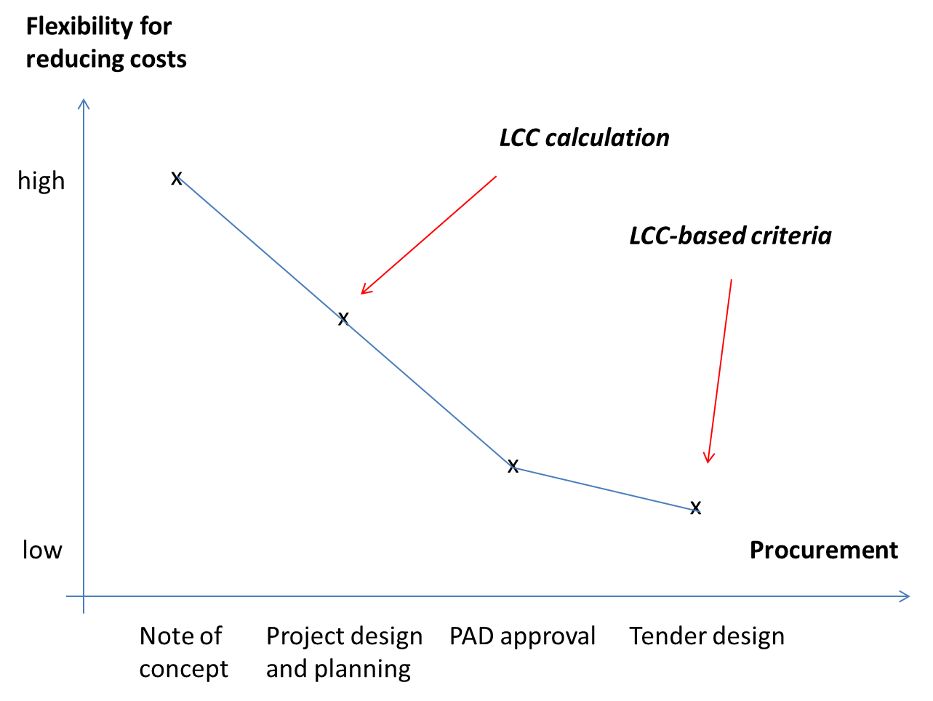
To summarize, a first LCC calculation (LCC1) will be done by project team during the design phase to compare and select the best appropriate technology. A second LCC calculation (LCC2) will be done when comparing offers. At this stage tenders are informed about the use of LCC as an award criterion

Concept Note (CN)
Proposal to be discussed: In the CN, it should be stated the importance (if any) of the environmental and social impacts, even though detailed impacts are not yet known at this stage.
It is of paramount importance to decide which externalities will have to be taken into account in the project and thus expressed in monetary value in the LCC1 calculation. Figure below stresses the issue depth related to environmental and social impacts.
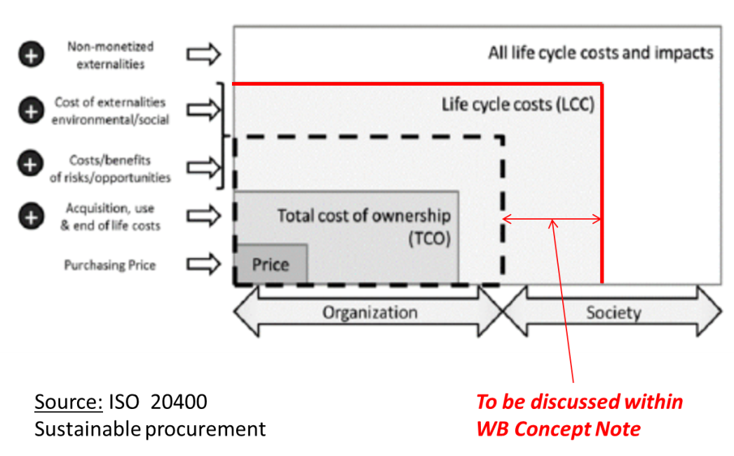
Because of its short term financial objectives, the private sector will probably limit the “depth” of LCC to total cost of ownership. For public sector however, Authorities may be willing to look at reducing GHG emissions, contributing to tackling climate change, reducing their environmental footprint, contributing to eco-friendly use of natural resources, and saving public resources.
At this stage, the main environmental and social impacts should be identified so that the impacts to be monetized will be included in the LCC1. Among these impacts, the CO₂ emissions are probably the most sensitive impact to consider. It should be recalled that power plants are one of the tree main sources of carbon emissions. Other potential impacts are: human and technical resources, energy / fuel consumption, quality of service, aesthetics, etc.
During this preliminary phase of design, it is important to: 1- express user requirements (in terms of needs and not as a particular product), 2-functional specifications (the solution deliver what users expect), 3-performance specification (with the required level of performance / capacity to serve with metrics, tolerance).
This is also the opportunity to compare different technologies and to narrow down the number of solutions:
  - Power generation: (coal), gas, solar, geothermal, wind, biomass, energy efficiency
  - Transmission and distribution (T&D): distributed generation, storage, street lighting
It should be noted that in order to compare LCCs, functional requirements and expected performances have to be defined with more details because underlying technologies are different and are not interchangeable. We have already seen that with the street lighting example. It is the same for power generation: 100 MW of hydro power with reservoir is more flexible than 100 MW of solar PV or wind power. This flexibility has a value the intermittent sources don’t have.

Last but not least, LCC1 calculation during the design phase may require data which are not yet available: capital costs (lack of offer at this stage), O&M costs for new technologies, energy cost forecast, etc. International databases do exist with generic costs (e.g. maintenance cost per kWh) but an update for specific geographies may be required. If during LCC1 calculation, a specific cost cannot be sized because of volatility of market prices, the risk will have to be identified as such. This risk may be a risk for the global project with or without LCC.
Project Appraisal Document (PAD)

Proposal to be discussed: The traditional PAD should be completed with an analysis of several alternatives (e.g. different technologies): 2 or more alternatives should have been studied and their LCC compared before selecting the most economically advantageous solution.

The use of LCC1 at the design stage opens also to a wide variety of procurement arrangements: refurbish a power plant vs acquire new plant, service vs supply, contract vs framework agreement, outsourcing, PPP, etc. With the LCC1 calculation during the design phase, project team will have to find arguments in order to justify the project. PAD should set economic, social and environmental objectives and confirm the need to procure and the contractual arrangement which is selected.

An issue may appear with LCC when anticipated capital cost / upfront cost is higher than what is expected for buying the cheapest infrastructure asset. It is the case for instance with a solar power plant where capital cost per kWh may be higher than other technologies but where O&M costs are very limited so. Indeed, total life cycle cost will be lower for the owner of the infrastructure but from but a pure procurement point of view, this may be wrong. The reason is because lower O&M costs will compensate a possible higher upfront cost but investment budget (for today) and operating budget (benefits in the future) are often disconnected especially in the public sector. When preparing the PAD, the owner of the projected infrastructure will have a key role in justifying the use of LCC2 during the procurement process.

Procurement

Proposal to be discussed: In the tendering package, award criteria should be added to take into account all life cycle costs. The tender evaluation will be based on the comparison of the LCC of each offer.
All compulsory technical specifications should be summarized with a table listing all the requirements and asking whether the offer comply (Yes or No). An offer not fully meeting the compulsory specification will be excluded.

The award criteria
The evaluation of the proposed solutions should lead to identify the most economically advantageous offer taking into account the life cycle cost and the associated selected externalities. This means the abolition of the lowest price criterion. For instance, criteria used for assessment of overall economic advantage and which are intended to apply to the contract award may be:
LCC
Functional characteristics
Technical performances (e.g. efficiency thresholds, longer user life)
Delivery date
Reliability of delivery
O&M costs, repairing costs, cost of use
Quality
Technical assistance and after sale services
Upgradeability (commitments with regards to availability of cost-effective spare parts)
Security of supply
Lifetime extension re-use), recycling (collection, recycling, waste treatment)
Cost of externalities (environmental and social costs)
In most countries, the inclusion of energy consumption costs and CO2 emissions as award criteria in the procurement process is totally legal. However, before referring to LCC in a tender notice, one should verify that LCC calculation is a recognized method.

As for traditional procurement, the award phase shall offer: equal treatment, transparency and non-discrimination. LCC can only be included as awarding criteria if costs can be monetized and objectively verifiable. This is a sine qua non condition to select a particular cost in the LCC formula. Data and calculation methodologies have to be objective also. The call for tenders shall identify all the types of information which are required to perform LCC calculation (all the items contained in the LCC formula). A good practice is to limit the number of cost drivers to a few, the main ones.
NB: if a cost seems to be too difficult to quantify, it should rather be used as a technical performance requirement.

Since use costs may not be directly under the control of the suppliers (e.g. cost of operation, cost of CO₂ emissions), it is important to ask them in the tender notice to provide evidences in support of the information given in their offer. A validation by a third party may be required.

In order to review offers it is important to get from tenders’ comparable data. For instance: define clearly the LCC parameters to be used (e.g. discount rate, energy price, number of years of usage, etc.) and to identify what data should be submitted, what standard should be used.
Review of main procurement arrangements for the energy sector

Several procurement arrangements are generally used for developing projects in the energy sector. They are summarized here, starting with the simplest type of contract.

Civil works contracts, procurement of goods
Project owner may purchase goods, spare parts or stationery, civil works. It the case when build a new grid. Poles, cables, transformers and many other pieces of equipment are bought from manufacturers. There is no real need to use LCC calculation (LCC2) here since almost all products are standards and available from vendor catalogs. However, we have seen that for transformer, LCC1 calculation may help to adapt the initial design, for instance by replacing a large transformer by several smaller ones or by introducing distributed generation.

Engineering Procurement Construction (EPC)

With this type of contract, the infrastructure owner asks to take care of all activities dealing with the construction of the project from the technical studies to the commissioning. The private party plays the role of system integrator delivering a turnkey project. Main benefit for the infrastructure owner is not to supply dedicated resources for the project except for supervising the contract.

O&M contract

With this contract (a particular type of management or service contract) the infrastructure owner engages a contractor for operation and management activities during a few years. In general, the operator is paid with a fee often based on performance.

Design Build Operate (DBO)

The infrastructure owner finances the project. The private company takes care of the construction (turnkey project) and the operation of the facility under the control of the owner. The private company is responsible of the design and the construction. If parts needed to be replaced before the assumed life span, costs would be charged to the operator. However, since the contractor is paid separately for the construction, he may be pushed to reduce the construction costs and thus increase its margin which does not optimize the life cycle costs.

Build Operate Transfer (BOT)

BOT is used to develop a limited project (e.g. new power plant or refurbishment of an existing one). The private company finances, owns, constructs and operates the projected infrastructure for a limited period of time. The operator is generally paid by the infrastructure owner. For instance, for a power plant, generation is delivered to a single buyer (the utility or off-taker) through a Power Purchase Agreement (PPA). At the end of the contract, the infrastructure is transferred to the public side.

Off-take / Power Purchase Agreement

This is the traditional type of contract between private companies operating a power plant (e.g. Independent Power Producer) and a utility (off-taker). Investments, operation and maintenance of the IPP are recovered by the price of kWh which is negotiated with the utility for a quite long period of time. Two main components are generally identified in this price: a charge for the capacity (MW) which is made available for the off taker and a charge for each kWh which is supplied. For solar and wind power, the contract may have a “take or pay” clause.

Joint venture

A project company is established with parts from the public and the private sectors. In general, the level of share ownership is such that the project company will have a scope limited to the construction, operation and maintenance. Main difficulties come from the risk of having two leaders with different views on the orientations and the day-to-day management of the project.

Concession

An entire infrastructure is given (contract of concession) to a concessionaire who will be responsible to finance required investments, operate, maintain and partially extend the infrastructure. The concessionaire is mainly paid by the clients of the infrastructure. Public sector remains the owner of the infrastructure and receives a concession fee from the concessionaire. At the end of this long term contract, the extended infrastructure is reverted to the owner. In many countries, utilities entrust the distribution grids or solar/hydro generation to concessionaires. In all cases, the concessionaires have to deliver a service with the same level of performance as if done by the public sector.

Public Private Partnership (PPP)

Because of the specific nature of infrastructure projects (e.g. needs for large amount of capital, delivery of a public service), the implication of the private sector in their development becomes an alternative to traditional public procurement. A PPP is an arrangement of collaboration between public and private parties. Collaboration means that the two partners agree to share resources, risks, responsibilities, rewards and value during the whole life cycle of the infrastructure. Two main situations may lead to the adoption of a PPP: 1- capital intensive projects, 2- need for private expertise to manage complex infrastructures. However, the use of LCC methodology is highly recommended to demonstrate, if it is the case, that PPP project provides more value for money than traditional public projects. PPPs are the most complex type of long-term contract where a significant part of responsibilities for an infrastructure and / or a public service is transferred to a private operator from investment to supply. Complexity comes often from the detailed sharing of responsibilities and risks between public and private sides. In general, remuneration of the operator is based on the quality of service and the level of performance which is provided to end users. It is in general a direct payment from the public side. At the end of the contract, the public party becomes the owner of the infrastructure.
During the preparation of the contract, all the risks are analyzed in the activities of the value chain and for the whole life cycle. The risks are then allocated to the party that is the best prepared to manage them. In other words, the infrastructure owner should answer the question: is the partner in a position to reduce costs compared to an internal activity?
In the public / private dialog, it is of paramount importance to align cost effectiveness and profits with public service coverage, quality and value for the users.
Because of the wide scope and the long term of a PPP project, the use of “whole-life” methodologies such as LCC is quite obvious. In addition, since a major part of the LCC is under the responsibility of only one party, this incentivizes the look for minimal costs and the research for innovative designs.
NB: PPP term is sometimes used as a generic type of contract for O&M, DBO, BOT or concession contracts.

Figure below summarizes the comparison between the main contractual arrangements used in the energy sector.

For an infrastructure owner in the public sector, what is the contractual arrangement providing the best value for public money? Next section proposes a few examples where LCC may be used.

Use of LCC to select a procurement arrangement

Public and private sectors may have different views on this matter. For public sector, procurement is very often focused on reducing spend and saving money. In addition, compliance with regulations is of paramount importance. As a consequence, transparent practices are very important. Since a few years, many public organizations do consider the environmental and social value when procuring goods and services, not just value for money. That is the reason why LCC is more and more often used. LCC calculation allows the infrastructure owner to compare the value and associated costs for different procurement arrangements but also, in the case of a PPP, to compare public and private procurements. This will be discussed in the following sections.

LCC calculation methodology is not related to a specific type of procurement contract. In all what we have seen so far in this document, the LCC principles do not make any assumption on a particular type of contract between the infrastructure owner and one market player. However, the resulting cost may be deeply influenced by the type of contract and the share of risks between public and private players. LCC calculation is used here for assessing value for money of the selected procurement arrangement.
Figure below summarizes the main components of a project in the energy sector and how roles may be assigned between the public sector (owner) and the private sector (developer, equipment manufacturer, operator, Service Company, etc.).

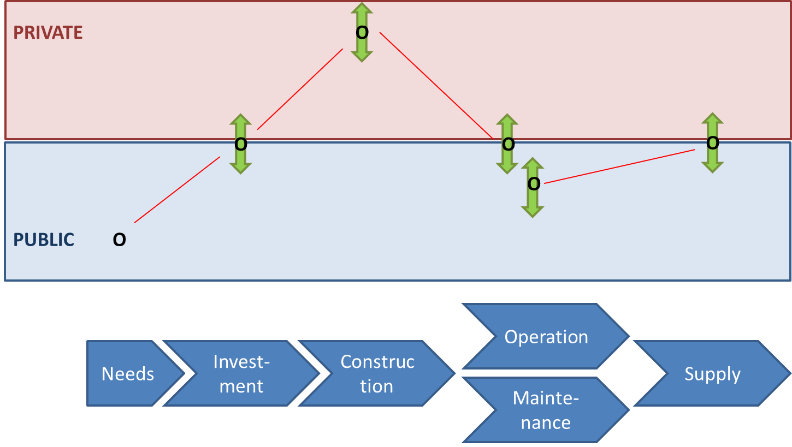

Before reviewing the main types of contracts which are in use for the energy sector, it might be useful to explain how to use LCC1 for selecting a particular type of contract.

The first step is the calculation of the life cycle cost during the design phase as recommended in this document. To do that is a good practice to assume as far as possible, a costing based on past internal experiences and as if public sector was responsible for the majority of the activities (design, project management, operation, maintenance and supply). As already mentioned, when a cost is unknown for the project team, an estimate may be found in international databases. This approach is important to provide the team with a rough estimation of the total cost with a set of well identified hypothesis. An important benefit of this preliminary estimation is to give a magnitude of the price for selected items which may be used during negotiation. For example, a too low- priced offer may then be identified.

In a second step, a discussion should occur for each activity (see figure above) in order to decide whether this activity should be done by the public side, subcontracted to a private operator or even totally outsourced. Many criteria may be used to decide up to what extent the infrastructure owner should rely on the private sector for a given activity. Among them: the cost, the lack of internal competences, core business or the level of risk.

A few examples are given below to illustrate the discussion around the respective roles of the infrastructure owner (public side) and the private sector. A specific sub-section will be dedicated to the use of LCC with PPP contracts.

Each repartition of the roles between public and private gives rise to specific types of contract. For instance:

  - Ownership / needs: needs are generally expressed by the public side, the infrastructure owner. This is the minimal role of the owner of an infrastructure. As already mentioned, these needs have to be expressed in functional terms and performance thresholds. For instance, the need for a utility could be to extend its power generation capacity by 400 MW. To do that, it may be possible to ask for IPPs (Independent Power Producer). A PPA (Power Purchase Agreement) is the signed between the IPP and the utility. Generally, the contract is signed with the IPP proposing the lowest price per MWh, but the lowest LLC could be used instead as the awarding criterion. This would encourage the market to develop “cleaner” power generation in the countries where there is no more public monopoly for electricity. PPP contracts are another procurement arrangement where the full value chain of electricity (generation, T&D and supply) may be transferred to a private operator for instance, for rural electrification. This late choice may be done when national utility does not have the skills and the available resources to manage in parallel an existing power system and the development of project covering wide areas, low density population and high financial risks.
  - Investments: they may be totally provided by the infrastructure owner but they may also be shared (partially or even totally) with the private sector. This is the case in a Public-Private Partnership (PPP). For example, to develop geothermal power generation, it is often required to start with an exploration phase where preliminary wells are drilled to size the geothermal resources. Because of the high level of uncertainty, it might be difficult to convince private investors. However, public money, if accepted at the national level, might be used to reduce the total investment cost. Private sector could be then asked to invest for developing power generators. LCC1 calculation would have then to be extended to take into account upstream activities.
  - Construction: several cases may be encountered. Project owners may procure the goods and subcontract the work. Civil works contracts are often used, for instance to build a grid extension. Project owners may also select a private company for the Engineering Procurement and Construction (EPC). Infrastructure owners have to know that EPC contractors are often inclined to minimize the capex and thus to purchase the cheapest brand among the list provided by the client. This does not minimize the LCC since opex are not taken into account. To prevent that, LCC-1 calculation may orient the contract with the selection of the technology (engineering) which would reduce total costs. In the case of grid construction (transmission / distribution) the alternative to EPC is to procure equipment and labor separately. LCC calculation helps the infrastructure owner to decide between make or buy. For some “young” utilities, new grid construction is part of the core business: teams are trained, equipped with modern tools and available. In this case, internal construction may be less expensive than asking the private sector. However, a grid extension in a well-established utility may be an issue because of a lack a trained and available personal for a new project.
The purchase of a construction may be replaced with the purchase of a “service”. For instance, in the above example of the street lighting, the City could ask a private company to (re)build and own the system for 20 years. The City would then pay an annual fee to have all luminaires in place and fully operational 365/365. For the City, LCC would serve as award criterion. For the supplier of the service, the electric consumption and the lifetime of the luminaires should be the main cost drivers. As a consequence, the LED technology should be the best technical choice.
When street lighting and extension of a distribution grid are needed together, a PPP contract may also be implemented. A preliminary LCC calculation (LCC1) should be used to prevent the private partner to collect almost all the benefits of an efficient design.
  - Operation and maintenance: they are often the core business of Utilities and as such are kept internally. However, for new technologies, private operators may be asked to provide this service to give enough time to the infrastructure owner to recruit and train new people. LCC1 calculation should be based on the cost of internal resources and compared with the cost of externalized operation (LCC2). It should be noted that some manufacturers and developers may propose to operate and maintain the infrastructure during a few years. For the infrastructure owner the question is to invest in training a new team or to purchase an O&M service during a few years. A Build Operate and Transfer (BOT) contract may be used is this case. The role of LCC is here limited to take a “make or buy” decision. From a procurement point of view, a large part of the life cycle is already taken into account with the BOT contract (with the exception of the end of life). In order to optimize the use of public money, the owner should calculate the best date to transfer the infrastructure by comparing LCC1 and LCC2.
A typical situation may be encountered in the case of a solar power plant. Operation and maintenance are quite limited tasks for the owner but they may be new and requiring specific expertise. Hiring new agents may be expensive if there is no enough activity for them. The alternative is to externalize the activity to a private operator which could then rationalize and mutualize the activity between several solar plants so that O&M costs have to be lower. LCC2 calculation should illustrate that.
Another example may be found with grid infrastructure. After extending his rural distribution grid, a grid owner may decide to give it to a concessionaire through a long term contract (concession). The concessionaire will be responsible to operate and maintain, repair and sometimes partially extend the grid. The concessionaire will be paid by rural villages and cities.
In a PPP contract, the partner is compensated for the capex investment over the operation period of the life cycle. The partner has to assume the maintenance risks while maintaining the required level of performance of the service. Obviously, the partner is naturally incentivized to design and construct the infrastructure so that O&M would be minimal. Could we say that PPP does provide the same incentives than LCC for improving value for money? The answer is negative for all externalities not included in the PPP contract (e.g. environmental and social impacts).
  - Supply: this commercial activity (selling a public service), including billing, is rarely outsourced. However, in a concession contract for instance, revenues may be collected by the selected operator, in particular if the initial investment has been done by the private sector. Some examples may be found with smart metering infrastructures and with rural electrification.

The above discussion is intended to demonstrate all the possibilities for sharing responsibilities between public and private sectors at each stage of the project (needs, investment, construction, operation, etc.). However, slicing the activities with specific contracts may create complexity, unnecessary procurement overhead and management issues. In general, only one or two contracts are used to cover the life cycle, except for PPPs (see next section below) where roles and responsibilities are tailored for each of the above activities.
LCC calculation is a tool used to evaluate costs and benefits of transferring to the private sector a part of the infrastructure life cycle. This is a transfer of responsibility but the infrastructure owner should remain accountable for the service delivery, except for privatization.

Figure below summarizes the positioning of some procurement arrangements in the energy value chain.

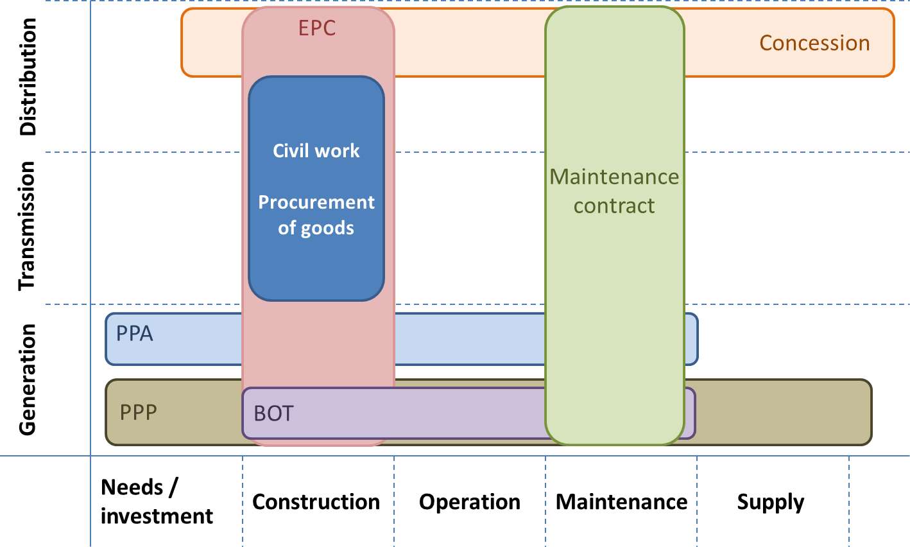
As shown on this figure, only the construction and the maintenance of the transmission part of the value chain may be contracted to a private company. The reason is the central role of the transmission for a power system. PPP contracts are rarely used except for rural electrification.
Use of LCC – the particular case of Public Private Partnership
The use of LCC in the preparation of PPP contracts for infrastructures does make sense because of the full control over the full lifetime of expenditures and the search of the best long-term value for money. PPPs are often the opportunity for the public sector to share or even to transfer risks to the partner. The transfer of risks provides incentives to innovate in the design of the project and is source of cost savings during the whole life cycle. Private sector is supposed to provide a better risk management than public sector does but this has to be demonstrated for each contract. Before transferring a risk, it is important to know what are the underlying costs such as cost overruns or consequences of the occurrence of a particular risk (e.g. lower than expected revenues, project completion delayed). As a consequence, the costs of risk have to be taken into account in the LCC calculation. However, when comparing different procurement arrangements, it is important to adopt a risk adjusted comparison in order to compare apples to apples.
When performing LCC calculation, we have seen that the discount rate often reflects the risks of the project. Since there is no formal relationship between the level of risk and the discount rate, it is wise to proceed with sensitivity test to ensure the final calculation has not been biased by the initial rate.
In general, the decision to implement a PPP is taken after comparing the net present value of the PPP project with the value it would have if implemented as a traditional public sector project. However, many parameters used for the calculation may prevent reaching a consensus. It is the case for example if there is no strict equivalent public project, if risks estimation is based on questionable data or if discount rate does not reflect real risks, etc.
The main objective of a PPP contract is to deliver a service (even if there is an underlying asset) with specific quality and level of performance for a long period of time. As a consequence, requirement specifications should be expressed in terms of performances for end users. For instance, in a distribution grid, the reliability of the infrastructure should be expressed with a threshold for SAFI and SAIDI indicators. The grid operator is then responsible to take all required actions (including replacement of weak portions of the grid) to maintain the level of reliability.
One of the main governance roles of the public side is to set key performance indicators aiming at minimizing the whole life cycle costs, selecting the optimal design / innovative technologies and reducing the environmental and social impacts.

Because of the long life of the contracted infrastructure service, LCC is a major tool used to analyze the cost evolution overtime, help to distribute the risks between contractors and ensure to reach public Authority’s objectives in terms of environmental and social impacts.

The private partner should be asked since the beginning of the work on the design of the project to prepare a preliminary LCC calculation (cf. LCC1) with the most cost significant items for the whole life cycle. This yearly estimation of the costs will help both the public side and the partner to estimate fees and budgets. At the same time the public party should do the same calculation on his own as for a project developed by public sector. These two calculations should then be compared to ensure private initiative will provide more value than the public one. The O&M costs for example are in general well known by the public party (better than the costs announced by designers or manufacturers) and they will be compared to the partner’s own evaluation. It is recommended at this stage, to ask the partner to evaluate alternative designs with their associated LCC calculation. Very often this is not well received (even single LCC calculation) because it may generate delays in the preparation process. However, these delays (and associated costs) remain very limited compared to the full life time of the infrastructure.

It is recommended to build a tool (e.g., spreadsheet) to implement LCC in order to easily update the calculation all along the life time of the project: design, selection of a partner, financial close, construction, operation and end of life.
According to a study done by Belfast University (UK), the top five benefits for using LCC calculation in PPP projects are:
    - increased long-term value and economic sustainability
    - reduced costs of construction, operation and maintenance
    - reduced needs for maintenance
    - optimized selection of materials, equipment and components
    - better understanding of risks and increased certainty and transparency.
Conclusion
LCC calculation is a powerful tool to compare costs of alternate project designs over their full life cycle. LCC does also provide a pertinent help to estimate the proper pricing of the proposals issued by the private sector so that owners are fully informed for comparing procurement options and proceed with the proper risk allocation, in particular in the case of PPPs. Some infrastructure owners implement a kind of shadow bid before entering in the procurement process; the goal is to predict bidder’s costs.

The use of LCC for comparing different designs and / procurement arrangements is often called LCCA (life cycle cost analysis). It is the case when looking to achieve the optimal value of the costs. These comparisons may require the support of technical experts in order to prepare feasibility studies and validate that the analyzed designs are technically sound.

It is true for any type of procurement arrangement but in particular for PPPs, a thorough treatment of risk and uncertainty has to be integrated in the LCC calculation.

LCC calculations require gathering data for estimating costs in particular future costs. Infrastructure owners need to identify the source of data they use and discuss their pertinence before taking them into account. In particular costing risks and other uncertain parameters should be reviewed with sensitivity analysis. The use of international databases or benchmarking studies may help but one should know how values have been calculated. In particular costs of O&M are very sensitive for utilities; however, they may be shared between collaborating countries and more often between different sectors in the same country.

LCC calculation is a good tool to help selecting the most efficient offer for the full life cycle rather than the cheapest solution at construction time. LCC helps also to compare different designs and select the solution maximizing value for money. However, LCC is not a magic solution; it introduces more complexity in the analysis of the project (devil hides himself in the details) and will require specific expertise to compare solutions.

Many contractual arrangements may be selected when implementing LCC calculation. For all of them, the infrastructure owner needs to keep an updated view of all the costs (direct and subcontracted) over the full life cycle. In the case of a PPP, the private sector takes the life cycle cost risk and is naturally inclined to minimize it overtime. However, this imposes to the public side to produce and freeze for a very long period of time output specifications including quality of service, environmental and social impacts.

Guide to using Life Cycle Cost (LCC) Analysis in Procurement and Management of Information and Communication Technology (ICT) Infrastructure

Contents
1 Guide for Using LCC in ICT Infrastructure Projects 3
1.1 Purpose of the guide 3
1.2 What is ICT? 3
1.3 What is Value for Money (VfM)? 3
Given that we operate in an environment of continuous change and ever-increasing complexity, VfM evaluation may be needed on an ongoing basis to reflect changes in industry structure, competitive landscape and advances in technology. 4
1.4 What is LCC Analysis? 4
1.5 When should we conduct LCC analysis? 5
1.5.1 Use of LCC at the Business Case phase 5
1.5.2 Procurement phase 6
1.5.3 Ongoing Management Phase 6
2 Developing your LCC model 6
2.1 Step 1 – Scope of the analysis 7
2.2 Step 2 - Capturing the data and insight 7
2.3 Convergence Workshop 7
2.4 Ongoing Management 8
3 Risks Associated with using LCC as a Predictive Model 8
4 Case Study 9
4.1 Project background 9
4.2 Project Requirements and Assumptions 9
4.2.1 Requirement 9
4.2.2 Assumptions and Parameters - On-premises Delivery Solution 9
4.2.3 Assumptions specific to Cloud-based Delivery 10
4.3 Approach to LCC Analysis 11
4.3.1 Option 1: On-Premises 11
4.3.2 Option 2: Cloud-Based 12
4.4 Using LCC to Inform Procurement Strategy and Vendor Selection 13

Guide for Using LCC in ICT Infrastructure Projects

Purpose of the guide
The purpose of this guide is to help the planning and procurement teams gain a sufficient understanding of Life Cycle Costing and the related analysis to achieve better value for money in projects involving Information and Communication Technologies (ICT) and supporting services. The guide is organized as follows:
- Definitions of ICT, Value for Money (VfM), and Life Cycle Cost analysis
- When should we use LCC and related analysis?
- Process for developing the LCC Model
- Risk related to using LCC in procurements
- ICT Infrastructure Planning and Procurement Case Study

What is ICT?
Although there is no consistent definition for Information and Communication Technologies (ICT), the term generally refers to all the technologies that are needed by an organization to enable their business and interact with the digital world. Depending on the project, it includes information and communications technology infrastructure and systems (including software, hardware, firmware, and networks). It also includes laptops and other portable devices, servers, workstations, printers, scanners, projectors, mobile phones and smartphones, software tools, cloud computing, access to the internet, IoT, websites, communications technology, physical assets, support functions, security, and operations management functions. It also may include, sensors, geographical positioning systems, cameras, electronic weighbridges, and associated software.

What is Value for Money (VfM)?
What is VfM and how do we know we are getting the best value for money?

According to the World Bank, VfM means the effective, efficient, and economic use of resources, which requires the evaluation of relevant costs and benefits, along with an assessment of risks and of non-price attributes and/or life-cycle costs, as appropriate. However, best VfM means a comparison between two or more investment alternatives and choosing the option that delivers the needed value at lowest cost or delivers higher value at the same or lower cost. If all else is equal but the cost of one option is more favorable than the others, then it is said that this option provides better value for money. Achieving best value for money at a moment in time involves conducting a fair open and transparent competitive procurement or partnership and where the vendor is delivering the products or service as planned.

When procuring ICT Infrastructure and supporting services, procurement professionals aim to achieve the best value for money, by running a competition and selecting vendor solutions and services that meet the requirements at the lowest cost.
However, different ICT solutions may incur different levels of costs at the different stages of their life cycle. As such, if the evaluated cost does not account for the total cost of the different stages in the life of the infrastructure, the VfM analysis would be inconclusive. In this case, you may be getting the best value in one segment of the life of the infrastructure at the expense of other segments.
Given that we operate in an environment of continuous change and ever-increasing complexity, VfM evaluation may be needed on an ongoing basis to reflect changes in industry structure, competitive landscape and advances in technology.

What is LCC Analysis?
LCC recognizes that costs need to be managed over the life of a product or service. According to World Bank, Life-cycle costing (LCC) seeks to integrate circular economy considerations into the evaluation of the cost of goods, services, and works for the procuring entity and the economy as a whole. LCC shifts the focus of procurement from the lowest cost of acquisition to best VfM, taking into account the costs incurred throughout the products’ lifetime as well as their environmental and social impact costs.
For consumers, it includes both one-time costs, recurring costs, environmental and social impact costs all together representing the total cost of ownership (TCO).
For producers, it includes:
- One-time costs: Product process and design costs, and
- Recurring costs - Manufacturing costs, costs of selling and supporting the product including environmental and social impact costs.
As shown in Figure 1 below, the costs of any ICT infrastructure in a project can be categorized into:
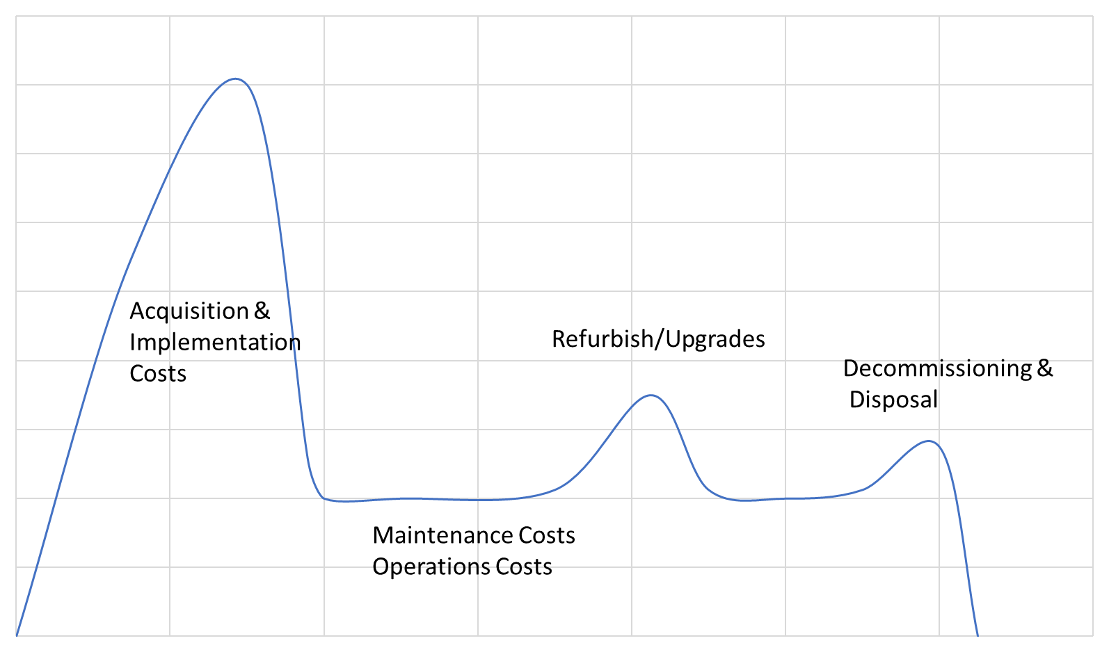
Figure 1. Shows the various cost categories in the Life Cycle of an ICT Infrastructure.
- Acquisition Costs – Cost of the technologies or initial costs of Product or Software as a Service
- Implementation Costs – Costs related to implementing the technologies and services into the target environment
- Ongoing Maintenance Costs - This includes maintenance costs on products and software licenses
- Operations Cost – Costs related to operating and supporting the digital assets including HW, SW, and data as well as costs related to project social and environmental impact.
- Decommissioning and Disposal Costs – Costs related to decommissioning and disposal of these assets and related services.
Life Cycle Analysis allows us to understand the costs of the various stages or areas of cost and provides us with the basis for developing effective procurement strategies that would deliver better value for money.

When should we conduct LCC analysis?
As depicted in Figure-2 below the LCC Analysis should first be conducted at the business case phase and carried through afterward to guide the procurement strategy and onto implementation and ongoing operations of a project.

Use of LCC at the Business Case phase
LCC analysis should be conducted at the business case stage of the procurement project as part of the process of evaluating available feasible options. Secondary research should be conducted to ensure that data for the LCC is relatively available to produce an LCC model at a minimum of 85% confidence level. If data is not available, then perhaps some primary research should be conducted to ensure we have a legitimate basis to conduct a comparative analysis among available business case options. Each option must include not only the costs that could be incurred by external organizations but also the internal costs related to implementation, changes to business processes, the cost of operating the LCC infrastructure, environmental and social impact costs as well as those costs related to managing the change.
Additionally, a macro and micro industry analysis should be conducted at the business case stage to ensure that we have a good understanding of the industry makeup, competitive landscape, and other factors that could impact the total cost of ownership.
LCC is then a “yardstick” for measuring value for money at the business case level and provides insights that drive procurement strategy. It allows us to compare different alternatives using the same measurement tool.
Figure 2. Shows the relation between LCC analysis and the procurement process.

Procurement phase
Once an option has been selected and the project moves into the procurement phase a procurement strategy is then developed. The Procurement strategy is generally concerned with determining exactly “what” we are going to acquire and the process via which to acquire such ICT assets and supporting services. Many questions will need to be answered, however, and from an LCC analysis perspective the key question the main focus would be to source best-of-breed vendors for each category of cost or stage of the life cycle. They can be sourced individually or aggregated into a single Request for Bids (RFB)process.
Generally speaking, at the procurement planning phase, we need to revisit the industry analysis conducted in the business case around industry capability, relationships between maintenance and support organizations, and the Original Equipment Manufacturers (OEMs) of the products and service solutions. In many cases ICT Hardware, software and services are provided through third parties. If there is evidence of sufficient, competitive industry capability for the full lifecycle, you may go with sourcing the products and services from one vendor for the entire lifecycle. This way the vendor is responsible for the entire cycle and not just one piece of it. If not, then you may have to select different vendors for various parts: HW and SW acquisition, Implementation, operation and support, and decommissioning.
Another question that arises in terms of business risk management is vendor strategy and capability sustainability. What if the industry conditions change and the selected vendor is no longer able to provide refresh cycles and ongoing support either to change in strategy or financial difficulties? What do we do in such a case? One strategy that can be pursued is to source more than one vendor for the same scope, where possible, and load balance the allocation of work based on regular value for money analysis and comparison to the original LCC model. This works very well in the case of commodities.
At this stage, we want to confirm the costs per life cycle phase, developed in the business case phase, to ensure they can be used as a valid basis for developing the weighing scales for the evaluation and selection framework. The LCC model provides the ratio of cost of each phase of the cycle to the overall cost which can be used to produce evaluation weights for sections of the Request for Bids (RFB). Again, emphasis should be placed on validating the LCC data especially if the business case is somewhat outdated.
In summary, the LCC analysis helps us arrive at the right procurement strategy and provides us with the proper framework for developing financial evaluation and basis of payments.

Ongoing Management Phase
During the implementation phase of the project, the initial LCC model is used as a baseline from which to measure financial performance. At every stage of the ICT project, a comparison should be made against the baseline LCC model to determine the reason for the variance, if any, and update the LCC model with actual data. This continuous learning process will enhance the accuracy of the model and the confidence level when used with similar projects.

Developing your LCC model

Developing the initial LCC model and conducting LCC analysis involves a 4-step process as depicted in Figure 3 below:

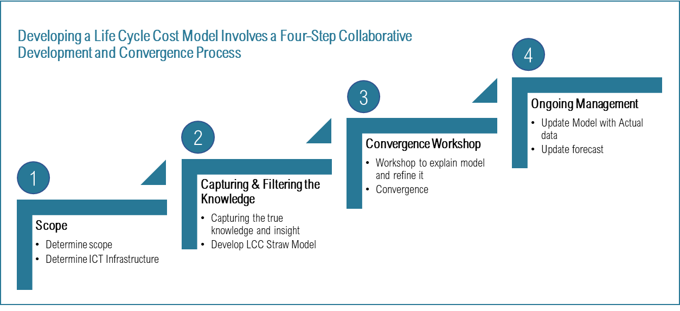
Figure 3. 4-step process for developing an effective LCC Model.

Step 1 – Scope of the analysis
Step 1 is focused on determining the scope of the LCC analysis required and will depend largely on the type of project at hand and the type of assets and support services required. It could include Hardware, software, buildings to house equipment, help desk, maintenance, evergreening, operations costs, decommissioning costs, etc.

Step 2 - Capturing the data and insight
This step aims to collect sufficient data to allow for the building of a strawman of the LCC model. There are several ways to collect data:
- Secondary research and information available from research firms, OEMs, and Service Providers
- Primary research – Conducting interviews to collect actual data from OEMs, service providers, and consumers
- Utilise existing LCC models from other similar projects
This is where the danger may lie in using LCC. It is a better indicator of past performance and not a legitimate barometer of future performance. The strength of the model is directly proportional to the quality of data collected in this step.

Convergence Workshop
Used as a guideline, the straw model developed in the previous stage, represents the core material for conducting a convergence workshop which will include all key stakeholders involved in the program. During the workshop, participants work together to refine, update, or otherwise use the straw model material to create a baseline LCC model. Activities of this step include:
- Schedule workshop: Prepare workshop material and identify participants
- Prepare and conduct a Convergence Workshop, delivered in two parts: The first part is focused on reviewing the data collection processes and a summary of findings. The second part is focused on a conducted a detailed walk-through of the costs, and cost drivers, and confirming the fundamental principles underpinning the model such as tax treatment, depreciation schedules, refresh cycles, etc.
- Workshop output integration – this activity involves integrating and documenting the revised straw model to produce the final initial or baseline LCC model.

Ongoing Management
The fourth step of the process is focused on updating the LCC model on an ongoing basis and drawing lessons learned for future use. The model should represent (to a 95% confidence level) the detailed costs related to the following stages:
- Acquisition and Capital Expenditure
- Implementation Costs
- Maintenance
- Operations Management
- Refresh
- Decommissioning and disposal Costs

Risks Associated with using LCC as a Predictive Model
LCC Analysis is primarily a “look into the rear-view mirror”, i.e., looking back at the actual costs and analyzing those costs to introduce efficiencies in future projects. There are two aspects to the use of LCC:
Projects with a high degree of certainty – the LCC analysis method works well as a predictive of total cost due to the availability of data. However, LCC should not be used as a cost prediction model in low certainty projects where cost substantiation cannot easily be derived. No shortage of evidence shows that many of the projects exhibiting cost overrun and schedule delays have used faulty LCC analysis as part of the business case.

Case Study
Below is a case study to illustrate the development of an LCC model for an ICT Infrastructure project.

Project background
To increase commerce between three of its major cities, this industrialized country with advanced economy is planning to implement a high-speed rail system that would see travel time by train becomes comparable to that of traveling by air. The project was awarded to a private sector consortium that includes over 50 suppliers along with a myriad of federal, state, and local governments. As part of the project, the prime vendor is to establish a collaborative environment where all stakeholders can communicate and coordinate their activities effectively and efficiently and have access to all the relationship business, and technical financial information needed to fulfill their role in the collaboration. A business case for acquiring the ICT infrastructure is being developed. The prime vendor requires a computing infrastructure of hardware, software, end-user digital assets (such as notebooks, desktops, and mobile devices for about 1000 personnel), and related operations management and support services. Two options are being considered:
- Option 1 – On-premises solution where the prime vendor would acquire the assets and related maintenance and support services, and
- Option 2 – Cloud-based collaboration SaaS solution where collaboration software, computing capacity, and storage, plus operations support services are acquired as a cloud service. The rest of the digital assets are the same as in Option 1.
To examine the financial implications of each option an LCC estimate for each option being examined is developed. Below is the LCC model for a total cost of ownership option.

Project Requirements and Assumptions

Requirement
  - Establish a collaboration environment where all stakeholders can communicate and coordinate their activities effectively and efficiently and have access to all the relationship business, technical, and financial information needed to fulfill their role in the collaboration.

Assumptions and Parameters - On-premises Delivery Solution
  - Establishment of a collaboration services environment using Microsoft 365, Office Suite, SharePoint, Teams, or similar products
  - Estimated number of users is 1,000.
  - New Notebooks for all users every 30 months
  - All users will require new cell phones.
  - Collaboration will take place over the internet
  - A five-year window for the total cost of ownership (TCO) calculations will be used.
  - Depreciation periods are set out in the Capital Assets worksheets.
  - Annual office space costs are $50 a square foot annually
  - Equipment installation costs include.
  - Operations and Help Desk support will be available 24/7 and include 5 technical resources & 1 manager/coordinator
  - Backup is performed daily
  - Operations space required for 3 cubicles & storage for spare user equipment
  - 3 months to complete implementation
  - Hardware maintenance costs are 10% of the purchase price annually.
  - Software maintenance costs are included in the annual costs
  - All estimates are in US dollars.
  - Inflation is assumed to be 3%.
  - Recover 5% of owned equipment cost at the end of the project

Assumptions specific to Cloud-based Delivery
  - No Servers required on-site
  - No local Technical Support for Servers & Server Software
  - Data Storage part of service
  - Collaboration software help desk & technical support part of cloud-based service
  - 2 full-time, on-premises resources still required for notebook, monitor, keyboard & mouse replacement support.
  - Disaster Recovery Option not included in LCC
Please note, that depending on the requirements of data residency and the legal framework surrounding the location of cloud services and availability of high-speed internet, the on-premises option may be the only option feasible. However, for this guide, the cloud-based solution is assumed to be technically and legally feasible.

Approach to LCC Analysis
The first step during the business case development phase is to develop an LCC model for both options that would allow us to conduct a comparative analysis and conclude certain recommendations. Using the previously described 4-step process described in Figure 3 in section 2, the business case and procurement team went on to develop the following LCC models:

Option 1: On-Premises
Capital Assets
Table 1: On-premises capital assets and approximate prices.

Summary of Life Cycle Costs
Table 2: On-premises summary of Life Cycle Costs.

Option 2: Cloud-Based
Capital Assets
Table 3: Cloud-based capital assets and approximate prices.

Summary of Life Cycle Costs

Table 4: Cloud-based Life Cycle Cost.

From a financial perspective, it is clear that the cloud-based option LCC of $9,365,298.00 offers significant advantages over the on-premises option at $11,768,148.00. If all else is equal, the team should be recommending the cloud option as a preferred way forward.

Using LCC to Inform Procurement Strategy and Vendor Selection

As discussed earlier, procurement strategy is concerned with answering two primary questions:
“What exactly are we procuring/sourcing?” And “how are we going to source it?”

To illustrate the point, LCC analysis has already identified what the source is. It is recommended that we source a cloud-based backend solution vs on-premises where we own the assets and manage the operating environment. The question now is how to source the various elements of this option?

Theoretically, and from a procurement perspective, we also have two main procurement options with potential derivatives in each option.
- Run one procurement for the provision of the entire package of the ICT Infrastructure including provisioning of assets, one-time implementation costs, cloud SaaS costs, and operational costs. The advantage of this option is that you have one prime vendor managing all aspects of the ICT infrastructure.

- Run two procurements: In this scenario, we source one vendor for the provision of a cloud-based SaaS solution and related implementation services, and two vendors for the provision of end-user digital assets on a fully managed service basis including maintenance, implementation, and operational support. The two vendors will share the load and more work can go to one vendor based on quarterly best value analysis. One of the critical aspects is the need to manage three relationships instead of one.
Only by conducting a micro-industry analysis to gain a deep understanding of the competitive landscape of the vendor community that we can decide on which of these two options we should choose and what the pricing evaluation strategy should be. Figure 4 below shows the results of a preliminary industry micro analysis to support project procurement activities:
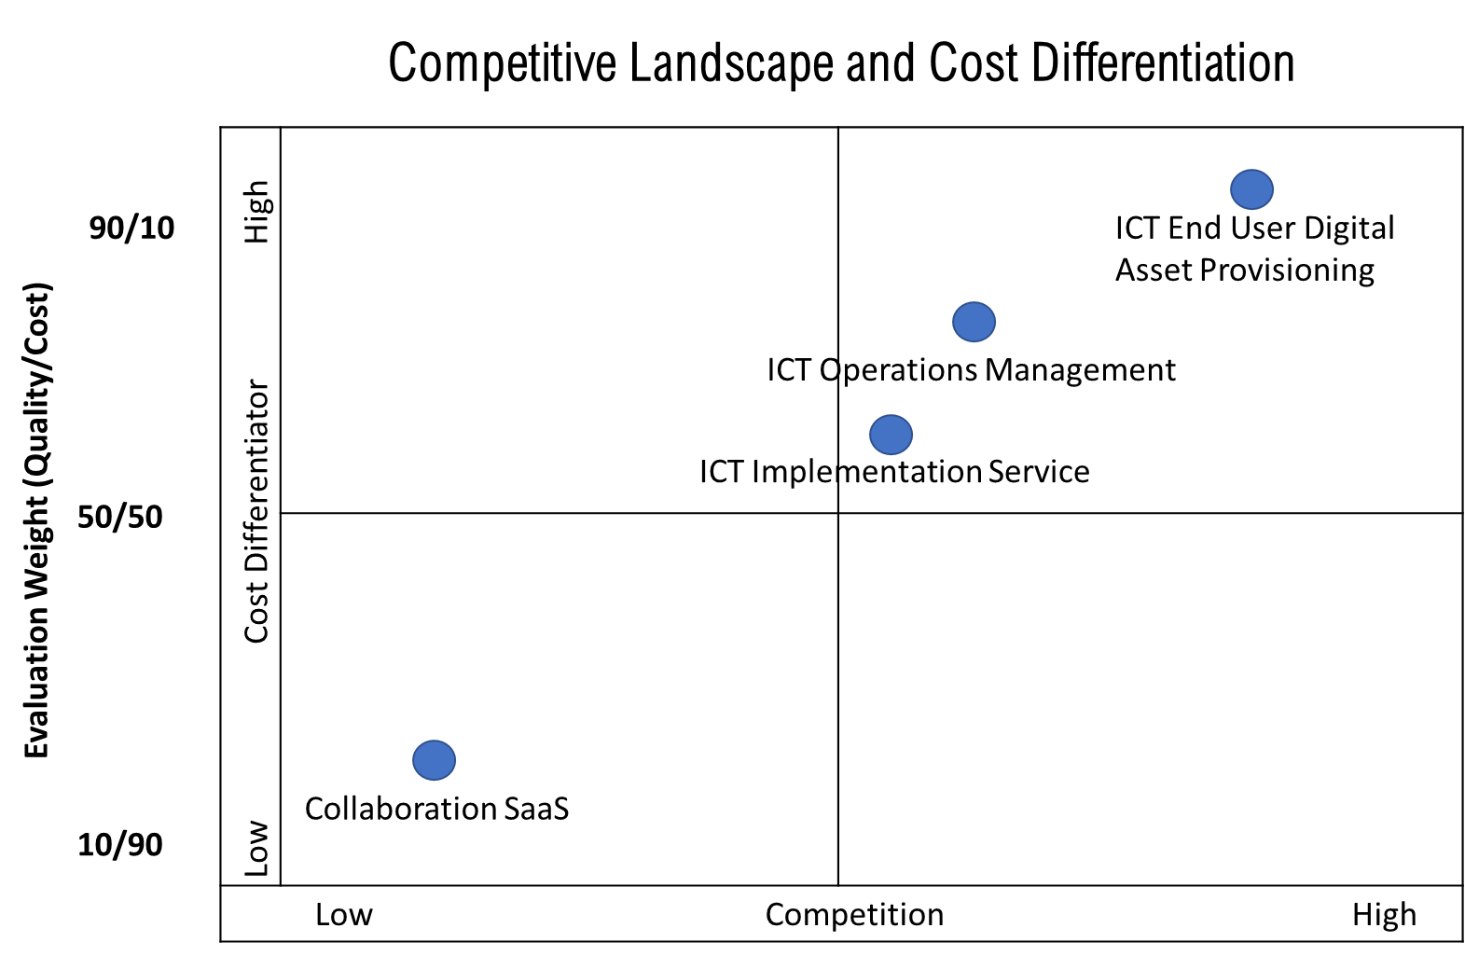
Figure 4: shows the competitive landscape of items in procurement scope, cost differentiation levels, and corresponding evaluation weights
- Collaboration SaaS and related implementation and support services – several providers can provide collaboration software on a subscription basis with full first and second-level support. Further revealed that this Industry group has three primary suppliers, and the competitive differentiators are more on the breadth of capability, and quality of service and less so on price. Thus, the financial evaluation weight on this component should be in the range of 20% Financial / 80% Technical
- Asset’s provisioning and operations management – Many organizations can provide end-user digital assets on a fully managed service basis including full 24/7 help desk support and on-site end-user support. There are two components of this service:
  - Provision of actual assets which is a highly competitive segment where the differentiator is primarily priced. The financial evaluation weight for this component should be around 90% Financial / 10% Technical and
  - Provision of the implementation and operations support services that are somewhat less competitive, and the differentiator is on both quality of service and price. The financial evaluation weight for this component should be around 50% Financial / 50% Technical
Relatability of scope components to each other – from an industry capability perspective the scope of services falls into at least 2 strategic groups. A SaaS group, and a Digital asset provision group. Provisioning of SaaS is not the same business model as the provisioning of digital assets and is not organically offered by the same companies providing hardware and maintenance services. So, it’s unlikely for companies in one industry group to be prime vendors responsible for the entire scope of the ICT. Unless properly treated this has a high likelihood of resulting in zero bids. This is where vendors can put together joint ventures and bid on complex ICT solutions.
- Note that vendors can put together joint ventures (JVs) and bid on complex ICT solutions. This can be done either through a prime contractor and a SaaS subcontractor or a digital asset provisioning a sub-contractor. In some cases, buyers with reasonable ICT maturity can act as Prime.
- Marginalization / Skewing – The LCC model shows that over 70% of the cost is in one bucket. Strong technical thresholds must exist to ensure technical criteria and quality in one area are not compromised at the expense of lower cost in another area. Taking a quick look at tables 4-4 will show the huge difference in costs of the various components or stages of the cost:
- Implementation Costs: $161,364
- End-users’ digital assets provisioning and maintenance costs: $7,420,110
- Operations costs which are mostly related to infrastructure support people and assets maintenance costs: $1,125,537
- Cloud SaaS costs: $ 785,290

As shown in Table 5 below, and irrespective of the approach, the financial evaluation that would deliver the best value for money would include two levels:
- Component level: Determining the right mix of technical and financial weights as shown in Figure 4 above. Establishing an optimum technical threshold that vendors must meet is key.
- Overall vendor evaluation scores: Selection based on the sum of LCC weighted scores as ratios of LCC component cost to LCC total cost.
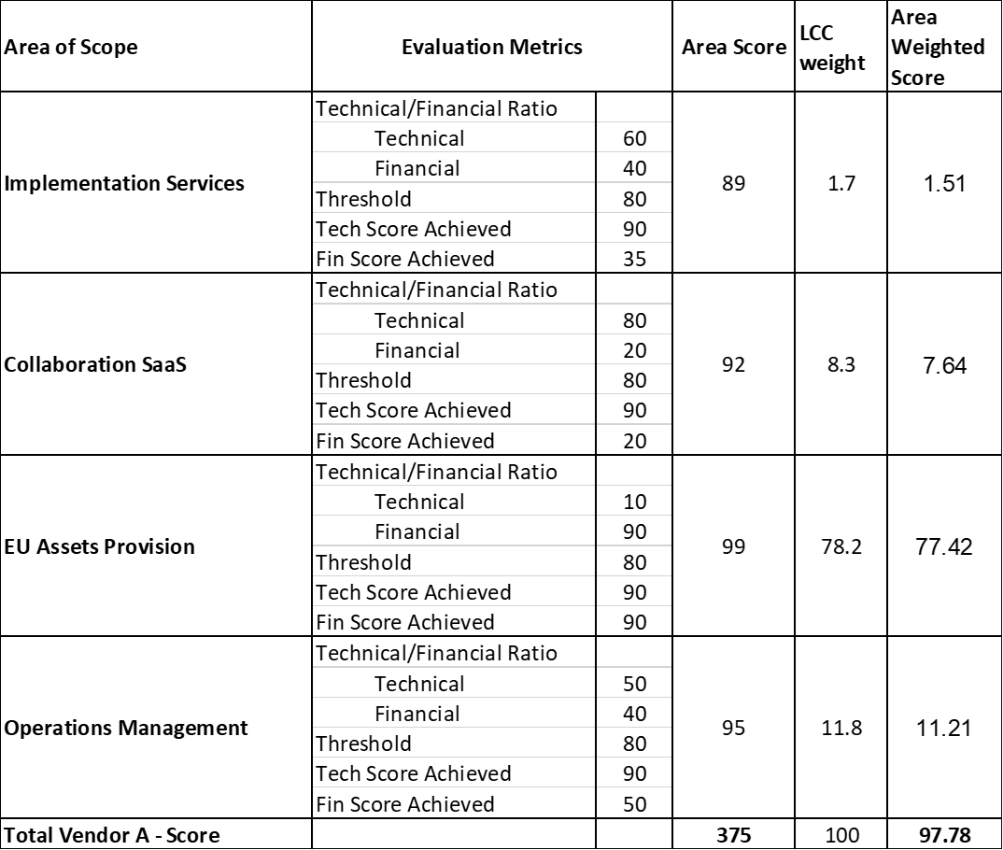

Table 5: Example of an evaluation scheme using LCC as a weighted score

In terms of selecting the preferred procurement approach, both Option 1, sourcing a prime and subs consortium, or Option 2, sourcing best-of-breed vendors with the owner acting as prime, are valid options with one being potentially more viable than the other depending on the answers to the following key questions:
- Can vendors in a strategic group act as a prime vendor for members of the other groups? Do they have the experience and skills to do it? If so, perhaps Option 1 is the preferred approach.
- Are there any third-party program management organizations that can act as a prime and manage the program but subcontract to best-breed organizations? If so, then Option 1 is perhaps more viable
- Does the Project Owner have the capacity and skills to act as the prime? If so, perhaps Options 2, is the preferred option.

Annexure 2 on Case Examples from sectors
Renewable Energy Sector
Case Example 1: Grid-connected Solar + BESS with 10 years OMS: India.
In this project, a large grid connected solar field along with BESS is being used to provide 3 hours of renewable power to the grid in the evening peak hours, replacing electricity supplied by coal power. This project uses a very 40 MW/ 120 MWHr BESS along with the associated Energy Management System to do time-shift of the renewable power from solar field by storing the electricity generated during the day and discharging the stored power during the non-solar hours. Managing a complex technical project of such size is currently beyond the technical expertise of the project owner and furthermore the long-term performance of the BESS is unknown under such operating conditions, so the project owner has included the requirement of a 10 year OMS agreement cost to be included in the bid price.
This approach serves two purposes- it provides an indication of the cost that the system supplier and OEMs feel will cover the long-term performance related penalties and also provides an opportunity for the project owner to safeguard their investment by hiring expert external technical help and learn the nuances of operating a BESS.
This project requires the EPC contractor to provide a clearly-defined operational safety,equipment availability and performance guarantee with associated financial penalties which are applicable for a period of 10 years from the onset of commercial operation.

Case Example 2 Tariff reduction for Solar Rooftop Projects in Maldives.

Background- The island nation of Maldives has almost 1192 islands clustered around 26 Coral Atolls and traditionally has been electrified using mini-grid running diesel generators. Many of the generators are old/ overused and often in urgent need to repair. The supply tariff ranges from 31 USCents/ KwHr in the bigger islands to 50 US Cents/ Kwhr in the smaller islands.
Using diesel as a fuel not only harms the pristine flora and fauna of the islands, but also affects the coral reefs that dot the entire archipelago. Usage of diesel as fuel for the island mini-grids is highly subsidized and the increasing cost of crude oil makes the subsidy component a major uncontrolled recurring expenditure for the Maldivian govt, which depends on tourism and fisheries as its major revenue earners.
As part of a long-term commitment towards a green power focused growth of Maldives, the World Bank has been providing funding and technical advisory services to establish a case for setting up solar power projects across the islands. After careful consideration of the complexities involved, the existing skillset of the utility staff and the specialized Operations and Maintenance Requirements for grid-connected Solar rooftop and ground-mounted projects, it was decided that the solar assets will be set up under a Tariff-based competitive bidding mode where Independent Power Producers ( IPPs) would be invited to set up solar projects in selected locations across Maldives and sell their power to the local utilities (STELCO and FENAKA) under a long-term power purchase agreement. World Bank would provide a backstop guarantee for the payments and the utilities would make payments in USD.
Structure of the Bids: The bids were carried on a tariff-based competitive bidding mode with 2 envelope 1 stage process wherein interested bidders would quote a final levelized tariff to the utilities under a BOO mode where the CAPEX and OMS and other replacement/ repair/ upgradation cost would be totally in account of the bidders.
As part of the bidding data room, the bidders were provided with clear GIS maps of the possible locations, roof structural designs (wherever available), location use rights, shading analysis and schematics of the nearest interconnection points, along with draft PPAs and other legal documents.
Results of the bids: the project attracted almost 10 international IPPs who quoted tariffs in the range of 10-17 US Cents/ KwHr for a 5 MWp Solar PV capacity. This was a reduction of more than 60 % of the current approved tariffs in Maldives. After the resounding success of this bid, another bid for 11 MWp of Solar PV projects is underway following the same construct and the local utilities are now offering more locations for setting up more such projects across the entire archipelago.
The concept of Lifecycle Cost Considerations is built into this project design wherein the utility has asked the bidders to take charge of the total cost of supply. In a situation where the project was to be built under a BOOT model with say 5–7-year concession, at the time of project takeover the utility has to conduct a full audit of the equipment performance and do some refurbishment/ repair and then also carry out the long-term operations and maintenance. In our view, for projects in areas where the utilities are not independently profitable and have experience of working with a specific technology (like large Solar PV or wind), it makes sense to bid out projects on TBCB mode with long-term PPA (20-25 years) and clear payment security mechanisms. We feel once the technology is fully demonstrated and a proper supply chain and maintenance ecosystem in developed in the operational area of a utility, it makes sense to continue with bids under the TBCB mode.
Solar farm (photovoltaic – mono / polycrystalline cells)
The main structure of the asset
Only solar farms with a power capacity > 1 MWp are considered here. Solar farm lifetime is expected to be in the range 25-30 years.
Main components that should be taken into account:
- Design
- PV panels (20 y)
- Mounting structure (30 y)
- Charger controller (if batteries) (7-10 y)
- (Batteries) (3-5 y)
- Inverters (7-10 y)
- Electric DC/AC installation (cables and wires, fuses, switches, connectors) (30 y)
- Substation (step up transformer, switchgear, metering system, communication & remote monitoring, point of connection) (30 y)
- Control room
- Access road
- Fence
- Transportation
- Land acquisition
- Land permit
- Land preparation
- Civil work
- Construction, mounting and testing the solar farm
Key performance parameters:
- PV panel efficiency (%)
- Loss of performance of PV panels (%/year)
- Ratio capacity/land use (kW/m²)
- Solar plant power capacity (MWp)
- System performance for DC and for AC (%)
- Solar plant timeframe (y)
- The specific costs which may be encountered during the life cycle
Operation:
- A 24/7 remote control of the plant is needed.
Maintenance:
- PV cleaning: removing regularly dust from panels is often required (a tank with water should be available on site)
- Regular visit (let’s say every two months) of the installation and tests (PV panels, switchboard, substation).
- Replacement (PV panels, wire and cables, instruments, etc.)
Replacement at the end of their lifetime:
- PV panels
- Inverters
- (Batteries)
Decommissioning / disposal:
- Dismantling PV panels and mounting structure
- Land preparation
- Waste management
- NB: recycling PV panels may be an environmental issue

Annex 2 on Case Examples
Case Examples – Water and Wastewater including network

A) Total Project Costs: US$ 400 M
Project objective: The Project Development Objective (PDO) is to reduce point-source pollution from targeted Urban Areas and support the central ministry to develop an institutional framework for main river basin management
Examples of Results Indicators: (i) Amount of Biochemical Oxygen Demand (BOD) pollution avoided due to project interventions; and (ii) Number of sewage treatment plants funded or rehabilitated under the Project which meet the national discharge standards at least 95 percent of the time
Wastewater treatment investments (IBRD $100 million): The National Authority has identified three wastewater treatment investment projects in three cities, located on the tributaries of the main river respectively. Each investment will consist of goods and works to intercept and divert wastewater currently flowing through open drains into the river, pumping stations and conveyance systems and the construction and/or rehabilitation of STPs to treat the wastewater prior to discharging it in the tributaries of the main river. These investments will be procured using the HAM PPP approach. As a part of project preparation, a market study on emerging lessons from the HAM contracting model was carried out.
Contracting Options explored
Four type of contract structures in waste water sector as below with pros and cons as under:
sl | Type of Contract | Remarks
1 | Design-Bid-Build (DBB) (item rate Contact) | Prone to substantial cost and time overrun. Based on reports and statistics, several projects were not operation and non-compliant with effluent standards. A study at the University of Texas at Austin on the performance of DB and DBB projects on U.S. Naval facilities examined the time and cost growth of 38 DB and 39 DBB projects. “The results showed that DB projects took less time, had less cost growth, and were less expensive to build in comparison to DBB projects.”
2 | Design and Build (DB) contract | DB contracts have been found to perform better than item-rate contracts in terms of time and cost overrun. A study by Penn State found that compared to DBB, DB projects had a six percent reduction in change orders, delivered 33 percent faster overall, and cost six percent  less.(2) However, this approach has risks of higher O&M costs (if O&M is separately contracted) as DB contractor does not have incentives for optimizing the design to minimize the O&M cost and therefore provide the lowest lifecycle cost. In addition, DB does not ensure utmost quality of construction
3 | DBOT contract | To address these concerns and to make contractors more accountable, National Authorities (NA) has promoted DBOT which combine construction and O&M, to ensure that O&M is adequately funded. To this end, NA has recently introduced DBOT contracts with a minimum 10 years of O&M.
4 | HAM Contract | Hybrid Annuity Model (HAM) under which 40 percent of the capital cost is paid to the concessionaire based on contractual milestones during construction and the balance 60 percent is paid as CAPEX annuities over 15 years in addition to the O&M annuities. However, both payments are linked to the performance of the treatment plant. Whereas HAM has emerged as the preferred contract type for Sewage Treatment Plants financed under National Program, DBOT continues to be the preferred contract type for sewer networks.

Reference: (1) Hale, D.R. (2005). An Empirical Comparison of Design/Build and Design/Bid/Build Project Delivery Methods. Austin, Texas: The University of Texas at Austin.
(2) Konchar, M. & Sanvido, V. (1998). Comparison of U.S Project Delivery
Systems. Journal of Construction Engineering and Management, Vol.
124, No. 6, November/December, 1998, 435-444.

Recommended Contracting Models: Mix of contracting method as follows:
Till now, National Authorities (NA) has been using mix of contracting method as follows,
• Design & Build Operate and Transfer Contract with 10 years of O&M (DBOT)
• Hybrid Annuity Model (HAM) with 15 years of O&M
Technology Options and use of LCC
The bidders are free to choose the technology of their choice provided, they demonstrate it has been successfully implemented in other similar projects. They can choose any technology which gives them price advantage and also meets the performance standards. National Authority only focus is on the laid down parameters and benchmarks for Project Procurement Strategy for Development of the quality of the treated water (Key Performance Indicators). There is an advent of newer technologies like Sequential Batch Reactor, Combitreat technology and Improved Biotower, hence, the bidding process is open to all kinds of newer technologies. Procurement will consider economy in operations like specific power consumption, which will be evaluated over the life of the project. Specifications will be framed keeping in mind the ease of maintenance. The STP supply market is abundant, competitive, well developed and with established requirements matching national/international quality standards.
Evaluation Methodology for LCC: Substantial Responsive: lowest evaluated bid Based Selection: subject to meeting VfM test (especially in case of HAM contracts Adjusted Bid Price Life-cycle costs and minimization of lifecycle cost is important).
Based on detailed project condition and market assessment including experience and capacity
of the client, this PPSD recommends the following procurement approaches and strategy
• For STP, Network Construction and O&M: Hybrid Annuity Model (HAM) contract type and contracting arrangement is found to be fit for the project requirement. The market approach would be open international market approach, post-qualification and RFB selection method is recommended.
• Selection of Consulting Firms for Procurement and Supervision Work: Competitive selection methods through request for EoI followed by RFP are recommended. Supervision work for construction and O&M work are basically time based contracts and the selection will follow Quality and Cost Based Selection (QCBS) method through open international market approach using request for EoI.
Lessons learned from the market on implementation of other similar Projects.
Following lessons are learned from implementation of DBOT and HAM projects
Smaller size of projects would not attract serious investors and therefore project size under this assistance has been determined accordingly to attract large and serious players.
• Project readiness level should be increased to de-risk the project and improve capacity of the private sector to respect implementation timeline.
• Robust coordination is required to coordinate design, construction and operation & maintenance including project monitoring by project engineers. Gaps in these aspects may result in quality construction and maintenance.
• Good quality DPR is also important to prepare the right scope of work for the contractor
• Staffs in EA may require specialized training in procurement, analysis and design of complex waste water system and contract management
B) Total Project Costs: US$ 482 M
Project Description: The Project Development Objective (PDO) is to support the provision of comprehensive sanitation infrastructure that combines waste water treatment, sewerage, and improved non-network sanitation system in Catchment Area.
Examples of Results Indicators: The achievements of the PDO will be measured using the following indicators:
People provided with access to improved sanitation services
People provided with access to improved sanitation services – Female.
Dedicated units for sanitation in Organizational Structure of NA (National Authority)

Sewerage and Wastewater Treatment (US$ 380.3 million): The component will include: (i) Subcomponent 2.1. Rehabilitation, replacement, and construction of sewers to maximize connections in the catchment to ensure last mile coverage; (ii) Sub-component 2.2. Reconstruction of the Trunk Mains; (iii) Sub-component 2.3. Construction/expansion of the STP, including provision of about 200 MLD primary and secondary treatment capacity; and (iv) Sub-component 2.4. Support to finalize feasibility studies, engineering designs, and bidding documents for priority sewerage and wastewater treatment interventions in the catchment area, which will form the basis for a future project.

Technological Aspects
NA has prepared a Sewerage Master Plan, which included as key components a STP (using Trickling Filter technology). An international Consulting Engineering firm has been engaged for preparation of conceptual design, estimate and bidding documents for DBO/DB contracts after review of alternative construction options.

The DB/DBO consultant will not take a definite decision on STP treatment technology. Rather, the consultant will only define permissible “families of technologies” in the DBO Bidding Documents, and bidders will be free within those limitations to come up with their own optimized technology proposals. Permissible “families of technologies” should be based on the recommendations in the Sanitation Master plan, be able to be accommodated on the existing STP premises (both the first STP stage and its final expansion) and be able to meet the envisaged STP discharge standards.
Two type of contracts with Remarks
sl | Type of Contract | Remarks
1 | Design Build (DB) Contracts, Total 4 Contracts two DB contracts for reconstruction eastern and western trunk mains and two DB contracts for reconstruction/ rehabilitation of sewer | The construction of trunk mains and sewer networks will follow the DB contract modality. For the trunk mains of the catchment area, a trenchless method of the construction has been debated with many different stakeholders and the Consultant for the benefit of less social impact. sewer networks, where there are conceptual designs and innovation can be introduced the selection method, RFP selection method has been decided.  Design-Build (DB) contract has been considered as the better contract compared to DBB method due to shorten lead time for procurement and implementation because detailed design of the trunk mains and sewer networks should be completed to initiate the tender for the construction under DBB.
2 | one DBO contract for replacement of the STP | DBO Contract: The estimated cost is US$ 100 million excluding the cost for three years O&M. Design-Build-Operate (DBO) approach has been considered as the most appropriate type of contract for this complex procurement as early as at the project identification. Having a single organization responsible for the design, build and operation of the works brings a number of potential cost and performance advantages. Cost efficiencies are gained because the contract is awarded on the basis of the lowest combined capital and operating costs. The contractor has an interest in making sure that the plant is durable, reliable and efficient to operate. So, the model rewards innovation in design, construction and operations. The DBO model will usually ensure improved works performance relative to public operation in part because the consequences of a breach of contract standards is more severe, for instance involving the imposition of penalties.

Annex 1- Typical Flow diagram for Water Treatment Plant
Coagulation
Pre-treatment
Filtration
Chlorination

Polyer
Coagulant
Raw Water Basins, Automatic Screens
Flocculation
Bar Screens
Sedimentation
Filter Backwash using air scour and water
Filters

Residual Management
Raw river water
Decant Basins
Water Recovery Basins
Storage and distribution
Feed pumps
Slow mixing using paddle wheels
Rapid mixing

Annex 2- Typical Flow Diagram for Wastewater Treatment Plant)
Air
disinfection
Prelim.
treatment
Secondary
clarifier
Aeration Tank
Primary
clarifier
final effluent
to sludge treatment and disposal
waste activated sludge
activated sludge
recycle
Primary sludge
Wastewater influent

Conventional Energy (Generation, Transmission and Distribution)
Case Example: Combined Cycle Power Plant in Bangladesh
Combined Cycle Power Plant -LCC principles was applied for the entire procurement process. The value of this contract for Combined Cycle Power Plant was US$ 284 million which was financed jointly by IsDB and Asian Development Bank and contract was signed in December 2013. The plant started its operation in June 2017.
Technical Justification: The proposed project involves retirement of the existing combined cycle power plant (CCPP) MW) with replacement by the proposed 450 MW CCPP. A comparison of various technological options (combined cycle, steam and gas turbine power plants) indicate that the combined cycle power plant was the best option for due to the following:
- Lower capital cost;
- Higher efficiency, resulting in lower fuel consumption and lower environmental pollution per kWh generated;
- Short lead time for construction and modular installation; and
- Smaller number of operation and maintenance personnel required compared with conventional steam power plants.
Combined Cycle Power Plant produces electricity and uses both a gas turbine and a steam turbine together to produce up to 50% more electricity from the same fuel than a traditional simple -cycle plant with only a gas turbine. In the simple cycle plant, the exhaust gas is flared causing thermal and environmental pollution impact and waste of energy.
Use of LCC and adoption of appropriate technology of Combined Cycle Power Plant led to substantial savings in fuel cost which was driven by fuel cost and better heat rate/efficiency as a factor in economic evaluation of bids. This led to competitive bids and selection of the winning bidder on the basis of both initial cost and net present value of fuel consumption over the life of the asset with lower environmental impact.
Summary of Evaluation: Parameters of range of output and guaranteed net heat rate at specified site conditions of a Combined Cycle Power Plant (Plant A) is as under:
Guaranteed net total base load capability at site Condition: 450±20% MW
Guaranteed net heat rate at site Condition for combined mode. : < 6700kj/kwh
The above figures show a range of output 450±20% MW and maximum heat rate < 6700kj/kwh, which is the amount of thermal energy required for producing one unit of electricity. A higher thermal energy would require more fuel consumption. In this case the bidders are required to offer a Combined Cycle Power Plant that minimizes fuel consumption and output is in the given range
Economic Evaluation Criteria: Evaluated cost per MW considering both Initial cost and Net Present Value of savings on fuel cost
As a simplified example, based on technical consideration and financial calculation, a figure of USD 100,000 is arrived at (without considering weighted average of heat rate at varying load conditions), for each unit of kj/kwh (heat energy per unit of electricity), which represents saving of fuel as NPV over the life of the asset (25 years), this value may be specified in Section III Option 2 of the Standard Procurement Document and the basis of arriving at figures explained in the Technical Specification.
The bidder in its offer shall guarantee other parameters like output and environmental norms as per Functional Guarantee/ technical Specification including the heat rate which shall be read out at the time of bid opening.
What is acceptable to the Employer: A limit of heat rate of 6700kj/kwh at 100 % load (Technical Specification)
Could the competing bidders offer better heat rate than specified (lower amount of thermal energy required for producing one unit of electricity) – Functional Guarantee
Please see the Evaluation table on how to combine the initial cost with better heat rate to get an Evaluated Cost on per MW basis if there are two bidders Bidder A and Bidder B and we assume these two bids are technically responsive and meet qualification requirements
Heat Rate guaranteed by Bidder A = 6500 kJ/KWh,
Heat Rate guaranteed by Bidder B = 6000 kJ/kWh
No adjustment for a Bidder B shall be made that offers the best heat rate like 6000 kJ/kWh (which is less than specified 6700kj/kwh at 100 % load) and making an adjustment for other Bidder A which offers heat rate like 6500 kJ/KWh, as US$ 100,000X 500= US$ 50,000,000 to be added to the initial cost of Bidder B for comparison of evaluated cost.
The value of US $ 50 million = LC 5000 million at 1 USD = 100 Local Currency (LC). The evaluated position is as under (figures in million LC)
Figures in Million LC
Bidder | Evaluated Initial Cost (assume no adjustment on bid price) | Adjustment as NPV for better heat rate |  | Evaluated cost | Output in MW | Evaluated cost LC/MW
Bidder A | 20000 | 5000 |  | 25000 | 400 | 62.5
Bidder B | 24000 | NIL |  | 24000 | 400 | 60.0
The above output is within the range of minus 20% of specified output of 450 MW and heat rates are within the specified limits of the bidding document
In the given example, Bidder A has offered a lower initial cost, but considering NPV of advantage for better heat rate and lower fuel consumption, the bid with the lowest evaluated cost combination, which is Bidder B is considered as bid offering maximum VfM and selected for award at the offered bid price of 24000 million LC (as per bid in foreign and local currencies)
At the time of performance and guarantee tests, Bidder B must meet the Functional Guarantee including the heat rate. In case of shortfall from the offered/guaranteed figures the contractor (Bidder B) shall pay liquidated damages as specified (1.5 times the figure used for evaluation) each unit of kj/kwh (heat energy per unit of electricity) for example USD 150,000 given in the Functional Guarantee table. If Bidder B achieves a heat rate of 6100 kJ/kWh instead of guaranteed 6000 kJ/kWh, an amount of USD 100 X 150,000= USD 15 million is payable to the Employer by Bidder/Contractor B
The Contractor shall also be required to pay any other Liquidated Damages for Shortfall in performance like if Output as achieved in Performance and Guarantee Test is 395 MW instead of 400 MW the unit then a prespecified amount like USD 1 million for each MW of shortfall which is USD 5 million shall be payable by Bidder/ Contractor B. However, Beneficiaries should indicate a figure of such liquidated damages in the Functional Guarantee table which is reasonable as a genuine pre-estimate of loss suffered by the Beneficiary/Employer and not a punitive amount
The contractor is also required to achieve specified and guaranteed emission limits including stack emission, NOx, Co, CO2, thermal emissions, noise
The Contractor’s aggregate liability to pay liquidated damages for failure to attain functional guarantees is generally specified (in Contract Forms in Appendix 8) as 10% of the Contract price
Based on performance and guarantee test the achieved heat rate/better efficiency a saving of about 9.37% over the specified value which in terms Net Present Value of lower fuel consumption translates US$ 44.41 million. This value represents about 15.49% savings compared to the initial cost of the facility which is US$ 284 million.
The Employer also entered into Long Term Service Agreement with the Supplier for critical equipment
In conclusion, the use of LCC in the entire procurement process led to substantial savings in fuel cost, significant sustainability impact and Value-for-Money.

Annex 3 on incorporation of LCC in PPSD
[insert Project number and name]
Practice Manual – A matrix for application of Life-cycle Costing (LCC) concept for infrastructure projects based on Investment Project Financing (IPF)
#1 stage of Design and Project Procurement Strategy for Development (PPSD)
Objectives: How to incorporate LCC concept at design and PPSD stage? How to obtain Value-for- Money (VFM) representing the optimum combination of total cost of ownership and quality? What issues are to be examined to ensure correct application of LCC as part of Three “D” procurement planning approach of Design -Demonstrate-Deliver in Acquisition lifecycle in procurement approach, bid evaluation and contract management? What elements of costs are to be considered in Evaluation Criteria (or fitness for purpose) to meet the buyer’s requirements? How to incorporate sustainability considerations as part of LCC? Finally, how to achieve the objective of building a quality Infrastructure through use of LCC in the entire procurement process including at contract implementation and post -warranty stage till the useful economic life/extended life of the asset?

Sl. | [1] Attribute | [2] Check-list question | [3] Input for PPSD for the project  [Address subjects in columns [1] and [2] and insert your input in this column] | [4] Application of LCC (Yes/No) | [5] Any remarks
1 | Elements of costs in LCC  a) purchase price or upfront costs of acquisition (CAPX);  b) installation and commissioning costs;  c) cost of operation and maintenance including costs of materials, servicing, spare parts, etc. over the useful life;  d) sustainability savings e.g. lower fuel consumption, social and environment impact (climate change);  e) cost of project land; and/or  f) decommissioning and disposal costs. | # 1 Public Investment Management: Has the project examined the Public Investment Management (PIM) guidance of the World Bank that advocates to use a unified system of project identification, appraisal, and implementation—which includes projects funded by the budget, by donors, or by the PPP—to ensure consistency in selection choices and throughout the life cycle of the project?  #2 Public Expenditure Financial Accountability: Has the project examined Dimension PI-11, on identification of total life-cycle cost including recurrent cost for (i)Economic analysis of investment proposals; (ii)Investment project selection; and (iii)Investment project costing
2 | Consideration for use of LCC  Life-cycle costing should be used when the costs of operation and/or maintenance over the specified life of the Goods or Works are estimated to be considerable in comparison with the initial cost and may vary among different Bids/Proposals. It is evaluated on a net present value (NPV) basis | What is the cost breakdown of major parts of equipment and facilities for the project?  What are the equipment and facilities where costs of operations and maintenance are considerable in comparison with the initial cost?  Based on the nature and complexity of the equipment and facility and technology adopted, is it expected that costs of operation and/or maintenance would vary among different bids and proposal?  Are such O&M costs demonstrable and verifiable before the facility is taken over by the Employer?  Are there replacement or mid-life upgrades that need careful cost considerations at the stage of design and procurement?
3. | Application of LCC in Design Phase  Application of LCC at design phase is valid for any infrastructure project/contract, where potential for savings is substantial. | What is the industry and/ or equipment specific ISO standards used for incorporation of LCC at design phase and if any such standards are being used for the given facility ?  Example: ISO for Buildings and Constructed Asset
4. | Operational context and Borrower perception/capability on use of LCC  Based on overall governance, economic, sustainability and technological aspects and Borrower’s perception on advantages of LCC there may be reluctance on the part of the Borrower to use LCC | Has the task team engaged with the Borrower/government counterpart/implementing agencies on considering the use of LCC, its advantages in long term and as a means for achieving VFM?  Are there similar projects executed by the Borrower in the past where application of LCC was considered as an established and routine practice?  Are there specialists or consultants of the Borrower who are knowledgeable or at least familiar with the application of LCC for the given project?
5. | Market Assessment on application of LCC  The information available to support the application of LCC will be different for each Project and there may often be information gaps that need to be addressed through research and market engagement  Market engagement can help establish the marketplace’s ability to meet the Borrower’s requirements related to LCC aspects, provide ideas on alternative approaches for meeting the requirements and can also motivate the right suppliers to bid | Was there any engagement actual or potential to assess the market practices and identify pricing methods the suppliers use in this market when LCC concepts are applied?  Is there an established industry practice for the given facility and equipment in use of LCC as economic evaluation criteria in selection and suppliers are familiar with the practice?  Examples: use of transformer losses (power transformer), heat rate/efficiency (combined cycle power plant); energy/chemical consumption (Waste Water Treatment Plant); Extended warranty/ Recurrent cost (IT infrastructure)  Was there an engagement with the market to assess marketplace ability to meet borrower’s requirement?  Example: In a constraint where land/space to construct the facility is limited, what are technological options or configuration of facility to meet the given constraint?
6 | Types of Requirements/Specification to promote LCC (further details at 7)  Performance/output- based specification (as opposed to conformance specification) are effective at allowing suppliers to bring their own expertise, creativity, innovation and resources to the bidding process without restricting them to predetermined methods or detailed processes | Are major parts of equipment and facilities for the project will be using performance/output- based specification that is expected bring better use of LCC principles with focus on achieving results?
7. | Incorporation of Sustainability, Green procurement, Carbon Credit/footprint criteria, reduction in emission or gender diversity plan | Does the major project components, equipment and facilities are expected to incorporate sustainable procurement requirements consistent with LCC principles? Please describe.  Examples: social-label criteria, eco-label criteria or international sustainability standards consistent with Bank’s core procurement principles  (Refer Annex III on Specification of PPSD Guide?
8 | Selection Method and contract type to promote use of LCC  Multi-stage procurement on the basis of conceptual design or performance or functional specification are practical for large and complex facilities or complex information and communication technology that is subject to technological advances  Contract type could be Design and build, Design/Build/Operate/Maintain,  EPC, Turnkey, Plant- Supply and Installation | What steps are proposed to promote use of LCC for major components of procurement through appropriate selection methods?  What kind of contracting arrangements are proposed to ensure application of LCC through contract types that ensures O&M/ Extended Warranty or Maintenance Contract responsibility to the contractor responsible for Design and Build/EPC/ Design, Supply Installation?  Example: In IT infrastructure contract model or Waste Water Treatment Plant the Contractor is responsible for Design, supply, installation, extended warranty, operation and/or maintenance for a specified number of years (like 3-5 years)
9 | Setting the Evaluation Criteria to factor LCC  Economic evaluation factors should capture key parameters and provide a quantitative measure (in Dollar terms), a methodology to evaluate bids offering different efficiency and consumption, while these bids meet the requirements of technical specification  Advantages on efficiency parameters or lower fuel/power consumption as offered by bidder/contractor could be verified and demonstrated before taking over of the facility.  No point in incorporating operation, maintenance costs or spares consumption as an economic evaluation factor, if these are not demonstrated by the selected bidder | How evaluation criteria are set up in bidding document that would ensure use of options (as specified in Standard Procurement Document) to promote use of LCC in selection process which demonstrable by the contractor and not just a promise? Please describe
10 | Contract Management and meeting the performance guarantee and consequences for shortfall to achieve VFM over the extended life of the asset:  The selected bidder is required to deliver the agreed performance/functional guarantees, which was the basis of selection at bid evaluation stage, failing which liquidated damages for shortfall in performance (calculated on a pre-determined basis as part of contractual commitment). Need for trained O&M personnel and service agreement for critical high technology equipment | What is the provision in the contract to ensure that performance/functional guarantees are met and contractor pays for liquidated damages in case of shortfall? Please describe  Note: (i)Need for extended warranty on critical component, servicing/overhaul agreement for critical high technology items to extend life of the product; and  (ii)Training of Operational and Maintenance personnel of the -Employer before the facilities are taken over.  Any plan to incorporate the above (i) and (ii) in note as part of Technical Specification/Employer’s Requirements

Summary Conclusion on Application of LCC concept at Design and PPSD stage to achieve VFM on a 10 -point Attribute Analysis (three key items)
1.
2.
3.

Annex 4 Relevant literature, source material and websites
LCC is has an extensive literature, the subject being linked to green and sustainable procurement. Few relevant publications are brought below and relevant link to websites listed at the end of this Annex.
In 2012, the World Bank published, “Public Procurement of Energy Efficient Products: Lessons from Around the World,” which includes energy efficiency and life-cycle cost calculators, technical specification catalogues, energy-efficient and green production lists, and information on energy labels. This publication provides an exhaustive list of resources and experience from several countries. Three notable examples in the Bank publication in the context of LCC are:

(a) Life-cycle costing and the U.S. Federal Energy Management Program (FEMP): The FEMP was established in 1995 under the Department of Energy’s Office of Energy Efficiency and Renewable Energy. In the purchasing program, FEMP offers energy and cost-saving calculators for energy-efficient products. These LCC tools allow federal agencies to enter their own input values, such as utility rates and hours of use. For example, one tool enables users to analyze the purchase of commercial unitary air conditioners. It requires only six parameters (condenser type, capacity, energy-efficiency ratio, annual hours of operation, energy cost, and quality of unit) and has a default value for each. The tool then calculates the lifetime cost for the user’s selection against a base model, the FEMP-designated (recommended) model, and the best model available.
(b) China’s Energy Efficient Product List: This requires public institutions to give priority to energy-saving products. In 2011, there were 28 products that included 22 energy-saving and six water-saving categories.
(c) Corporate sustainability at the World Bank: The Bank is seeking to reduce its environmental impact. The goal of the policy is for 40 percent of the total purchases of electronic equipment by corporate procurement to meet environmentally preferable product criteria. The most recent purchase for computer monitors has several green features, such as the elimination of environmentally sensitive material, end-of-life recycling or re-use, and use of an energy-efficient power supply. This procurement incorporated the Electronic Product Environmental Assessment Tool (EPEAT) in addition to Energy Star.
The Green Purchasing Network of Japan was established in 1996 and advocates the following principles:
- Consider whether a product is needed before purchasing it.
- Consider the life cycle of products and services and consider the environmental impacts from the overall life cycle of a product, including those incurred through a service provided, from the extraction of raw materials to disposal.
- Consider supplier efforts by selecting products and services offered by suppliers who make a conscious effort to care for the environment.
- Collect and use environmental information by gathering data on products, services, and their respective suppliers, and employ that information when making a purchase.
Relevant websites on LCC
1.G20 Principles for Quality Infrastructure Investments
https://www.mof.go.jp/english/policy/international_policy/convention/g20/annex6_1.pdf
2.World Bank’s External website: www.worldbank.org/procure
https://www.worldbank.org/en/projects-operations/products-and-services/brief/procurement-new-framework
3. Guidance Note on Use of Life-Cycle Costing (LCC) in Procurement of Goods and Works Contract for IsDB/MDB financed Projects developed by IsDB in April 2021 (with input from the World Bank)
Project Procurement (isdb.org)
https://www.isdb.org/project-procurement/sites/pproc/files/media/documents/Latest%20Revised%20version-IsDB%20-%20Guidance%20Note%20-LCC-%20April%202021%20%284%29%20%282%29.pdf
4. Guide on Public Investment Management by the World Bank (2020)
https://openknowledge.worldbank.org/handle/10986/33368
5. ISO 15686- 5 on LCC and supplement for Building and Constructed Assets- Service Life Planning- Part 5 – Life Cycle Cost 2008 ( revision in 2017)
https://www.iso.org/standard/61148.html
6. Procurement Regulations for ADB Borrowers | Asian Development Bank
https://www.adb.org/sites/default/files/procurement-value-money.pdf
7. New Procurement Framework | African Development Bank - Building today, a better Africa tomorrow (afdb.org)
8. Life cycle costing - GPP - Environment - European Commission (europa.eu)
9. Whole Life Costing (cips.org)
10. Policies & Guides | State Procurement Board (spb.sa.gov.au)
11. Life Cycle Costing - Standards Australia
12. Microsoft PowerPoint - TCO Method Basics.pptx (abb.com)
13. Total Cost of Ownership (TCO) - Lifetime costs for transformers (abb.com)
14.Life cycle costing - GPP - Environment - European Commission (europa.eu)
15. World Bank Document (Public Procurement of Energy Efficient Product – Lessons from around the World (2012)

EC, “Life-Cycle Costing - Green Public Procurement,” European Commission, https://ec.europa.eu/environment/gpp/lcc.htm.
World Bank, “Procurement Guidance. Evaluation Criteria: Use of Evaluation Criteria for Procurement of Goods, Works, and Non-Consulting Services Using RFP and RFP” (Washington, DC: World Bank, 2016), 13–14.
ISO, “ISO 15686-5 2008. Buildings and Constructed Assets. Service-Life Planning - Part 5: Life Cycle Costing,” First ed., June 15, 2008.
British Standards Institute Staff, “Standardized Method of Life Cycle Costing for Construction Procurement, A Supplement to BS ISO 156865 - Buildings and Constructed Assets. Service Life Planning. Life Cycle Costing” (London: British Standards Institution, 2008).
Public Investment Management (PIM) Guide 2020 (the World Bank)
Public Investment Management (PIM) Guide 2020 (the World Bank)
https://openknowledge.worldbank.org/handle/10986/36508
Green Public Procurement: An Overview of Green Reforms in Country Procurement Systems 2021 https://openknowledge.worldbank.org/handle/10986/36508
https://www.sigmaweb.org/publications/Public-Procurement-Policy-Brief-34-200117.pdf
EC, “Life Cycle Costing.”
Smart SPP, “How do Drive Energy Efficient Innovation through Sustainable Procurement,” https://smart-spp.eu/index.php?id=6988.
GPP 2020, “Measuring Energy and CO₂ Savings,” https://gpp2020.eu/low-carbon-tenders/measuring-savings/.
ISO 15686-5 Building and Constructed Assets- Part 5- Life Cycle Costing (First edition 2008-06-15)
Procurement Regulation for Investment Project Financing (IPF) Borrower (November 2020- fourth Edition)
Project Procurement Strategy for Development (PPSD) Long Form Detailed Guide July 2016
https://www.worldbank.org/en/projects-operations/products-and-services/brief/procurement-new-framework
Standardized Method of Life Cycle Costing for Construction Procurement (PD 156865) – A Supplement to BS ISO 156865- Building and Construction Assets – Service Life Planning- Part 5 Life Cycle Costing (2008)
https://www.worldbank.org/en/projects-operations/products-and-services/brief/procurement-new-framework#SPD
SPM : suspended particulate matter.
VHC : volatile hydro carbon
e.g., ramp rate, turndown, start-up time)
Carbon capture and storage
Ratio of the electrical power evacuated by the power substation to the rate of supplied heat
Based on net power
Net power = combustion turbine power + steam turbine power - auxiliaries
For a more detailed analysis of the costs, see DOE document “COST AND PERFORMANCE BASELINE FOR FOSSIL ENERGY PLANTS VOLUME 1: BITUMINOUS COAL AND NATURAL GAS TO ELECTRICITY “
Monoethanolamine
The Concept Environmental and Social Review Summary may also contribute to that in proposing specific quantified objectives.
Market conditions, standards, national regulations may be different.
One shall state in the contract documents or in the tender notice all the criteria which one intends to apply to the award.
As already noted, the goal is to move from product-based criteria to performance-based criteria. This may help manufacturers to develop innovative strategies to attain the level of performance requested by users.
When environmental issues have a very high importance for projects, one may consider using a separate award criterion on CO2 emissions, for instance, with a higher weighting.
For example: compliance with an international standard, test reports, certification, legal compliance, etc.
Is sometimes also called Affermage or leasing.
Is also called Private Finance Initiative (PFI) in the UK.
Value for money means here the optimal combination of costs and revenues of the selected contractual arrangement for delivering the infrastructure services.
In a concession, the payment is done through the end users of the service.
An IPP is a private company who owns a power plant and who sells power (MW) either to industrial clients or to utilities.
LCC2 is calculated with a variable number of years for externalizing operation. The latest date for transferring the infrastructure is when LCC2 becomes higher than LCC1.
Either by means of infrastructure user charges or by public sector payments.
It should be noted that all risks are not transferable to the partner.
The risk evaluation may be made by using a matrix with: risk, consequence, probability of occurrence and estimated cost.
System Average Interruption Frequency Index
System Average Interruption Duration Index
Sometimes, this is called “Public Sector Comparator”.
The application of whole life cycle costing in PFI/PPP projects (Xianhai Meng1 and Fiona Harshaw)
To be valid these studies should compare very similar utilities
This part of the report was authored by Andy Akrouche, the Consultant and reviewed by Joseph Huntington La Cascia (Hunt La Cascia) Senior Procurement Specialist, the World Bank
Green Public Procurement : An Overview of Green Reforms in Country Procurement Systems
A business case usually includes a skeleton or a straw model of a procurement strategy for each viable option so as to facilitate its evaluation. A full procurement strategy document is then developed for the selected alternative
Project Procurement Strategy for Development – Long Form Detailed Guide (July 2016), the World Bank
Public Investment Management (PIM) Guide 2020, the World Bank
https://www.pefa.org/about
ISO, “ISO 15686-5 2008. Buildings and Constructed Assets. Service-Life Planning - Part 5: Life Cycle Costing,” First ed., June 15, 2008. British Standards Institute Staff, “Standardized Method of Life Cycle Costing for Construction Procurement, A Supplement to BS ISO 156865 - Buildings and Constructed Assets. Service Life Planning. Life Cycle Costing” (London: British Standards Institution, 2008).
https://www.worldbank.org/en/projects-operations/products-and-services/brief/procurement-new-framework Refer: EPC/Turnkey/Plant/DBM for WWTP/ Road- Output and Performance Based/Information System
The document can be found at https://openknowledge.worldbank.org/handle/10986/17485.
For more information, see https://www.gpn.jp/english/.

